# Mastering Wardley Mapping for Project Success:

# A Strategic Guide for Project Managers

### **WARNING: This content was generated using Generative AI. While efforts have been made to ensure accuracy and coherence, readers should approach the material with critical thinking and verify important information from authoritative sources.**

# Table of Contents

Introduction: The Power of Wardley Mapping for Project Managers 5

What is Wardley Mapping? 5

Origins and key concepts 5

How Wardley Mapping differs from traditional project management tools 7

Why Project Managers Need Wardley Mapping 8

Enhancing strategic decision-making 8

Improving project planning and execution 10

Anticipating and managing change 12

Chapter 1: Fundamentals of Wardley Mapping for Project Managers 14

Components of a Wardley Map 14

Understanding the value chain 14

Mapping evolution and movement 15

Anchoring the map with user needs 17

Creating Your First Wardley Map 19

Step-by-step guide to mapping a project 19

Common pitfalls and how to avoid them 20

Iterating and refining your map 21

Integrating Wardley Mapping with Project Management Methodologies 23

Wardley Mapping and Agile 23

Wardley Mapping and Traditional Waterfall 24

Hybrid approaches for maximum benefit 26

Chapter 2: Strategic Project Planning with Wardley Maps 29

Identifying Project Opportunities and Risks 29

Using maps to spot potential pitfalls 29

Leveraging maps for resource allocation 30

Anticipating market changes and their impact on projects 32

Stakeholder Management and Communication 33

Visualising stakeholder needs and expectations 33

Using maps to align project goals with organisational strategy 35

Effective communication of project strategy using Wardley Maps 37

Building Resilient Project Strategies 39

Scenario planning with Wardley Maps 39

Adapting to change and uncertainty 41

Creating flexible project roadmaps 43

Chapter 3: Executing Projects with Wardley Mapping 46

Tactical Decision-Making During Project Execution 46

Using maps for daily and weekly planning 46

Prioritising tasks and activities based on map insights 47

Managing dependencies and constraints 49

Monitoring and Controlling Projects with Wardley Maps 51

Tracking project progress and evolution 51

Identifying and addressing bottlenecks 53

Adapting to unexpected changes and challenges 55

Continuous Improvement and Learning 57

Using maps for post-project reviews 57

Building organisational knowledge through mapping 59

Evolving project management practices based on map insights 60

Chapter 4: Advanced Wardley Mapping Techniques for Project Managers 63

Multi-Project and Programme Management 63

Creating and managing portfolio maps 63

Balancing resources across multiple projects 64

Identifying synergies and conflicts between projects 66

Integrating Wardley Mapping with Other Strategic Tools 68

Combining Wardley Maps with SWOT analysis 68

Using Wardley Maps alongside Balanced Scorecards 68

Enhancing Risk Management with Wardley Mapping 68

Wardley Mapping for Specific Project Types 68

IT and software development projects 68

Product development and innovation projects 68

Organisational change and transformation projects 68

Conclusion: Becoming a Wardley Mapping Master 69

Developing Your Wardley Mapping Skills 69

Continuous learning and practice 69

Building a community of practice within your organisation 69

Resources for further study and improvement 69

The Future of Project Management with Wardley Mapping 69

Emerging trends and developments 69

Potential impacts on the project management profession 69

Preparing for the evolving landscape of strategic project management 69

Appendix - Book Generation Details 70

Appendix: Further Reading on Wardley Mapping 71

Core Wardley Mapping Series 71

Practical Resources 74

Specialized Applications 75

# Introduction: The Power of Wardley Mapping for Project Managers

## What is Wardley Mapping?

### Origins and key concepts

Wardley Mapping is a strategic planning technique developed by Simon Wardley in the early 2000s. It provides a visual representation of the components needed to serve user needs, their relationships, and their evolution over time. This powerful tool has gained significant traction in the business and technology sectors, and is increasingly being adopted by project managers to enhance their strategic decision-making capabilities.

The key concepts of Wardley Mapping revolve around four main elements:

* User Needs: The anchor and starting point of any Wardley Map, representing the ultimate goal or purpose of the system being mapped.
* Value Chain: The series of components that are required to meet the user needs, arranged vertically based on their visibility to the user.
* Evolution: The horizontal axis of the map, representing how components evolve from genesis (novel) to commodity (ubiquitous) over time.
* Movement: The dynamic nature of the map, showing how components shift along the evolution axis and how this impacts the entire system.

Wardley Mapping draws inspiration from various disciplines, including military strategy, lean manufacturing, and systems thinking. It combines these influences to create a unique approach that helps organisations understand their current position, anticipate future changes, and make informed strategic decisions.

A prominent technology executive once said, ‘Wardley Mapping has revolutionised the way we think about strategy. It’s like having a GPS for business decision-making.’

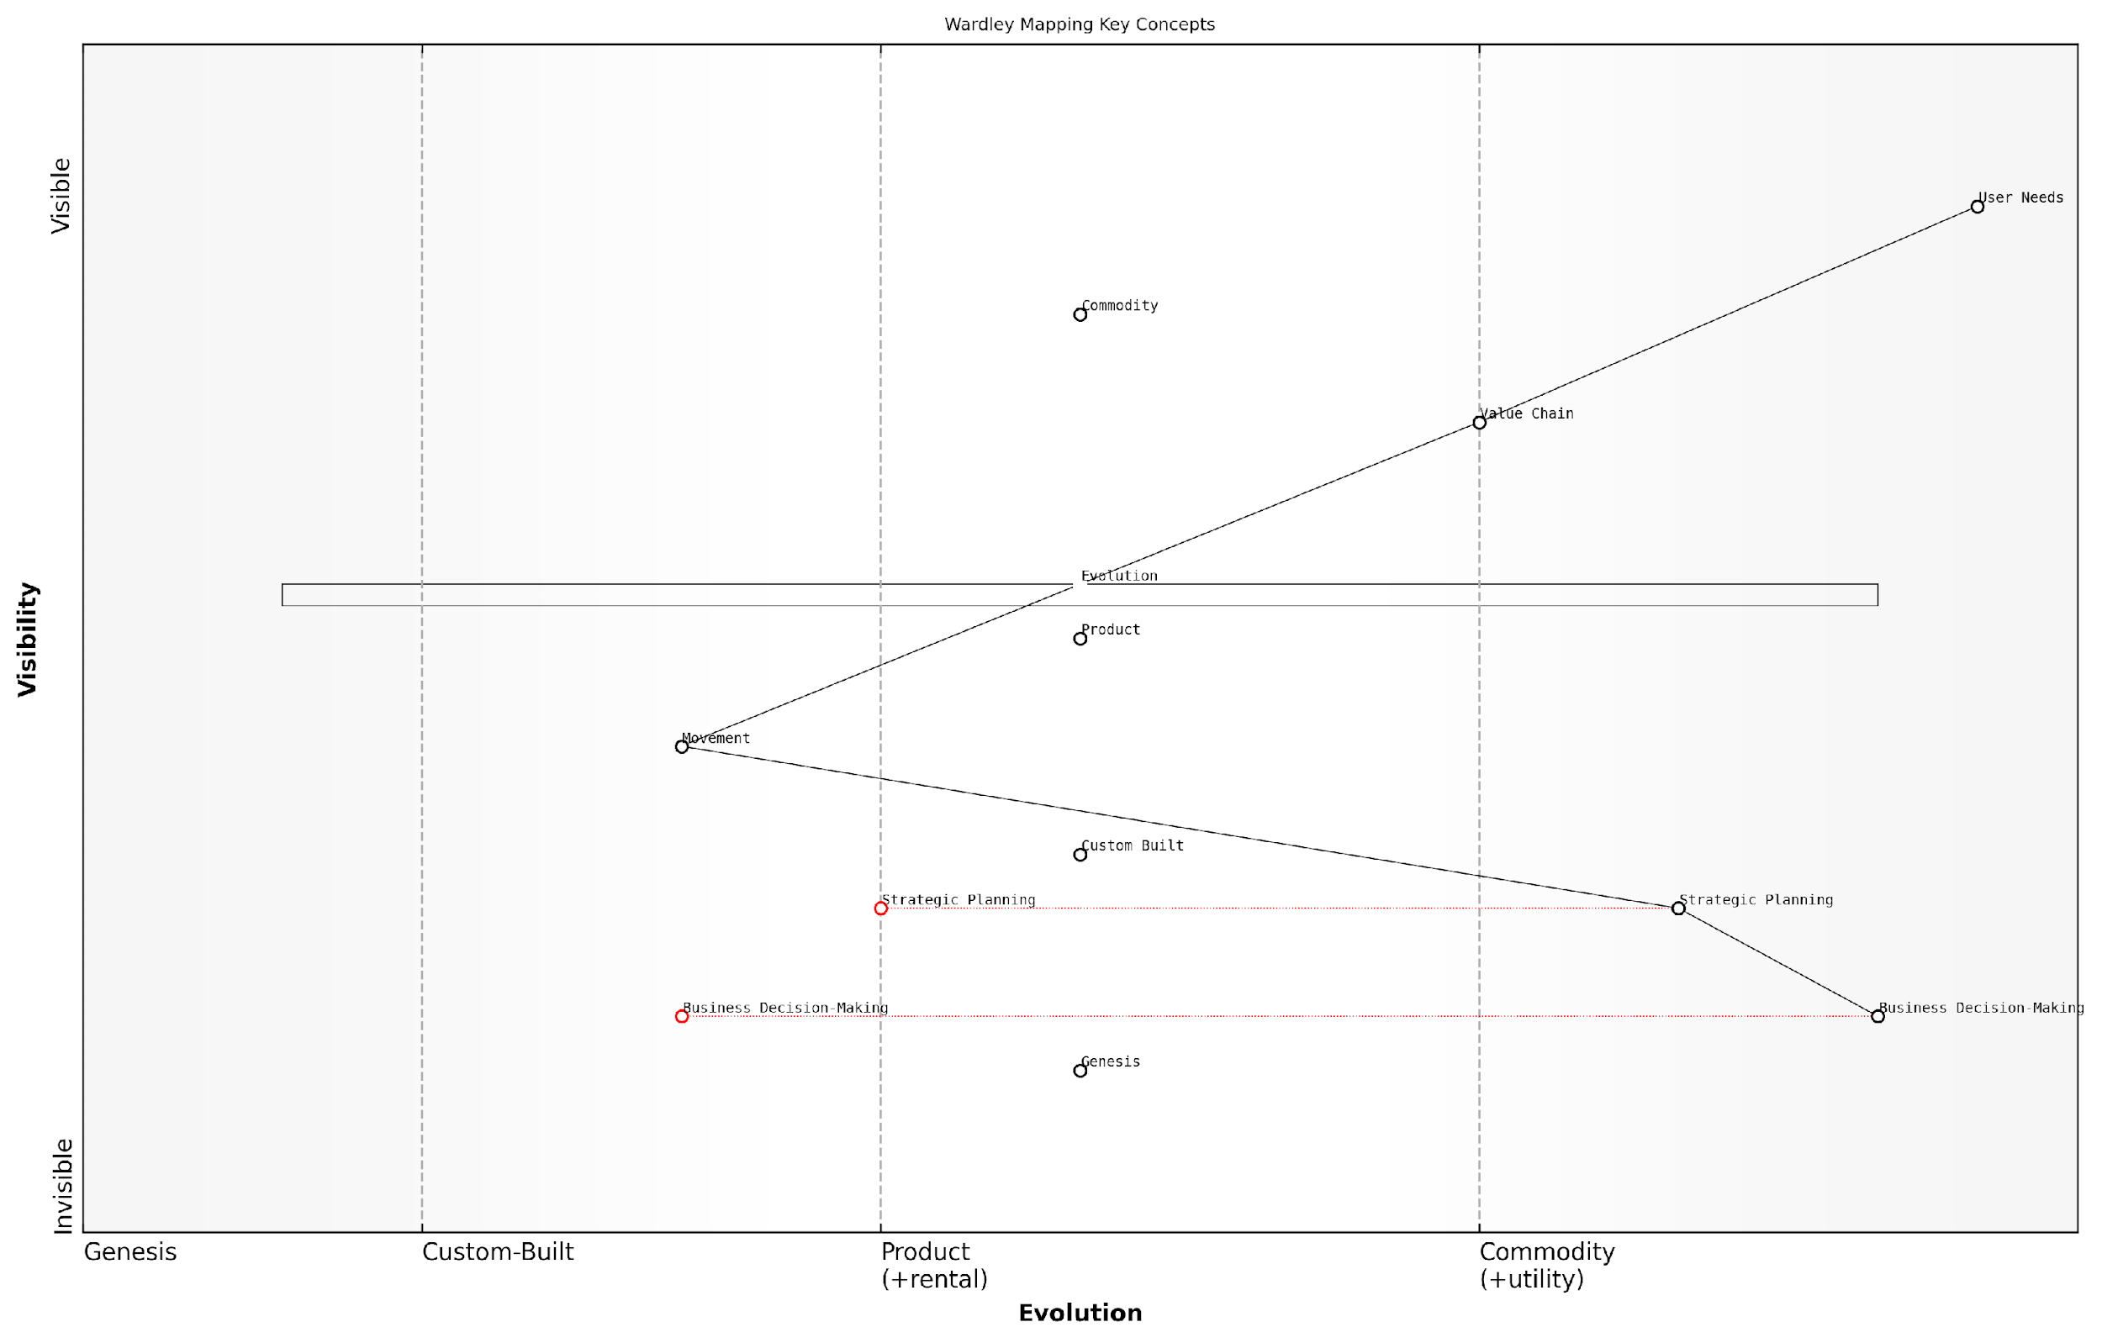

*Draft Wardley Map: [Insert Wardley Map: Origins and key concepts]*

[Edit this draft Wardley Map](https://create.wardleymaps.ai/#clone:b3b14374d7e4e238bd)

Wardley Map Assessment

This Wardley Map of key concepts presents a robust framework for strategic analysis and decision-making, with a strong emphasis on user needs, value chain dynamics, and the evolution of components. The positioning of Strategic Planning and Business Decision-Making as evolving components suggests significant potential for growth and refinement in practical applications. The explicit inclusion of Evolution and Movement concepts differentiates this approach from traditional strategic frameworks, offering unique insights into market dynamics. To fully capitalise on this potential, focus should be placed on developing practical tools and methodologies that bridge the gap between theoretical understanding and business application, particularly in the areas of Evolution and Movement analysis. There’s also a clear opportunity to leverage emerging technologies like AI and machine learning to enhance the predictive and real-time capabilities of Wardley Mapping. Overall, this map indicates that Wardley Mapping is a powerful and evolving approach to strategic analysis, with significant potential for further development and wide-ranging applications in business decision-making.

[View full Wardley Map report](http://markdown_wardley_map_reports/wardley_map_report_01_Origins_and_key_concepts.md)

### How Wardley Mapping differs from traditional project management tools

Wardley Mapping represents a significant departure from traditional project management tools, offering a unique approach to strategic planning and decision-making. While conventional tools often focus on timelines, resources, and deliverables, Wardley Mapping provides a visual representation of the entire value chain and its evolution.

* Emphasis on situational awareness: Wardley Mapping helps project managers understand the broader context of their projects, including market forces and technological evolution.
* Visual representation of dependencies: Unlike Gantt charts or network diagrams, Wardley Maps show the relationships between components in a value chain and their relative maturity.
* Dynamic nature: Wardley Maps are designed to be updated regularly, reflecting the evolving nature of projects and markets, whereas traditional tools often present a static view.
* Strategic focus: While traditional tools are tactical, Wardley Mapping encourages strategic thinking by visualising future scenarios and potential disruptions.

Furthermore, Wardley Mapping introduces the concept of evolution, which is largely absent in traditional project management tools. This allows project managers to anticipate changes in the competitive landscape and adjust their strategies accordingly.

‘Wardley Mapping provides a level of strategic insight that traditional tools simply can’t match. It’s like comparing a 2D drawing to a 3D model - the depth of understanding is incomparable,’ notes a seasoned project management consultant.

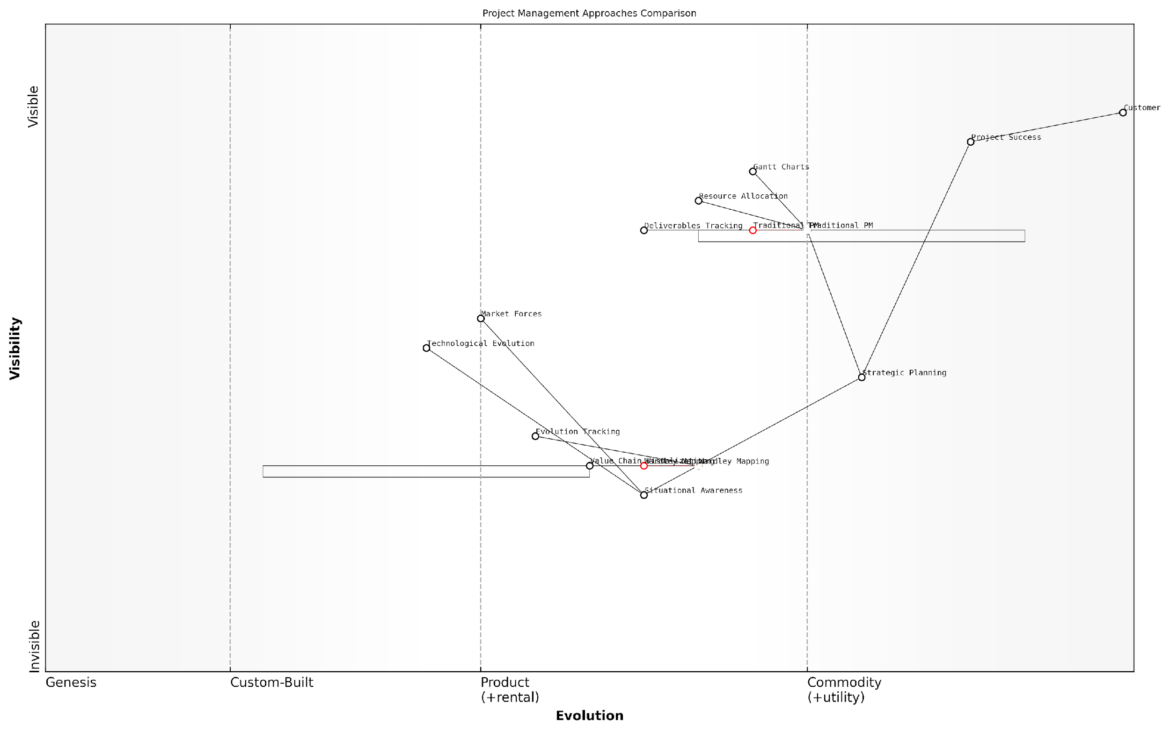

*Draft Wardley Map: [Insert Wardley Map: How Wardley Mapping differs from traditional project management tools]*

[Edit this draft Wardley Map](https://create.wardleymaps.ai/#clone:dabfde40c070bc7083)

Wardley Map Assessment

This Wardley Map reveals a project management landscape in transition, with traditional approaches being challenged by more evolved, strategy-focused methodologies like Wardley Mapping. The key strategic opportunity lies in bridging the gap between these approaches, leveraging the operational strengths of traditional PM while incorporating the strategic insights and adaptability of Wardley Mapping. Organisations that can successfully integrate these approaches, building capabilities in situational awareness and strategic thinking while maintaining operational excellence, will be well-positioned to deliver superior project outcomes and customer value in increasingly complex and rapidly evolving environments.

[View full Wardley Map report](http://markdown_wardley_map_reports/wardley_map_report_02_How_Wardley_Mapping_differs_from_traditional_proje.md)

## Why Project Managers Need Wardley Mapping

### Enhancing strategic decision-making

Wardley Mapping offers project managers a powerful tool for enhancing strategic decision-making, providing a visual and dynamic approach to understanding the complex landscape of projects and organisations. By incorporating Wardley Mapping into their toolkit, project managers can significantly improve their ability to make informed, strategic decisions that align with organisational goals and market realities.

* Visualising the entire value chain: Wardley Maps help project managers see beyond individual tasks to understand how components interact and evolve within the broader ecosystem.
* Identifying strategic opportunities: By mapping the landscape, project managers can spot potential areas for innovation, cost reduction, or competitive advantage.
* Anticipating market changes: Wardley Mapping enables project managers to foresee shifts in technology and market dynamics, allowing for proactive decision-making.
* Aligning projects with business strategy: Maps provide a common language for discussing strategy across different levels of the organisation, ensuring project goals are in sync with overall business objectives.

With Wardley Mapping, project managers can move beyond traditional decision-making frameworks that often fail to capture the full complexity of modern projects. This approach enables them to consider not just the immediate project requirements, but also the broader context of market evolution, technological change, and strategic positioning.

Wardley Mapping has revolutionised our decision-making process. It’s like having a strategic radar that helps us navigate the complexities of our projects and the market.

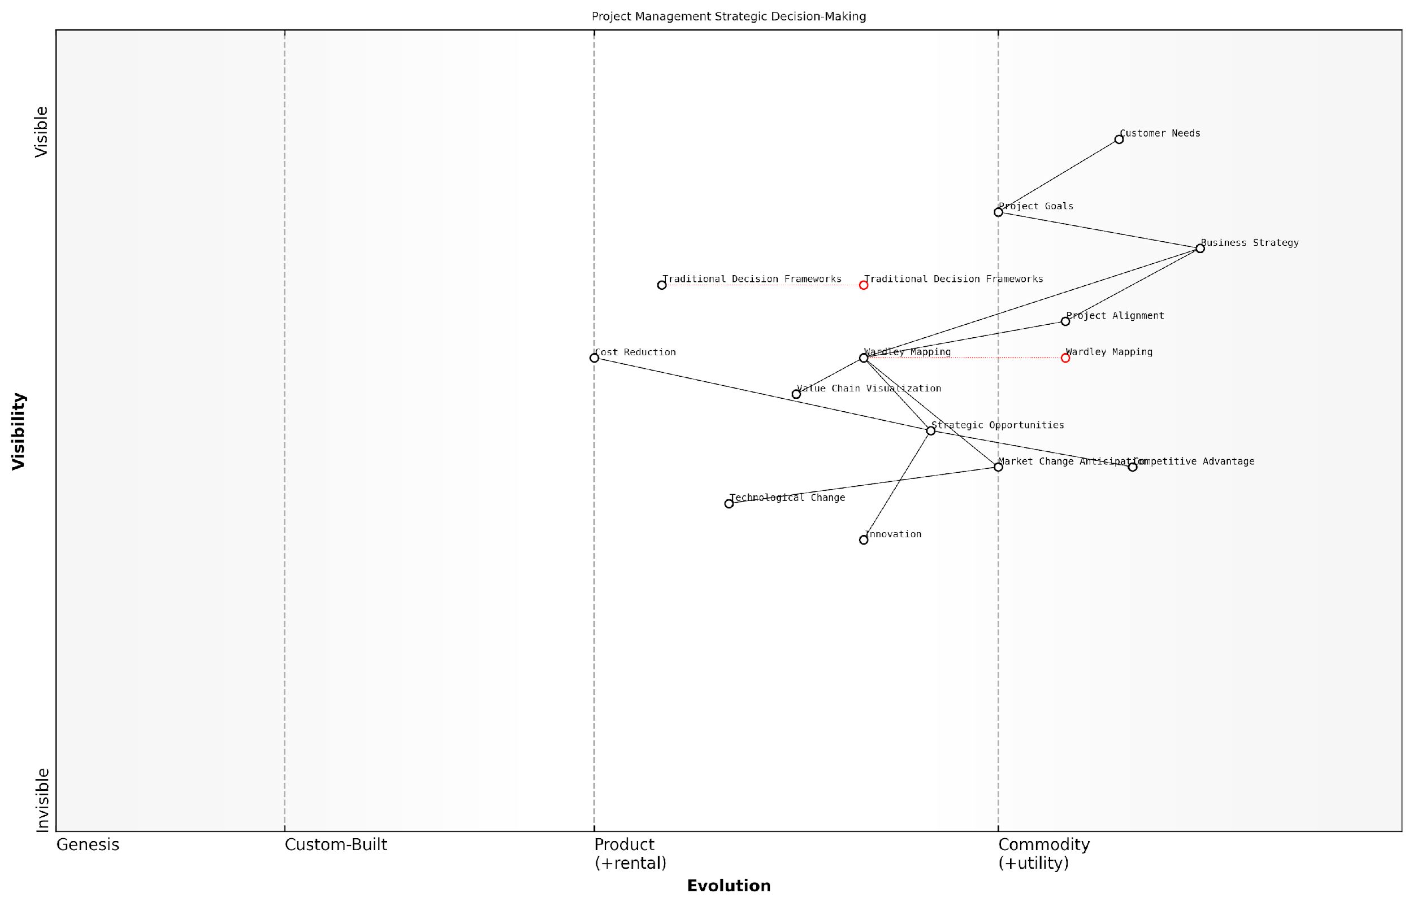

*Draft Wardley Map: [Insert Wardley Map: Enhancing strategic decision-making]*

[Edit this draft Wardley Map](https://create.wardleymaps.ai/#clone:3eafa601a697e4d03b)

Wardley Map Assessment

This Wardley Map reveals a strategic shift in project management towards more dynamic, market-responsive approaches centred around Wardley Mapping. The positioning of Wardley Mapping as a central, evolving component suggests significant potential for enhancing strategic decision-making in project management. However, successful implementation will require addressing capability gaps, managing the transition from traditional frameworks, and fostering a culture of continuous strategic adaptation. The map indicates opportunities for innovation in strategic tools and methodologies, particularly in leveraging emerging technologies. Overall, organisations that successfully navigate this transition stand to gain significant competitive advantages through more aligned, responsive, and strategically driven project management practices.

[View full Wardley Map report](http://markdown_wardley_map_reports/wardley_map_report_03_Enhancing_strategic_decision-making.md)

### Improving project planning and execution

Wardley Mapping offers project managers a powerful tool for improving project planning and execution. By providing a visual representation of the project landscape, Wardley Maps enable project managers to make more informed decisions and navigate complex environments with greater confidence.

* Enhanced situational awareness: Wardley Maps help project managers understand the entire ecosystem of their project, including dependencies, evolving technologies, and market forces.
* Better resource allocation: By visualising the value chain and evolution of components, project managers can more effectively allocate resources to areas that will drive the most value.
* Improved risk management: Wardley Mapping allows for the identification of potential risks and bottlenecks early in the project lifecycle, enabling proactive mitigation strategies.
* Adaptive planning: As projects evolve, Wardley Maps provide a framework for adjusting plans and strategies in response to changing conditions and emerging opportunities.

With Wardley Mapping, project managers can move beyond traditional planning tools and gain a strategic advantage in project execution. This approach enables them to anticipate changes, make data-driven decisions, and align project goals with broader organisational objectives.

Wardley Mapping has revolutionised our approach to project management. It’s like having a GPS for navigating complex project landscapes.

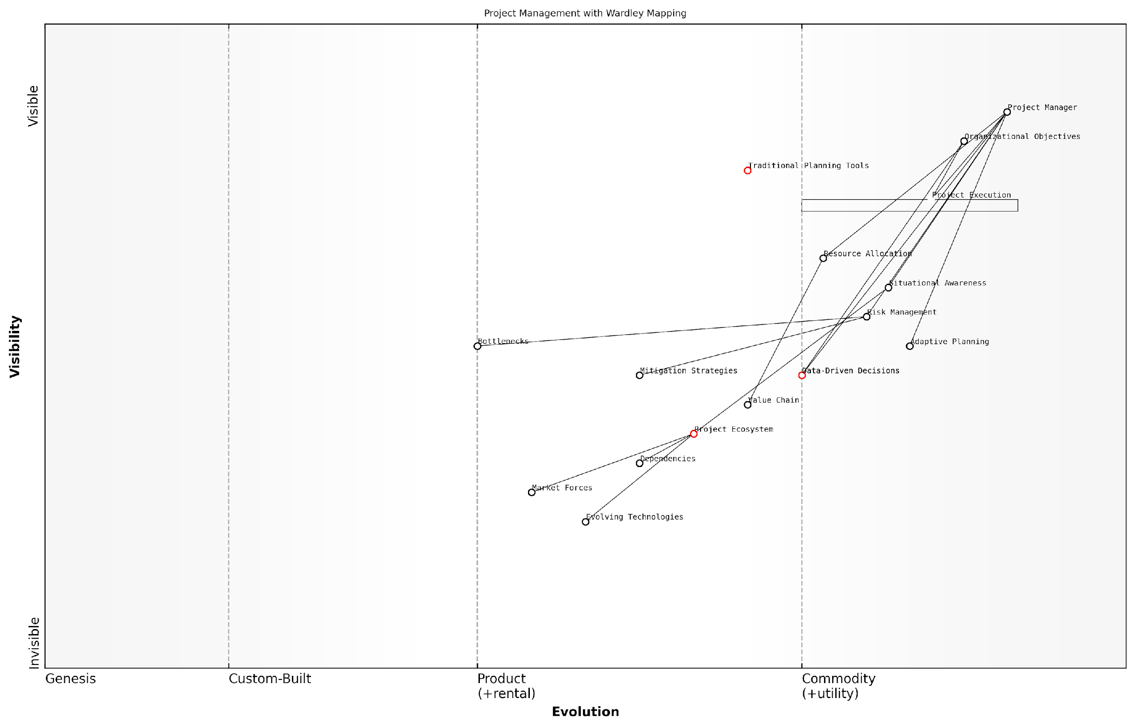

*Draft Wardley Map: [Insert Wardley Map: Improving project planning and execution]*

[Edit this draft Wardley Map](https://create.wardleymaps.ai/#clone:9d5a9436a315eae458)

Wardley Map Assessment

This Wardley Map reveals a project management landscape in transition, moving from traditional, tool-centric approaches to more adaptive, data-driven methodologies. The strategic positioning of components like Situational Awareness and Data-Driven Decisions indicates a recognition of their importance in modern project management. However, the map also highlights potential challenges, such as the inertia of Traditional Planning Tools and the need for better integration of emerging capabilities. To capitalise on this evolving landscape, organisations should focus on enhancing their data analytics capabilities, developing more robust situational awareness, and fostering a more adaptive approach to planning and execution. The explicit inclusion of the Project Ecosystem as a key component suggests an opportunity for organisations to gain a competitive edge by better understanding and managing the complex environments in which their projects operate. Overall, this map provides a clear direction for the future of project management, emphasising the need for a more holistic, data-informed, and adaptive approach to ensure project success in increasingly complex and dynamic environments.

[View full Wardley Map report](http://markdown_wardley_map_reports/wardley_map_report_04_Improving_project_planning_and_execution.md)

### Anticipating and managing change

In today’s rapidly evolving business landscape, project managers face the constant challenge of anticipating and managing change. Wardley Mapping provides a powerful tool to address this challenge, offering a strategic approach to understanding and navigating the complex dynamics of project environments.

* Visualising the evolution of project components
* Identifying potential disruptors and market shifts
* Developing adaptive strategies to mitigate risks

By mapping the value chain and evolution of project components, project managers can gain insights into future trends and potential disruptions. This foresight allows for proactive planning and the development of flexible strategies that can adapt to changing circumstances.

A seasoned project manager once remarked, ‘Wardley Mapping has transformed our ability to anticipate change. It’s like having a crystal ball for project planning.’

Moreover, Wardley Mapping enables project managers to communicate the impact of change to stakeholders more effectively. By visualising the project landscape and its evolution, teams can better understand the rationale behind strategic decisions and the need for adaptability.

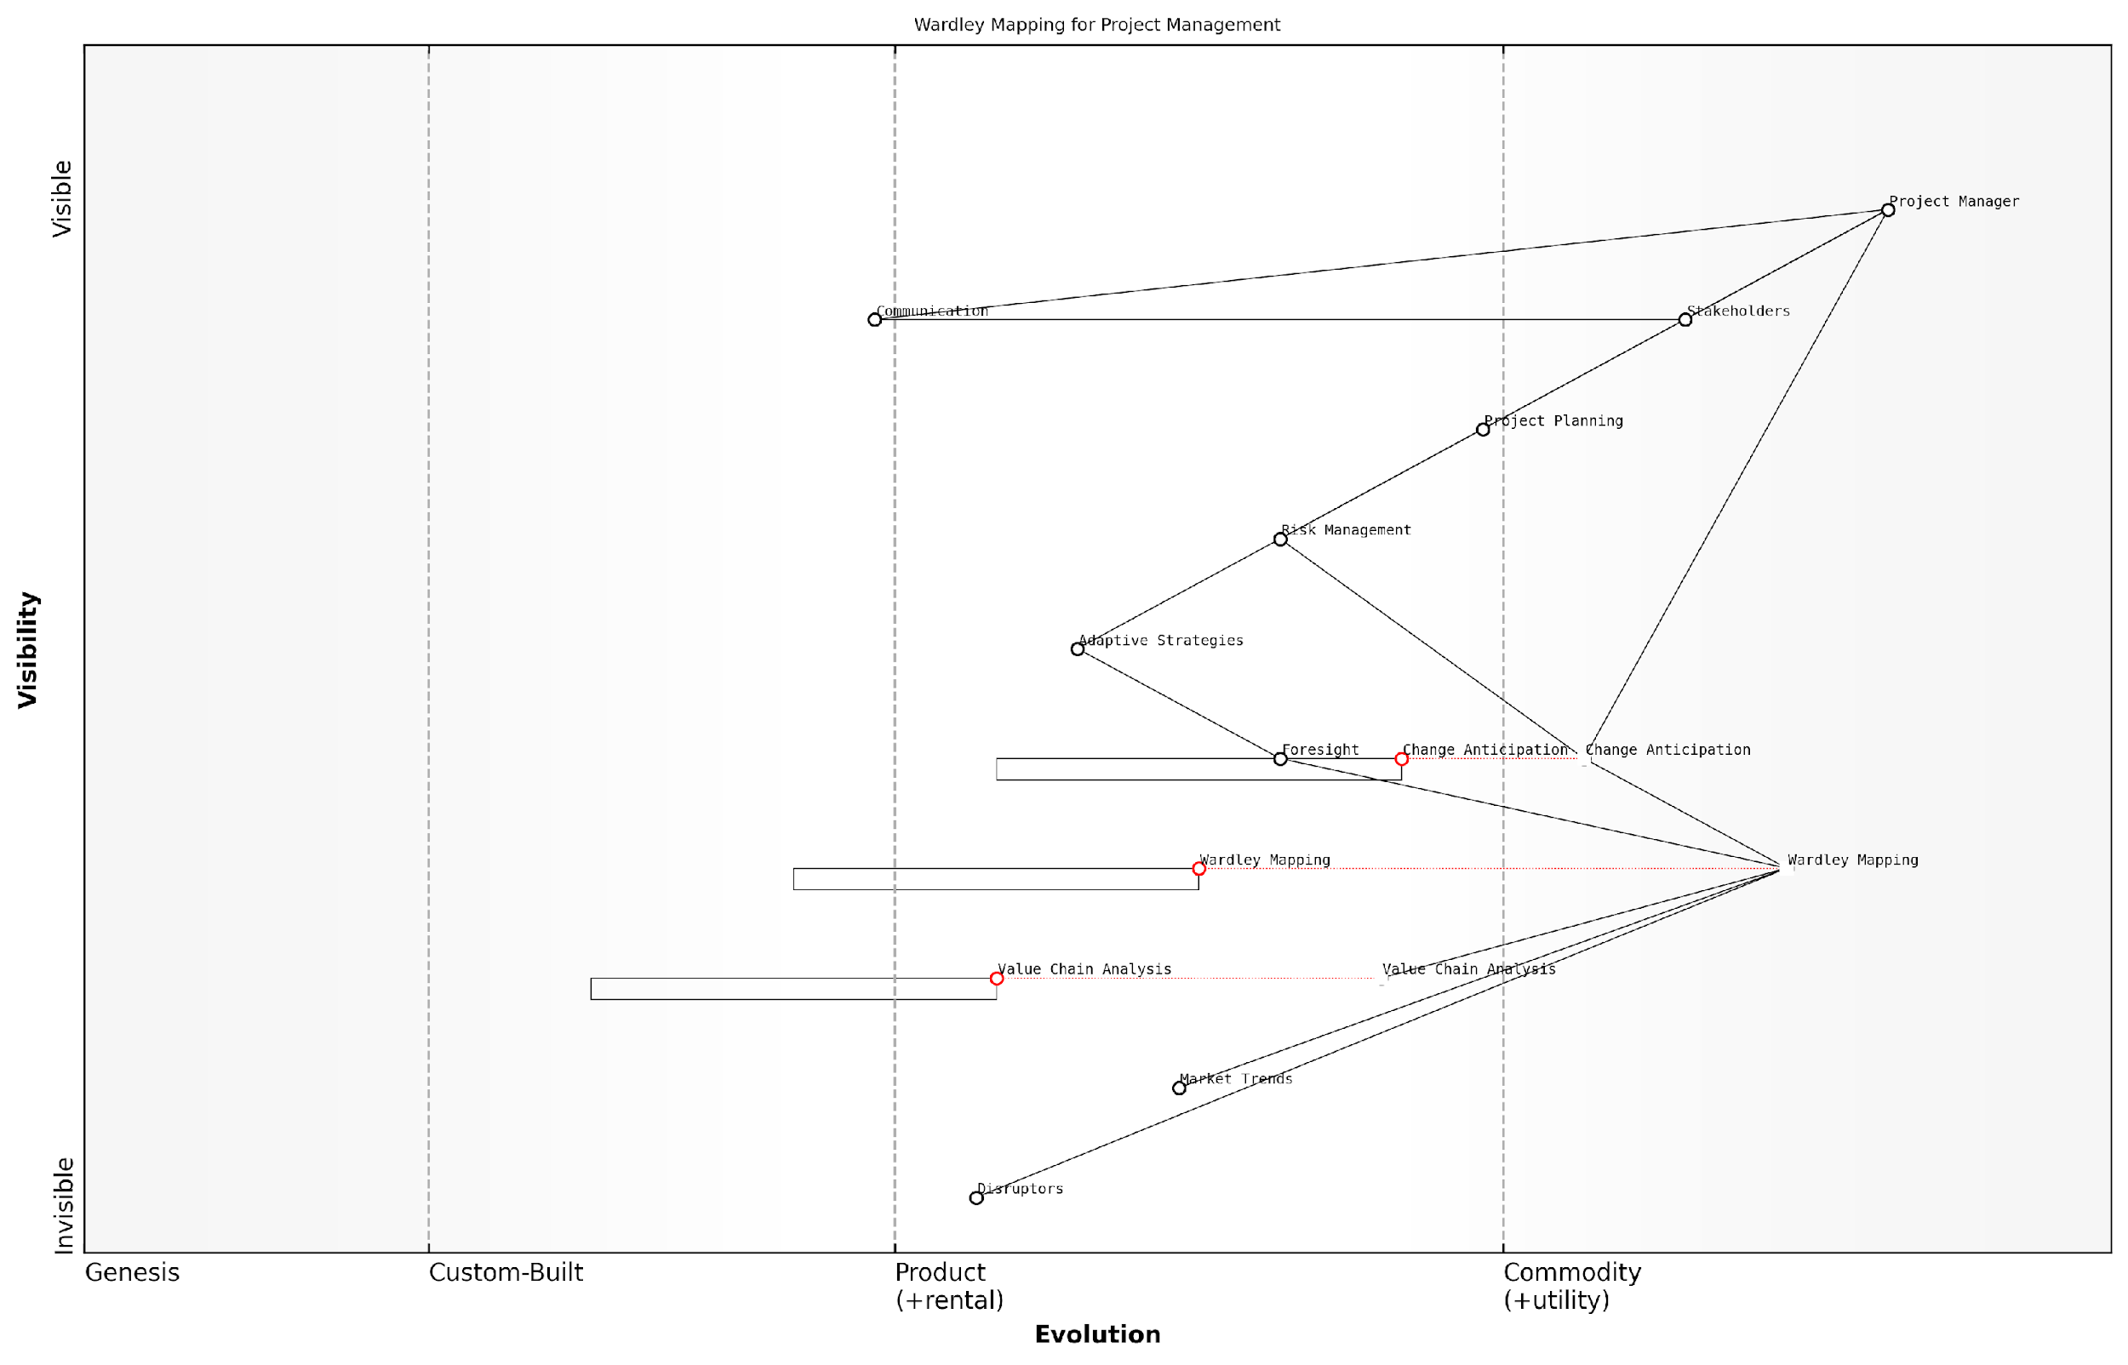

*Draft Wardley Map: [Insert Wardley Map: Anticipating and managing change]*

[Edit this draft Wardley Map](https://create.wardleymaps.ai/#clone:08da6c6eb65dccc8cd)

Wardley Map Assessment

This Wardley Map represents a forward-thinking approach to project management that emphasises strategic foresight and adaptability. By positioning Wardley Mapping as a key tool for Change Anticipation, the organisation is well-positioned to handle complex, dynamic project environments. However, successful implementation will require significant investment in training, tool development, and organisational change. The potential rewards include a competitive advantage in project delivery, especially in rapidly changing markets. Key focus areas should be the integration of Wardley Mapping insights into practical project execution, the development of adaptive strategies, and the cultivation of a culture that values and acts on strategic foresight.

[View full Wardley Map report](http://markdown_wardley_map_reports/wardley_map_report_05_Anticipating_and_managing_change.md)

# Chapter 1: Fundamentals of Wardley Mapping for Project Managers

## Components of a Wardley Map

### Understanding the value chain

The value chain is a fundamental component of a Wardley Map and serves as the backbone for visualising how value flows through a project or organisation. For project managers, understanding the value chain is crucial for identifying key components, dependencies, and potential areas for improvement.

In the context of Wardley Mapping, the value chain represents the series of activities or components that contribute to delivering value to the end user. These components are arranged vertically on the map, with those closest to the user at the top and supporting components below.

* User needs: The topmost element of the value chain, representing the ultimate goal of the project or service
* Visible components: Elements that directly interact with or are visible to the user
* Supporting components: Underlying elements that enable the visible components to function
* Foundational components: Basic building blocks that support the entire system

Project managers can use the value chain in Wardley Mapping to gain insights into:

* Critical dependencies between components
* Potential bottlenecks or weak links in the project
* Opportunities for optimisation or outsourcing
* Areas where innovation or investment may yield the greatest returns

A seasoned project manager once remarked, ‘Understanding the value chain through Wardley Mapping has completely transformed how I approach project planning and resource allocation. It’s like having a high-resolution X-ray of your project’s anatomy.’

By mapping out the value chain, project managers can make more informed decisions about project priorities, resource allocation, and risk management. This visual representation also facilitates better communication with stakeholders, helping to align project goals with overall organisational strategy.

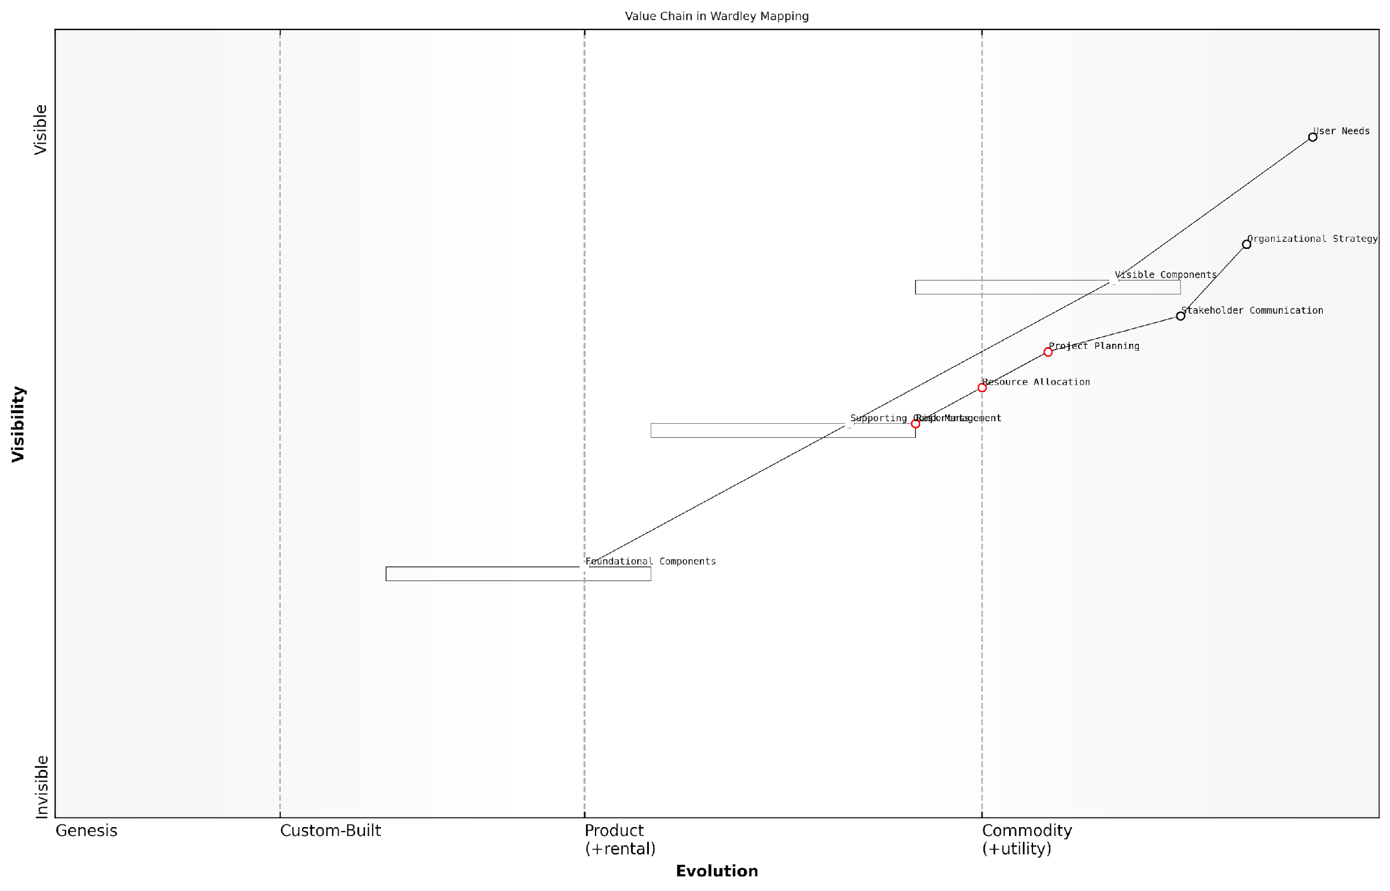

*Draft Wardley Map: [Insert Wardley Map: Understanding the value chain]*

[Edit this draft Wardley Map](https://create.wardleymaps.ai/#clone:2a3e42bd88b9680acb)

Wardley Map Assessment

This Wardley Map reveals a well-structured project management value chain with a strong focus on aligning with user needs and organisational strategy. The central position of Project Planning highlights its critical role in coordinating various components. There are significant opportunities for innovation in Supporting Components and potential for gaining competitive advantage through better integration of Organisational Strategy with project execution. Key areas for improvement include enhancing Risk Management capabilities and creating a more seamless flow between Supporting and Visible Components. The organisation should focus on maintaining its strong alignment with User Needs while preparing for the future commoditization of lower-level components by investing in innovation at the Visible Component and Organisational Strategy levels.

[View full Wardley Map report](http://markdown_wardley_map_reports/wardley_map_report_06_Understanding_the_value_chain.md)

### Mapping evolution and movement

One of the key components that sets Wardley Maps apart from other strategic tools is the concept of evolution and movement. This dimension adds a crucial dynamic element to the map, allowing project managers to visualise how components change over time and anticipate future shifts in the project landscape.

Evolution in Wardley Mapping is represented on the horizontal axis of the map, typically divided into four stages:

* Genesis: Novel, uncertain, and rapidly changing components
* Custom-built: Emerging understanding, some standardisation
* Product: Well-understood, feature-differentiation focus
* Commodity: Highly standardised, utility-like services

As project managers, understanding the evolution of components is crucial for several reasons:

* Anticipating future changes in technology or processes
* Identifying potential areas for innovation or cost-saving
* Aligning project strategies with the maturity of components
* Making informed decisions about build vs. buy options

Movement in Wardley Maps refers to the natural progression of components from left to right on the evolution axis. This movement is driven by competition, user needs, and technological advancements. Project managers must be aware that this movement is often inevitable and can significantly impact project planning and execution.

Understanding the evolution of components is like having a crystal ball for your project. It allows you to see where things are heading and adapt your strategy accordingly.

To effectively map evolution and movement, project managers should:

* Regularly assess the current evolutionary stage of each component
* Consider external factors that might accelerate or hinder evolution
* Plan for the impact of component evolution on project timelines and resources
* Use the map to communicate potential future states to stakeholders

By incorporating evolution and movement into their Wardley Maps, project managers gain a powerful tool for strategic foresight, enabling them to navigate the complex and ever-changing landscape of modern projects with greater confidence and agility.

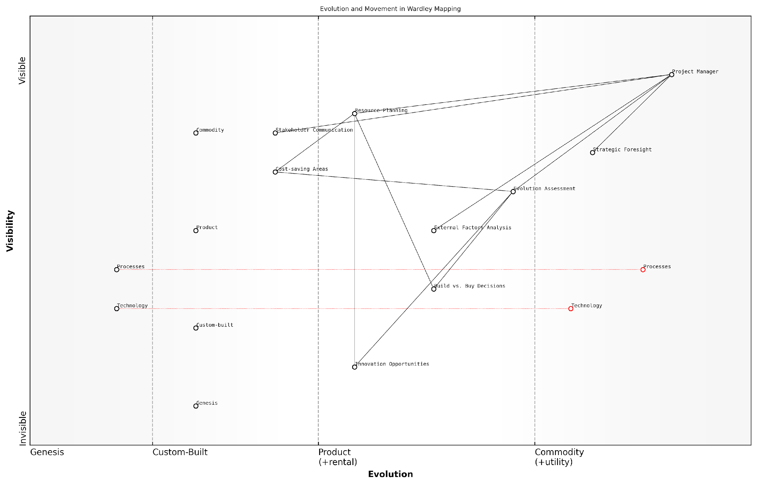

*Draft Wardley Map: [Insert Wardley Map: Mapping evolution and movement]*

[Edit this draft Wardley Map](https://create.wardleymaps.ai/#clone:23e7671233a8b37a1b)

Wardley Map Assessment

This Wardley Map represents a sophisticated approach to project management that emphasises strategic foresight and evolution assessment. The positioning of components suggests a mature understanding of project dynamics, with opportunities for innovation in data analytics, automation, and ecosystem integration. The key strategic focus should be on enhancing the integration between strategic insights and operational execution, while also evolving capabilities in resource planning and stakeholder communication to match the sophistication of the strategic components. By addressing these areas, the project management approach depicted can maintain its strategic advantage and adapt effectively to future changes in the project landscape.

[View full Wardley Map report](http://markdown_wardley_map_reports/wardley_map_report_07_Mapping_evolution_and_movement.md)

### Anchoring the map with user needs

At the heart of every Wardley Map lies the user need, serving as the anchor and driving force behind the entire value chain. For project managers, understanding and accurately representing user needs is crucial for creating meaningful and effective maps.

User needs form the foundation of the map, positioned at the top of the value chain. They represent the ultimate purpose of the project or system being mapped. By starting with user needs, project managers ensure that every component and activity in the map is aligned with delivering value to the end user.

* Identify the primary users or stakeholders of the project
* Conduct user research to uncover genuine needs and pain points
* Articulate user needs clearly and concisely
* Prioritise user needs based on importance and impact

When anchoring the map with user needs, it’s essential to distinguish between genuine needs and wants or solutions. Focus on the underlying problem or desire, rather than specific features or implementations. This approach allows for more flexibility and innovation in addressing user needs throughout the project lifecycle.

A well-defined user need acts as a North Star for the entire project, guiding decision-making and ensuring that all efforts contribute to delivering real value.

Project managers should regularly revisit and validate user needs throughout the project, as they may evolve or change over time. This iterative process ensures that the map remains relevant and aligned with the project’s ultimate goals.

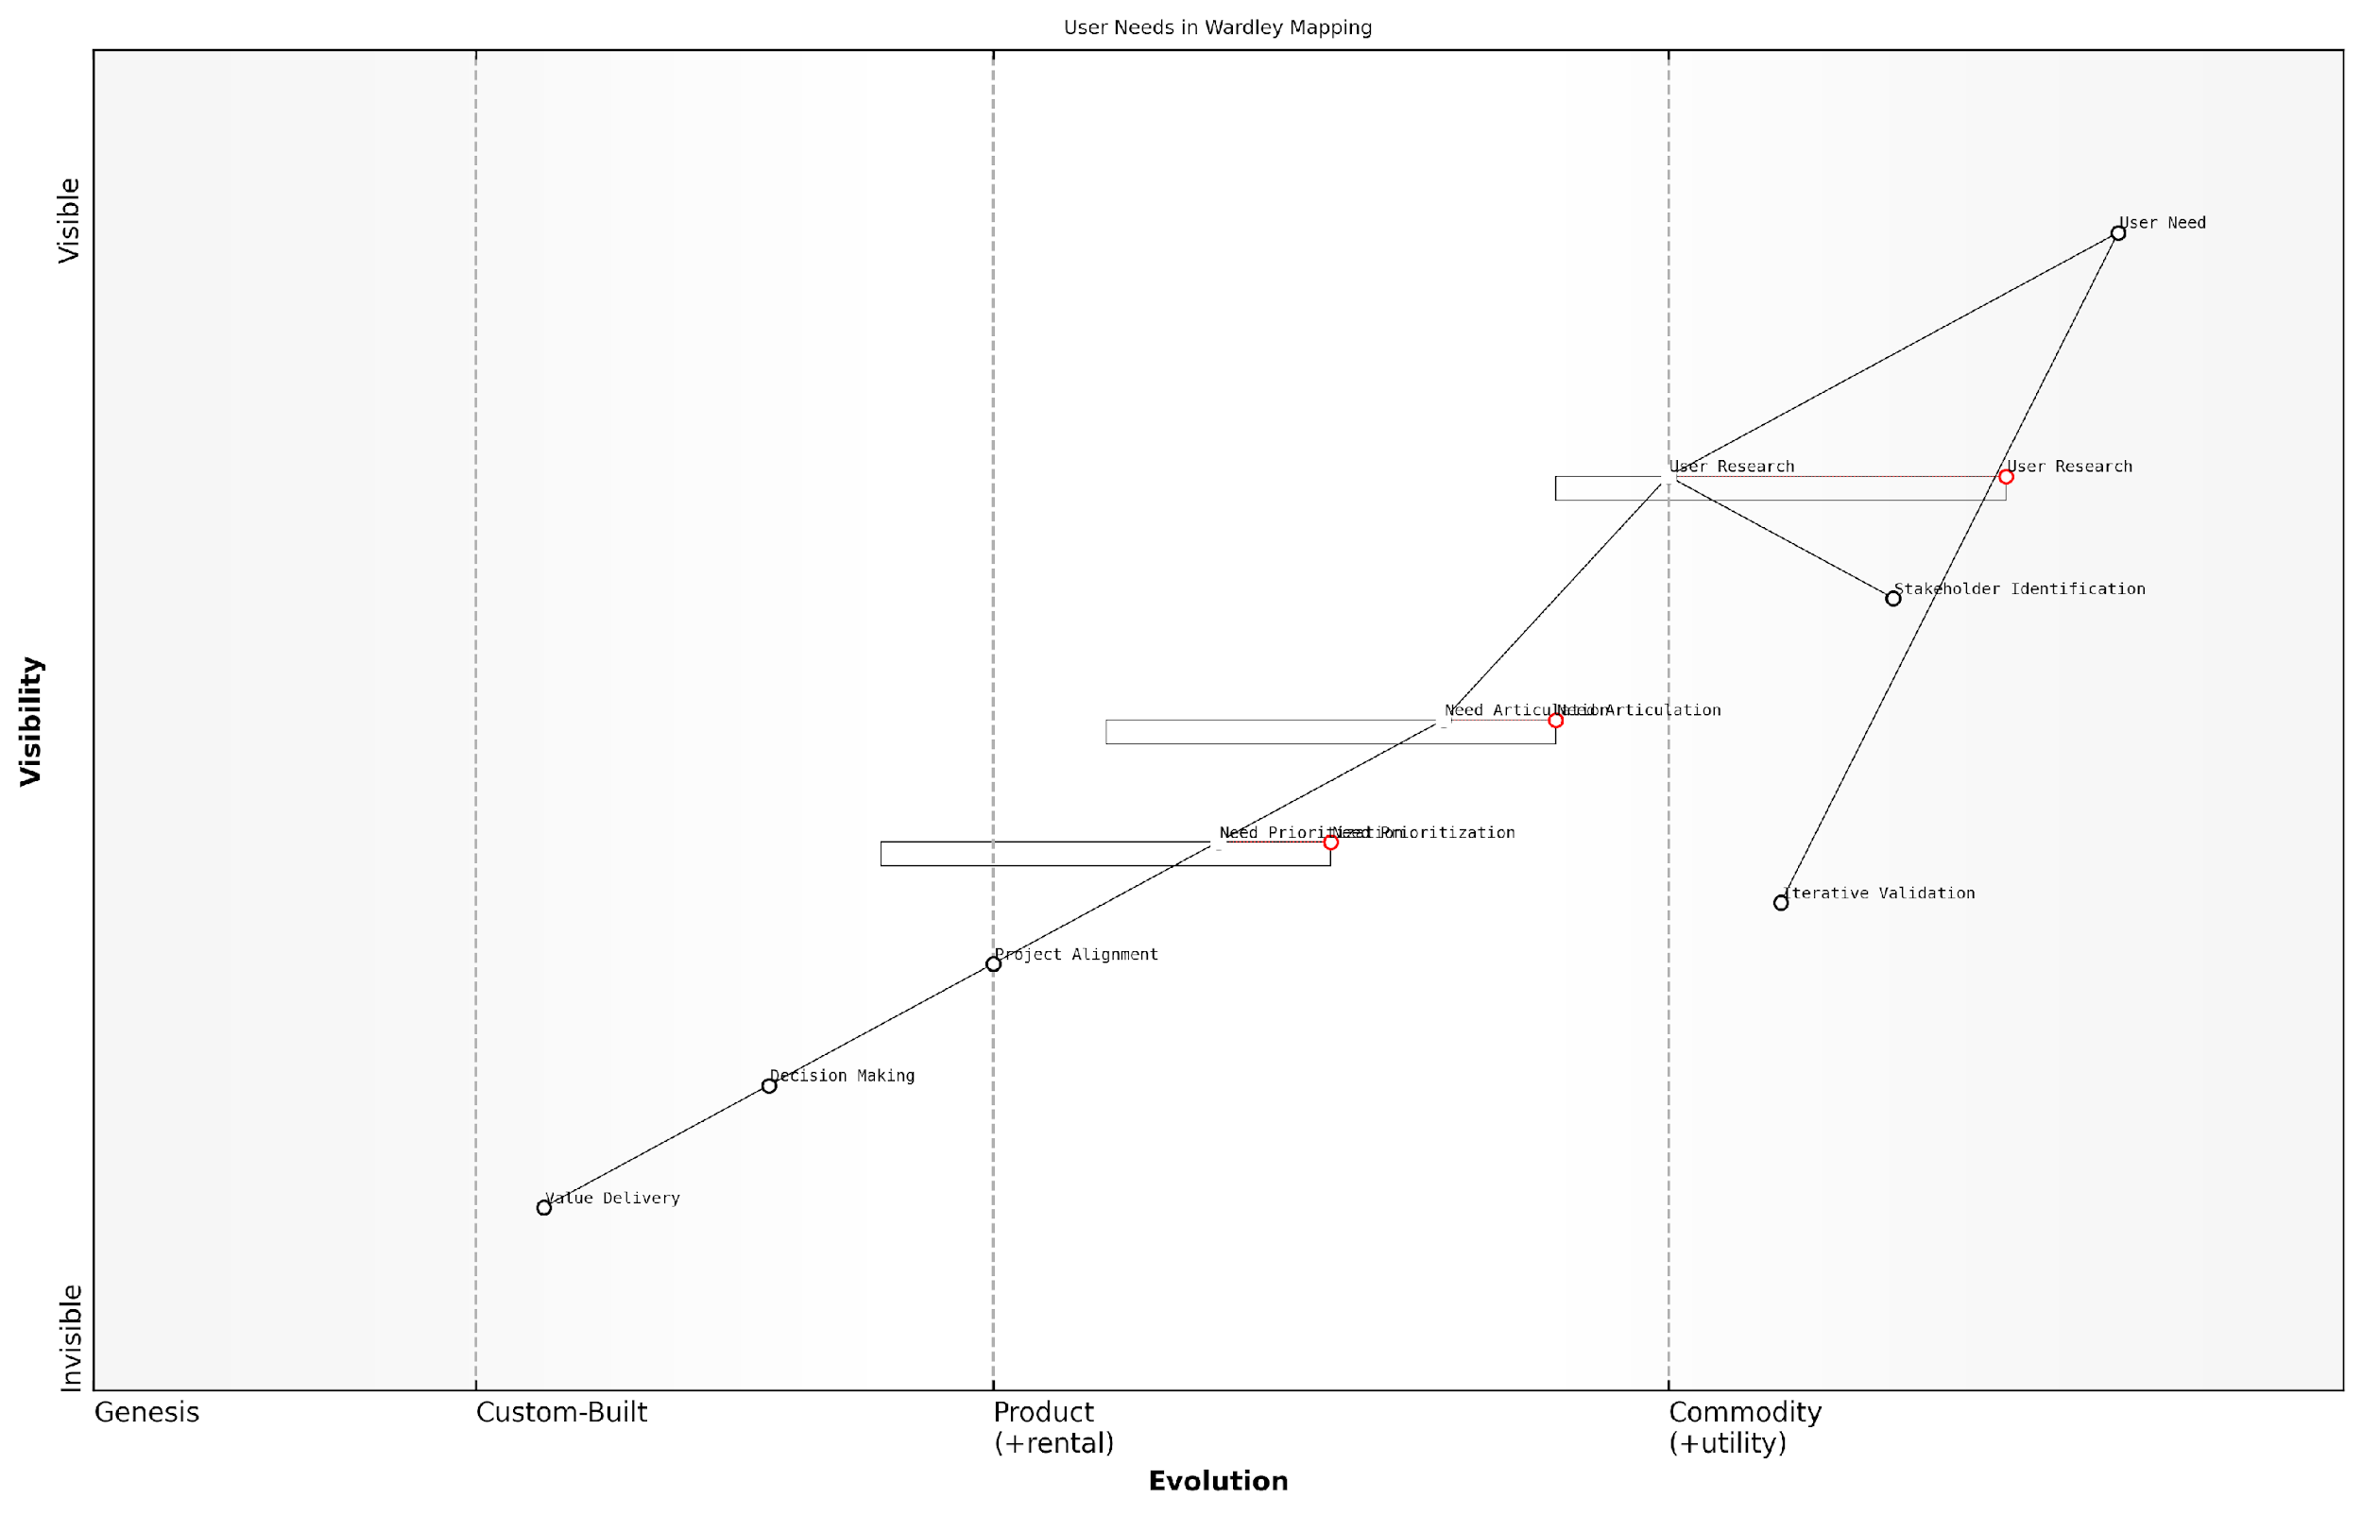

*Draft Wardley Map: [Insert Wardley Map: Anchoring the map with user needs]*

[Edit this draft Wardley Map](https://create.wardleymaps.ai/#clone:68e6e1df4fca65e1f2)

Wardley Map Assessment

This Wardley Map effectively illustrates the process of addressing user needs in project management. It highlights the critical role of user research and need articulation while emphasising the importance of iterative validation. The map suggests opportunities for innovation in areas like AI-driven research and prioritisation. To maintain competitive advantage, organisations should focus on evolving their capabilities in key areas like need articulation and project alignment, while preparing for the commoditization of user research. The integration of iterative validation throughout the process is a strength that should be further developed. Overall, this map provides a solid foundation for strategic decision-making in user-centric project management.

[View full Wardley Map report](http://markdown_wardley_map_reports/wardley_map_report_08_Anchoring_the_map_with_user_needs.md)

## Creating Your First Wardley Map

### Step-by-step guide to mapping a project

Creating your first Wardley Map for a project can seem daunting, but by following these steps, you’ll be able to visualise your project’s components and their relationships effectively. Remember, the goal is to create a visual representation of your project’s value chain and the evolution of its components.

* Step 1: Identify the user need
* Step 2: List the components
* Step 3: Position components on the value chain
* Step 4: Determine component evolution
* Step 5: Draw links between components
* Step 6: Analyse and refine your map

Let’s break down each step in detail:

Step 1: Identify the user need - Start by clearly defining the primary user need your project aims to address. This will be the anchor at the top of your map.

Step 2: List the components - Brainstorm all the components (activities, practices, data, etc.) required to meet the user need. Include everything from customer-facing elements to back-end infrastructure.

Step 3: Position components on the value chain - Arrange the components vertically based on their visibility to the user. Place user-facing components at the top and foundational elements at the bottom.

Step 4: Determine component evolution - For each component, assess its evolutionary stage (Genesis, Custom-Built, Product, or Commodity) and position it horizontally on the map accordingly.

Step 5: Draw links between components - Connect the components to show dependencies and relationships within the value chain.

Step 6: Analyse and refine your map - Review your map, looking for patterns, dependencies, and potential areas of improvement or risk. Iterate and refine as needed.

A seasoned project manager once said, ‘Creating your first Wardley Map is like learning to ride a bicycle. It might be wobbly at first, but with practice, it becomes an invaluable tool for navigating complex project landscapes.’

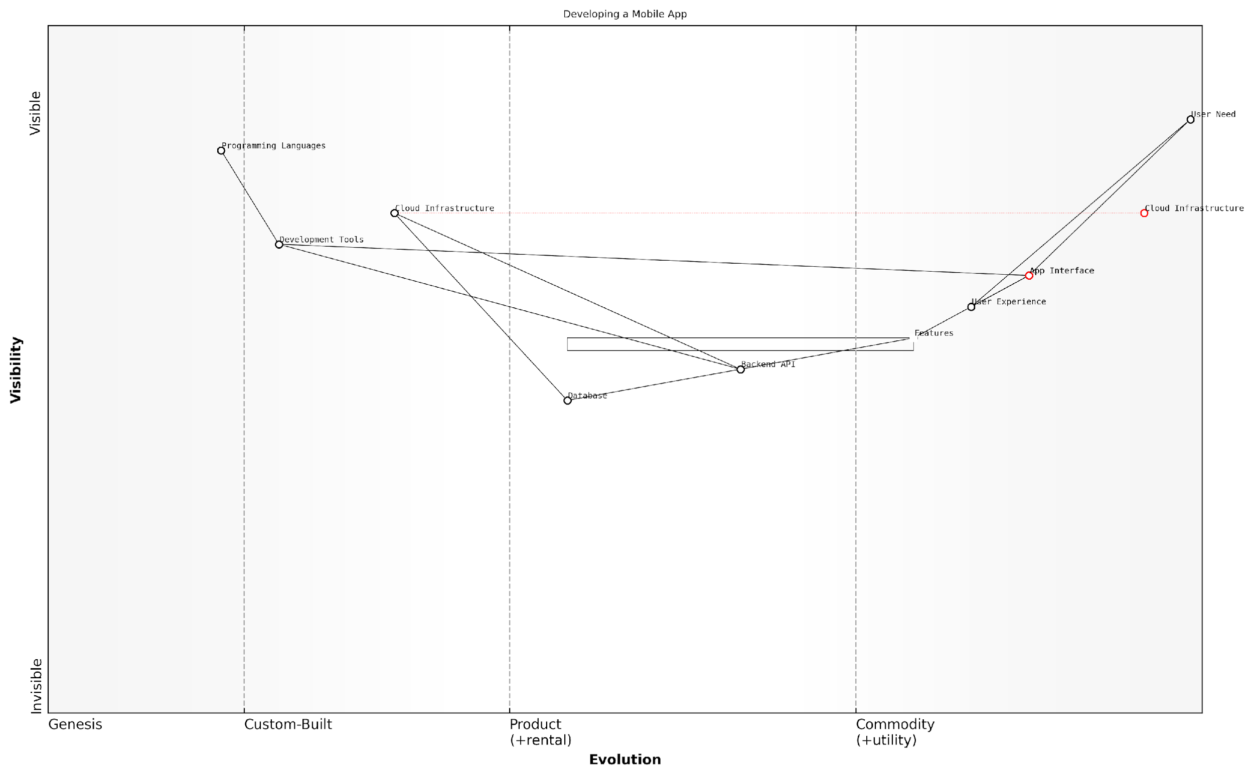

*Draft Wardley Map: [Insert Wardley Map: Step-by-step guide to mapping a project]*

[Edit this draft Wardley Map](https://create.wardleymaps.ai/#clone:98086b80ae90fd6489)

Wardley Map Assessment

The map represents a solid foundation for mobile app development with clear opportunities for strategic evolution. Key focus areas should be evolving backend components, accelerating feature development, and investing in emerging technologies for user experience enhancement. The strong positioning of user-facing components provides a competitive advantage, while the evolving cloud infrastructure offers scalability. To maintain and improve market position, the organisation should prioritise backend evolution and explore AI-driven innovations in user experience.

[View full Wardley Map report](http://markdown_wardley_map_reports/wardley_map_report_09_Step-by-step_guide_to_mapping_a_project.md)

### Common pitfalls and how to avoid them

As project managers begin to create their first Wardley Maps, they often encounter several common pitfalls. Being aware of these challenges and knowing how to navigate them is crucial for successful mapping and deriving valuable insights for project management.

* Overcomplicating the map: Trying to include too many components or details can make the map difficult to read and interpret.
* Misplacing components on the evolution axis: Incorrectly assessing the maturity of components can lead to flawed strategic decisions.
* Neglecting the user needs: Failing to anchor the map with clear user needs can result in a map that doesn’t accurately reflect project priorities.
* Ignoring dependencies: Not considering the relationships between components can lead to overlooking critical project dependencies.
* Static thinking: Treating the map as a fixed document rather than a dynamic tool that evolves with the project.
* Lack of stakeholder involvement: Creating the map in isolation without input from key stakeholders can result in missed perspectives and incomplete understanding.

To avoid these pitfalls, project managers should follow these best practices:

* Start simple: Begin with a basic map focusing on core components and gradually add complexity as needed.
* Collaborate and validate: Involve team members and stakeholders in the mapping process to ensure diverse perspectives and accurate placement of components.
* Focus on user needs: Always anchor your map with clear, well-defined user needs to maintain project alignment.
* Regularly review and update: Treat your Wardley Map as a living document, updating it as the project progresses and new information emerges.
* Use supporting data: Leverage market research, industry trends, and project data to inform component placement on the evolution axis.
* Practise and iterate: Develop your mapping skills through regular practice and iteration, learning from each mapping exercise.

A seasoned project manager once said, ‘Your first Wardley Map won’t be perfect, but each one you create will provide valuable insights and improve your strategic thinking.’

By being aware of these common pitfalls and actively working to avoid them, project managers can harness the full potential of Wardley Mapping to enhance their strategic decision-making and project outcomes.

### Iterating and refining your map

Creating a Wardley Map is an iterative process. Your first map is unlikely to be perfect, and that’s perfectly normal. The key is to start with a basic map and continuously refine it as you gain more insights and information.

* Review and validate: Regularly review your map with team members and stakeholders to ensure it accurately represents the project landscape.
* Incorporate feedback: Be open to feedback and adjust your map accordingly. Different perspectives can reveal blind spots or new connections.
* Update as you learn: As you gather more information about your project and its environment, update your map to reflect new insights.
* Experiment with different layouts: Try rearranging components to see if different layouts reveal new relationships or dependencies.
* Use versioning: Keep track of different versions of your map to document how your understanding evolves over time.

Remember that the process of creating and refining the map is often as valuable as the final product. It encourages critical thinking about your project’s components, their relationships, and their evolution.

A seasoned project manager once said, ‘My first Wardley Map was a mess, but each iteration brought clarity. Now, I can’t imagine starting a project without one.’

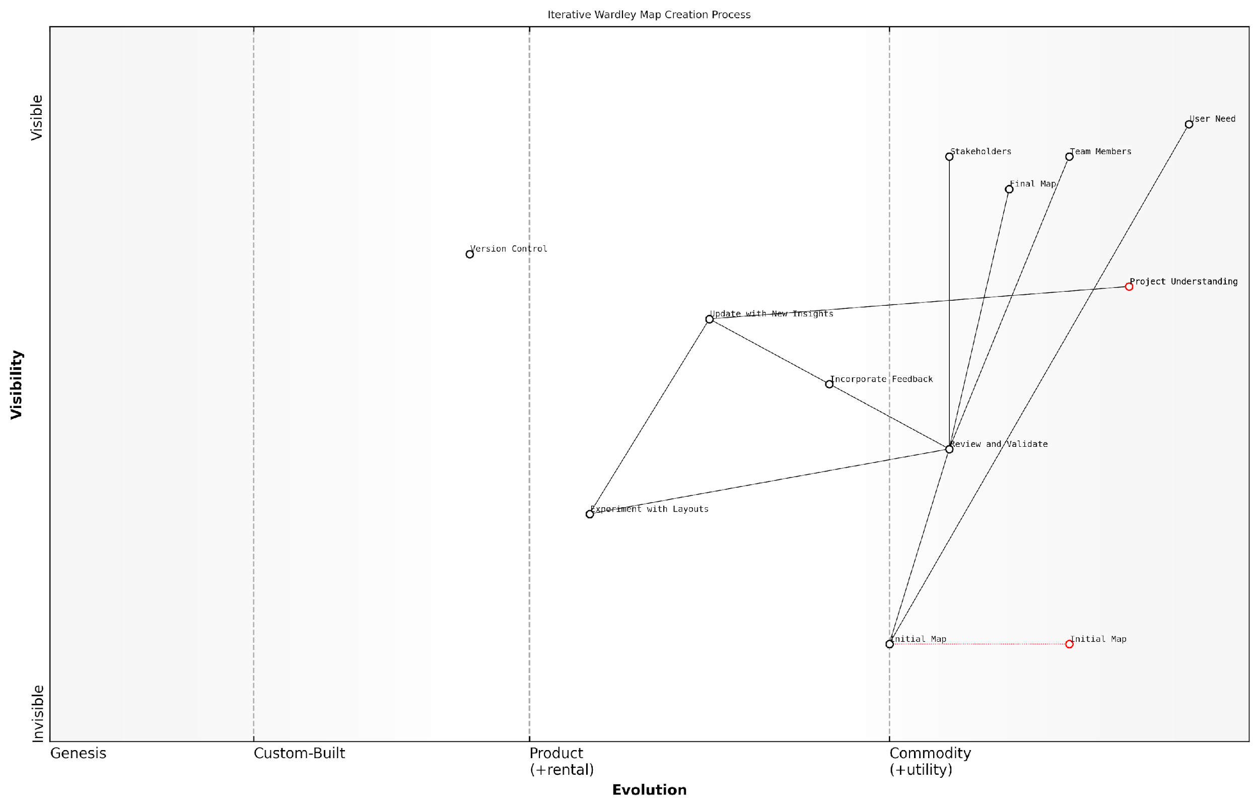

*Draft Wardley Map: [Insert Wardley Map: Iterating and refining your map]*

[Edit this draft Wardley Map](https://create.wardleymaps.ai/#clone:d11fa8905c418b8e6a)

Wardley Map Assessment

This Wardley Map effectively captures the iterative and collaborative nature of map creation, emphasising the importance of continuous refinement and stakeholder involvement. The process is well-structured to evolve from initial uncertainty to a validated, insightful final product. Key opportunities lie in leveraging emerging technologies to enhance the mapping process and in positioning the mapping methodology as a central tool for strategic decision-making. The focus on experimentation and version control provides a strong foundation for innovation and reliability. To maintain competitive advantage, the organisation should invest in advanced analytics capabilities and AI-assisted mapping tools while continuing to prioritise stakeholder engagement and user needs.

[View full Wardley Map report](http://markdown_wardley_map_reports/wardley_map_report_11_Iterating_and_refining_your_map.md)

## Integrating Wardley Mapping with Project Management Methodologies

### Wardley Mapping and Agile

Integrating Wardley Mapping with Agile methodologies creates a powerful synergy that enhances both strategic planning and project execution. This combination allows project managers to leverage the strengths of both approaches, resulting in more adaptable and value-driven project outcomes.

Wardley Mapping complements Agile by providing a strategic context for iterative development. While Agile focuses on delivering working software incrementally, Wardley Mapping offers a broader view of the project landscape, helping teams understand where components are in their evolutionary journey and how they relate to user needs.

* Use Wardley Maps to inform product backlog prioritisation
* Align sprint goals with strategic moves identified in the map
* Incorporate map updates into sprint retrospectives to track project evolution
* Utilise maps to facilitate communication between development teams and stakeholders

One of the key benefits of combining Wardley Mapping with Agile is the ability to make more informed decisions about build vs. buy choices. By understanding the evolutionary stage of each component, teams can better decide whether to develop custom solutions or leverage existing products or services.

Integrating Wardley Mapping into our Agile process has dramatically improved our ability to deliver strategic value. It’s like having a GPS for our product roadmap.

However, it’s important to note that introducing Wardley Mapping to an Agile team requires careful consideration. The initial learning curve can be steep, and there’s a risk of over-complicating the process if not implemented thoughtfully.

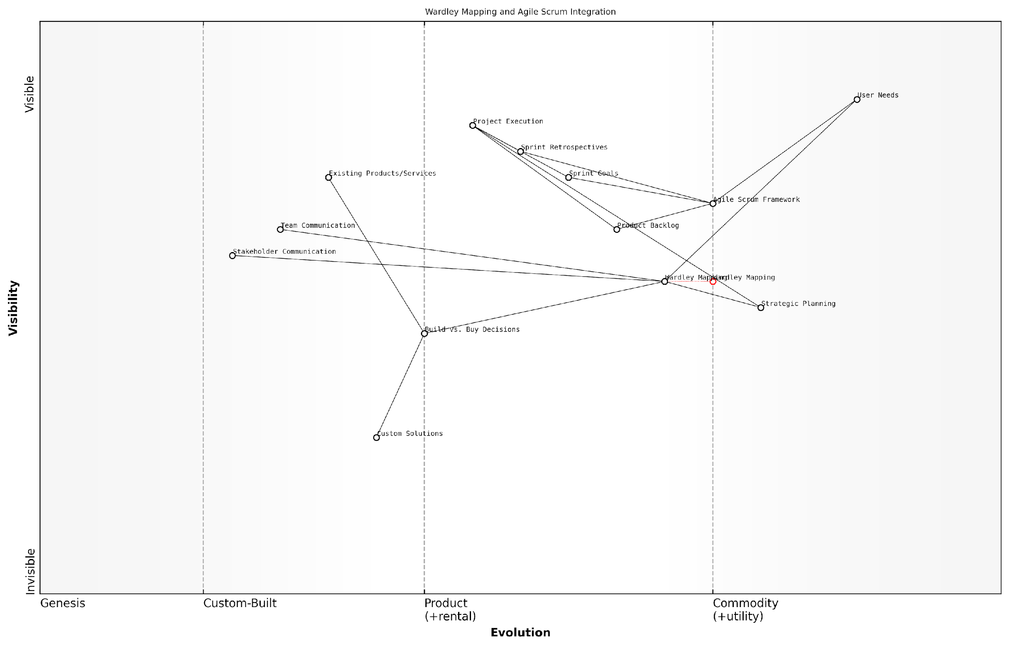

*Draft Wardley Map: [Insert Wardley Map: Wardley Mapping and Agile]*

[Edit this draft Wardley Map](https://create.wardleymaps.ai/#clone:3a8648abae4e0f78a4)

Wardley Map Assessment

This map represents a forward-thinking approach to project management that combines strategic foresight with agile execution. The integration of Wardley Mapping with Agile Scrum has the potential to create significant competitive advantage by aligning long-term strategy with short-term delivery. Key opportunities lie in developing better integration between these methodologies, upskilling teams, and creating tools that support this integrated approach. The main challenges will be in effectively bridging the different timescales and mindsets of strategic planning and agile execution. Organisations that can master this integration will be well-positioned to deliver projects that are both strategically aligned and adaptable to change.

[View full Wardley Map report](http://markdown_wardley_map_reports/wardley_map_report_12_Wardley_Mapping_and_Agile.md)

By thoughtfully integrating Wardley Mapping into Agile practices, project managers can create a more robust and adaptive approach to project management, one that balances short-term delivery with long-term strategic positioning.

### Wardley Mapping and Traditional Waterfall

While Wardley Mapping is often associated with more adaptive methodologies, it can also provide significant value when integrated with traditional Waterfall project management approaches. This integration can enhance strategic decision-making and improve project outcomes within the structured framework of Waterfall.

* Enhanced Requirements Gathering: Use Wardley Maps to visualise and analyse user needs, ensuring a more comprehensive understanding of project requirements at the outset.
* Improved Risk Management: Identify potential risks and dependencies early in the project lifecycle by mapping the entire value chain.
* Strategic Resource Allocation: Allocate resources more effectively by understanding the evolutionary stage of each project component.
* Better Vendor Selection: Evaluate potential vendors and technologies based on their position on the map and their alignment with project goals.
* Long-term Planning: Utilise Wardley Maps to forecast future industry trends and plan for long-term project sustainability.

To integrate Wardley Mapping with Waterfall, consider incorporating mapping exercises at key stages of the project lifecycle:

* Initiation: Create an initial map to understand the project landscape and stakeholder needs.
* Planning: Refine the map to inform detailed project plans and risk assessments.
* Execution: Use the map to guide decision-making and track progress against the planned evolution of components.
* Monitoring and Controlling: Update the map regularly to reflect changes in the project environment and adjust plans accordingly.
* Closing: Review the final map to capture lessons learnt and inform future projects.

Integrating Wardley Mapping with Waterfall has transformed our approach to large-scale, complex projects. It provides a strategic lens that complements our structured methodology, resulting in more robust and future-proof solutions.

While the integration of Wardley Mapping with Waterfall can be powerful, it’s important to recognise that it may require some adaptation of traditional Waterfall practices. Project managers should be prepared to introduce more flexibility into the process, particularly when it comes to responding to insights gained from ongoing mapping exercises.

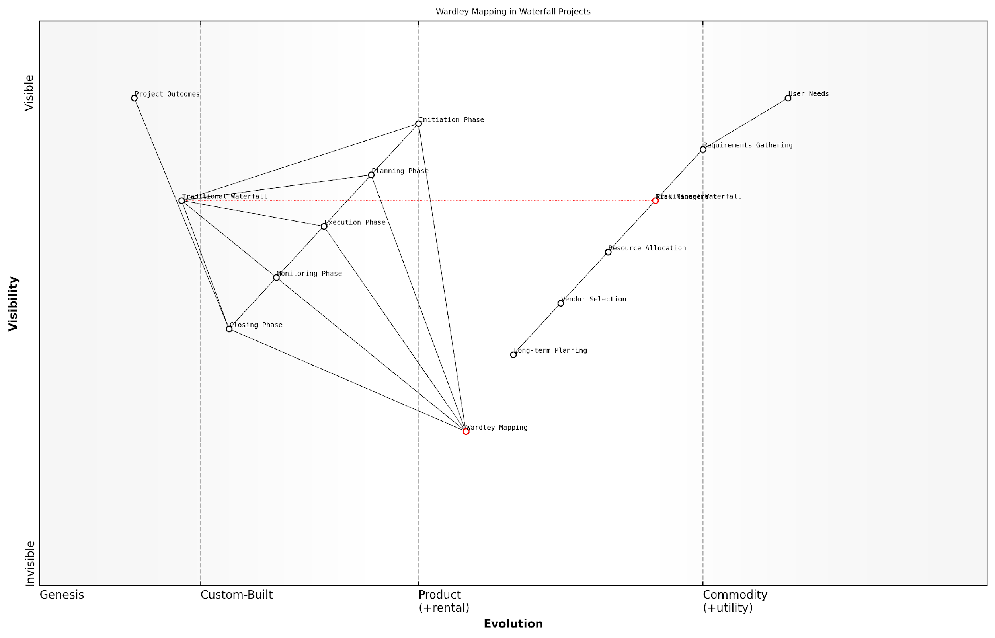

*Draft Wardley Map: [Insert Wardley Map: Wardley Mapping and Traditional Waterfall]*

[Edit this draft Wardley Map](https://create.wardleymaps.ai/#clone:4e168be4efee7098e1)

Wardley Map Assessment

This map represents a significant opportunity to enhance traditional waterfall project management with strategic insights from Wardley Mapping. By integrating Wardley Mapping across all project phases, organisations can improve alignment with user needs, enhance risk management, and make more informed strategic decisions throughout the project lifecycle. The challenge lies in effectively integrating these new strategic tools without disrupting existing processes, requiring a balanced approach to change management and skill development.

[View full Wardley Map report](http://markdown_wardley_map_reports/wardley_map_report_13_Wardley_Mapping_and_Traditional_Waterfall.md)

### Hybrid approaches for maximum benefit

Integrating Wardley Mapping with existing project management methodologies can create powerful hybrid approaches that leverage the strengths of both. By combining the strategic insights of Wardley Mapping with the structured processes of traditional methodologies, project managers can achieve a more comprehensive and adaptable approach to project execution.

* Agile-Wardley Hybrid: Incorporate Wardley Mapping into sprint planning and backlog prioritisation
* Waterfall-Wardley Hybrid: Use Wardley Maps to inform stage-gate decisions and risk assessments
* Prince2-Wardley Hybrid: Enhance business case development and project justification with mapping insights
* Lean-Wardley Hybrid: Identify value streams and eliminate waste using map-driven analysis

These hybrid approaches allow project managers to maintain the familiar structures of their preferred methodologies while enhancing strategic decision-making and adaptability. For example, in an Agile-Wardley hybrid, teams can use Wardley Maps to visualise the evolving project landscape during sprint retrospectives, informing adjustments to the product backlog and sprint goals.

By combining Wardley Mapping with our existing Agile framework, we’ve been able to anticipate market shifts and adjust our project priorities more effectively than ever before.

To implement a hybrid approach effectively, project managers should:

* Identify key decision points in their current methodology where Wardley Mapping can add value
* Train team members in basic mapping techniques to foster a shared understanding
* Regularly update and review maps alongside traditional project artefacts
* Use maps to facilitate discussions about project strategy and adaptation

By adopting a hybrid approach, project managers can harness the full potential of Wardley Mapping while maintaining the structure and familiarity of established project management practices. This balanced approach often leads to more robust project strategies, improved risk management, and greater ability to navigate complex, evolving project landscapes.

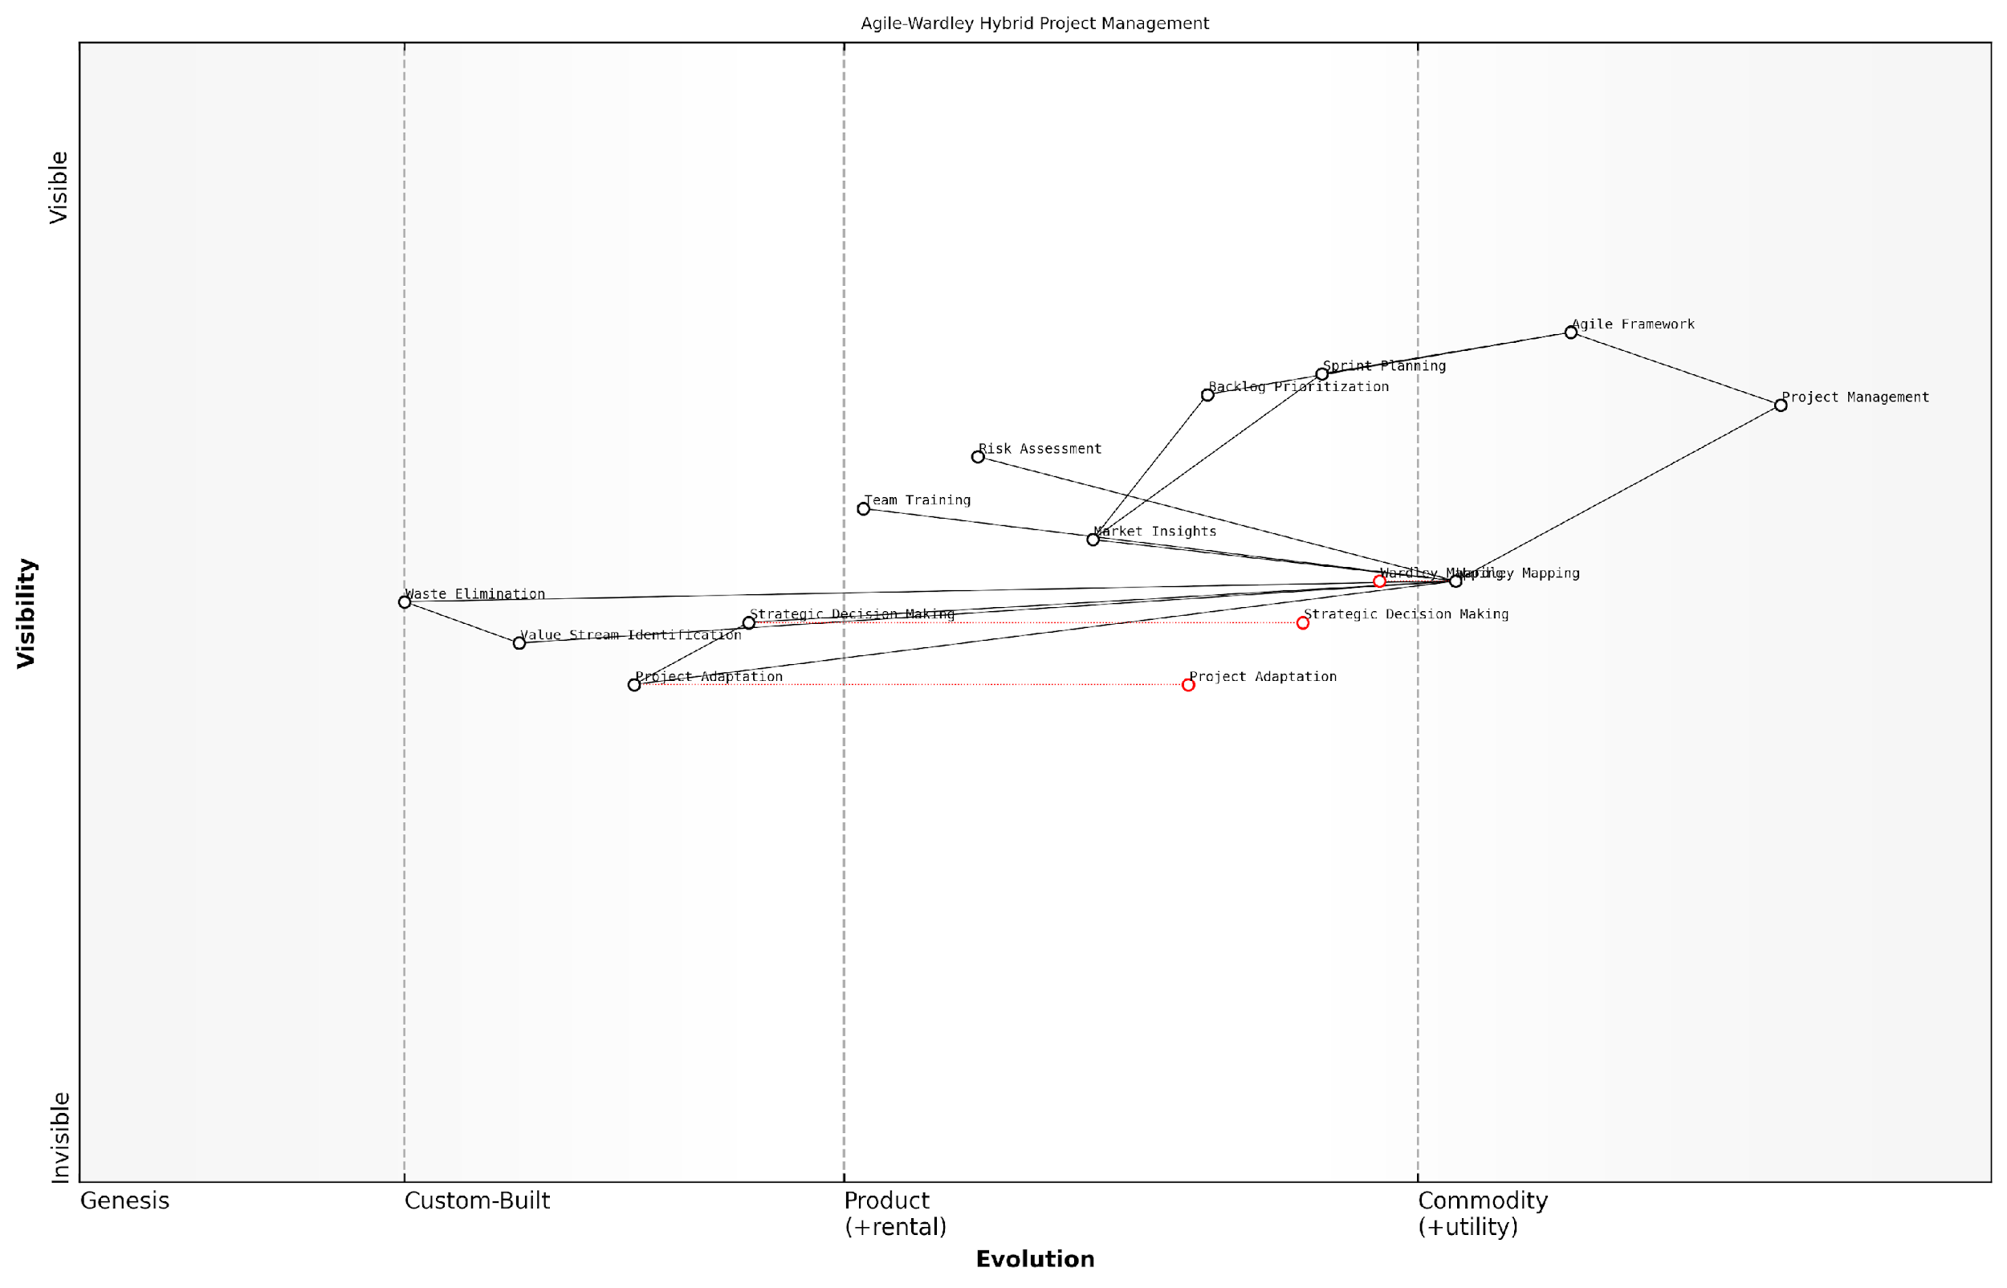

*Draft Wardley Map: [Insert Wardley Map: Hybrid approaches for maximum benefit]*

[Edit this draft Wardley Map](https://create.wardleymaps.ai/#clone:5852abd667c4c01601)

Wardley Map Assessment

This Wardley Map represents a forward-thinking approach to project management that combines the flexibility of Agile with the strategic insights of Wardley Mapping. It positions the organisation to be highly adaptive to market changes while maintaining structured project execution. The key challenge and opportunity lie in fully integrating these approaches and developing the capabilities to leverage their combined power effectively. Success in this integration could provide a significant competitive advantage in project delivery and strategic alignment.

[View full Wardley Map report](http://markdown_wardley_map_reports/wardley_map_report_14_Hybrid_approaches_for_maximum_benefit.md)

# Chapter 2: Strategic Project Planning with Wardley Maps

## Identifying Project Opportunities and Risks

### Using maps to spot potential pitfalls

Wardley Maps are powerful tools for project managers to identify and anticipate potential pitfalls in their projects. By visualising the entire value chain and the evolution of components, project managers can gain insights into areas of risk and vulnerability that might otherwise go unnoticed.

* Identify dependencies: Maps reveal hidden dependencies between components, highlighting potential single points of failure or bottlenecks.
* Spot evolving components: Recognise components that are rapidly evolving, which may introduce uncertainty and risk into the project.
* Recognise inertia: Identify areas where organisational or technological inertia may hinder project progress.
* Anticipate market shifts: Visualise how changes in the competitive landscape might impact your project’s viability or direction.

One of the key advantages of using Wardley Maps for spotting pitfalls is the ability to see the entire ecosystem in which your project operates. This holistic view allows project managers to consider external factors that might not be apparent in traditional project management tools.

A seasoned project manager once said, ‘Wardley Maps helped us identify a critical supplier risk that we had completely overlooked in our initial risk assessment. It potentially saved us millions in project delays.’

To effectively use Wardley Maps for spotting pitfalls, project managers should:

* Regularly update and review the map as the project progresses
* Involve team members and stakeholders in map creation and analysis
* Use the map in conjunction with traditional risk management techniques
* Pay special attention to components near evolutionary boundaries

By leveraging Wardley Maps to spot potential pitfalls, project managers can proactively address risks, make more informed decisions, and increase the likelihood of project success.

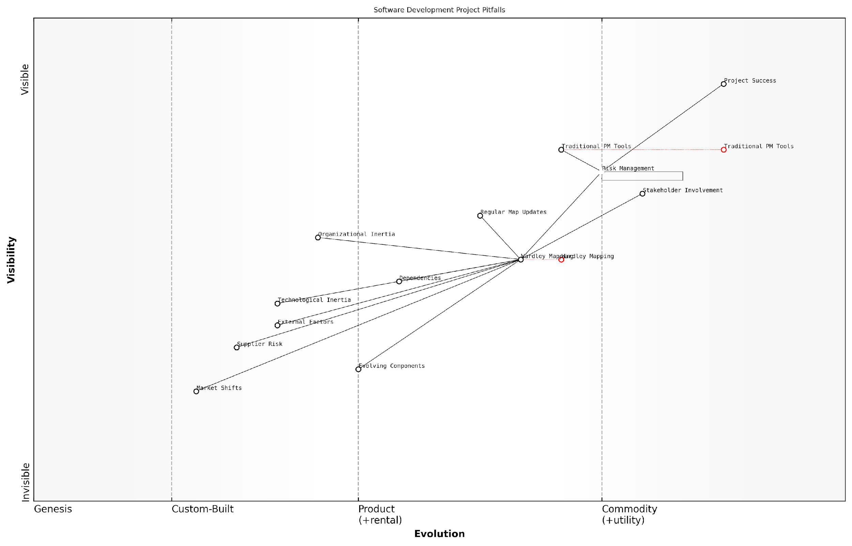

*Draft Wardley Map: [Insert Wardley Map: Using maps to spot potential pitfalls]*

[Edit this draft Wardley Map](https://create.wardleymaps.ai/#clone:fe5ddf0850615b43d0)

Wardley Map Assessment

This Wardley Map reveals a software development project management landscape in transition, balancing traditional approaches with emerging strategic tools like Wardley Mapping. The key to success lies in effectively managing the evolution from traditional to more adaptive practices, while proactively addressing external factors, dependencies, and organisational inertia. Organisations that can master this balance, leveraging both established tools and innovative approaches like Wardley Mapping, will be better positioned to navigate project pitfalls and achieve consistent success in an increasingly complex and dynamic environment.

[View full Wardley Map report](http://markdown_wardley_map_reports/wardley_map_report_15_Using_maps_to_spot_potential_pitfalls.md)

### Leveraging maps for resource allocation

Wardley Maps provide project managers with a powerful tool for optimising resource allocation. By visualising the entire value chain and the evolutionary stage of each component, project managers can make more informed decisions about where to invest time, money, and personnel.

* Identify critical components: Use the map to pinpoint which components are most crucial to project success and allocate resources accordingly.
* Recognise evolutionary stages: Understand which components are in genesis, custom, product, or commodity stages to determine appropriate resource strategies.
* Spot inefficiencies: Identify areas where resources are being over-allocated to commoditised components or under-allocated to strategic differentiators.
* Anticipate future needs: Use the map to predict where resources will be needed as components evolve, allowing for proactive planning.

By leveraging Wardley Maps, project managers can align resource allocation with strategic goals, ensuring that investments are made in areas that provide the most value and competitive advantage.

A seasoned project manager once said, ‘Wardley Mapping transformed our resource allocation process. We stopped wasting effort on commodity components and redirected our best talent to areas where we could truly differentiate.’

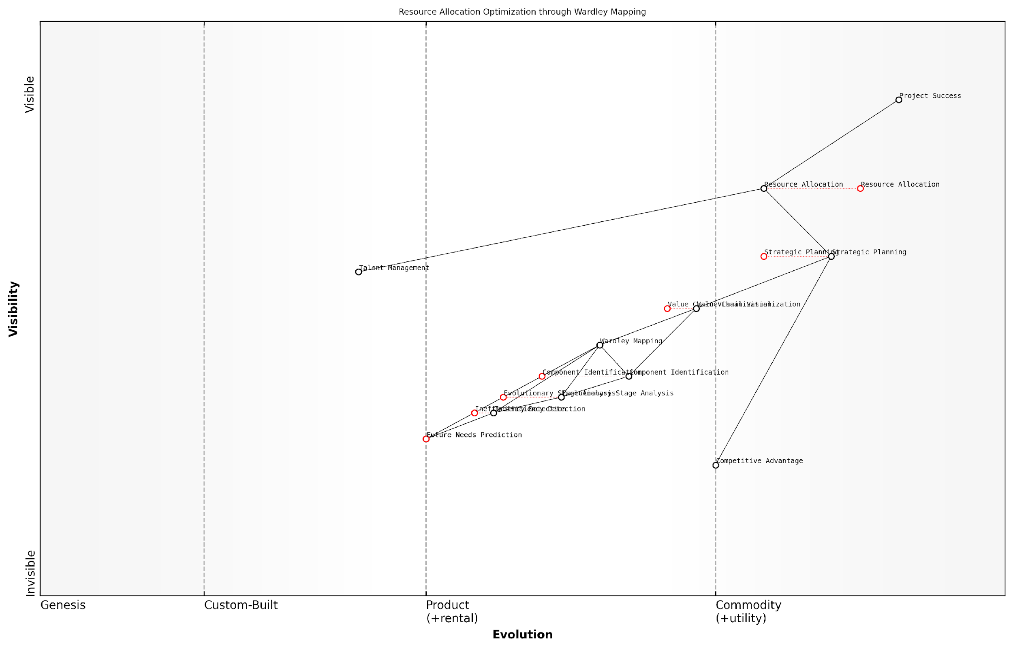

*Draft Wardley Map: [Insert Wardley Map: Leveraging maps for resource allocation]*

[Edit this draft Wardley Map](https://create.wardleymaps.ai/#clone:e09b4b82ede9c20693)

Wardley Map Assessment

This Wardley Map represents a sophisticated approach to resource allocation optimization, leveraging Wardley Mapping as a central strategic tool. The organisation shows strength in strategic planning and resource allocation, with emerging capabilities in predictive analytics. To maintain and enhance its competitive position, the focus should be on rapidly evolving the genesis and custom-built components, particularly in areas of future prediction and inefficiency detection. There’s also a significant opportunity to create a more integrated ecosystem, especially by better incorporating talent management into the strategic framework. The central position of Wardley Mapping suggests a strong commitment to strategic visualisation, which could be a key differentiator if continuously evolved and effectively operationalized across all levels of the organisation.

[View full Wardley Map report](http://markdown_wardley_map_reports/wardley_map_report_16_Leveraging_maps_for_resource_allocation.md)

### Anticipating market changes and their impact on projects

In the dynamic landscape of project management, anticipating market changes is crucial for project success. Wardley Maps provide project managers with a powerful tool to visualise and predict these changes, allowing for proactive strategy adjustments and risk mitigation.

* Identify evolving components: Use Wardley Maps to track the evolution of key project components and anticipate when they might shift from one stage to another.
* Monitor industry trends: Regularly update your maps to reflect emerging technologies, changing customer needs, and shifts in the competitive landscape.
* Assess impact on project timeline and resources: Analyse how predicted market changes might affect your project’s schedule, budget, and resource requirements.
* Identify new opportunities: Use maps to spot potential areas for innovation or expansion within your project scope.
* Prepare contingency plans: Develop alternative strategies for different market scenarios identified through mapping.

By leveraging Wardley Maps to anticipate market changes, project managers can better position their projects for success, even in turbulent environments. This proactive approach allows for more informed decision-making and strategic planning throughout the project lifecycle.

A seasoned project manager once said, ‘The ability to anticipate and adapt to market changes is what separates successful projects from those that fail. Wardley Mapping gives us the foresight we need to stay ahead of the curve.’

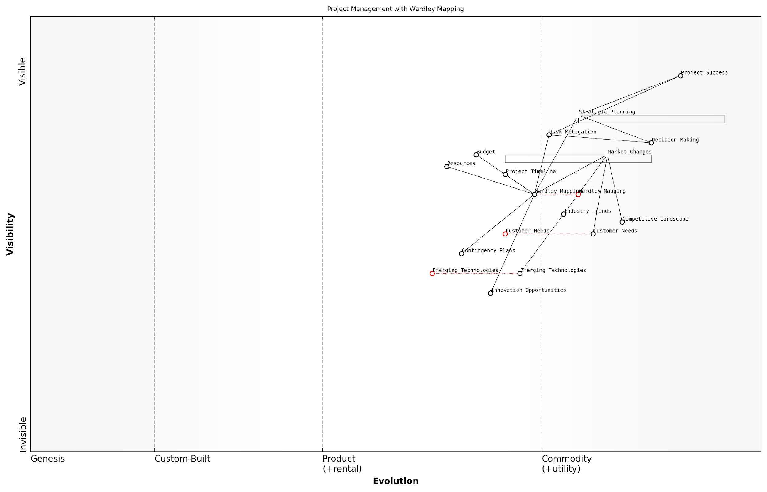

*Draft Wardley Map: [Insert Wardley Map: Anticipating market changes and their impact on projects]*

[Edit this draft Wardley Map](https://create.wardleymaps.ai/#clone:39ec1149a90189c447)

Wardley Map Assessment

This Wardley Map reveals a project management approach that is strategically positioned to anticipate and adapt to market changes. The central role of Wardley Mapping provides a strong foundation for informed decision-making and risk mitigation. However, there are opportunities to enhance the integration of emerging technologies and innovation into the strategic planning process. By focusing on these areas and maintaining a dynamic, market-responsive approach, the organisation can significantly improve its project success rate and competitive positioning in a rapidly evolving landscape.

[View full Wardley Map report](http://markdown_wardley_map_reports/wardley_map_report_17_Anticipating_market_changes_and_their_impact_on_pr.md)

## Stakeholder Management and Communication

### Visualising stakeholder needs and expectations

Wardley Mapping provides project managers with a powerful tool for visualising and understanding stakeholder needs and expectations. By incorporating stakeholders into your project’s Wardley Map, you can gain valuable insights into their positions, influences, and potential impacts on your project’s success.

To effectively visualise stakeholder needs and expectations using Wardley Maps, consider the following approach:

* Identify key stakeholders and their primary needs
* Position stakeholders on the map relative to the value chain
* Analyse stakeholder dependencies and relationships
* Assess the evolution of stakeholder needs over time
* Use the map to communicate stakeholder dynamics to the project team

When mapping stakeholders, it’s crucial to consider both their explicit and implicit needs. Explicit needs are often clearly stated, while implicit needs may require deeper analysis and understanding of the stakeholder’s context and motivations.

A seasoned project manager once said, ‘Understanding stakeholder needs is like peeling an onion. There are always layers beneath the surface that you need to uncover to truly grasp their expectations.’

By visualising stakeholder needs and expectations on a Wardley Map, project managers can:

* Identify potential conflicts or alignments between stakeholders
* Anticipate how changes in the project landscape might affect stakeholder expectations
* Develop targeted communication strategies for different stakeholder groups
* Prioritise stakeholder management efforts based on their position and influence

Remember that stakeholder needs and expectations are not static. As the project evolves, so too will the positions and influences of your stakeholders. Regularly updating your Wardley Map to reflect these changes will ensure that your stakeholder management strategy remains effective throughout the project lifecycle.

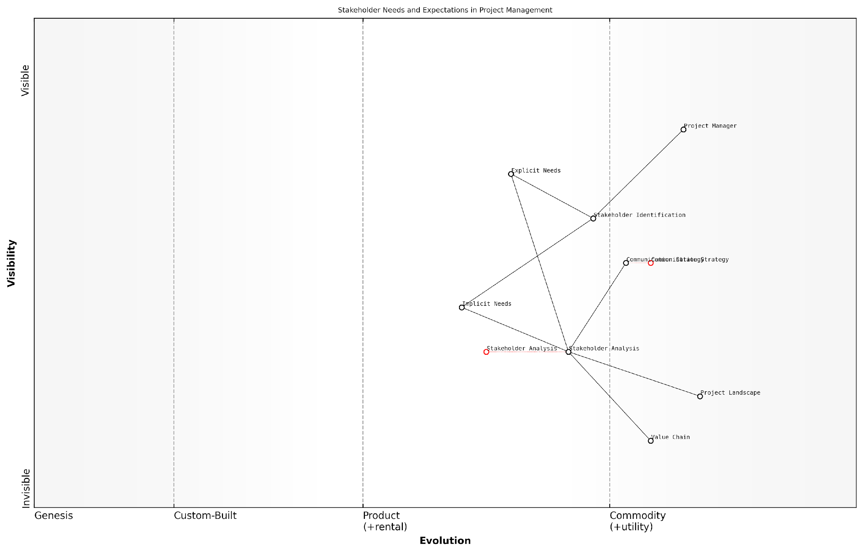

*Draft Wardley Map: [Insert Wardley Map: Visualising stakeholder needs and expectations]*

[Edit this draft Wardley Map](https://create.wardleymaps.ai/#clone:68a83ca8799f220f8a)

Wardley Map Assessment

This Wardley Map reveals a maturing system for managing stakeholder needs and expectations in project management. While many components are well-evolved, there are significant opportunities for innovation, particularly in Implicit Needs identification and advanced Stakeholder Analysis. The strategic focus should be on developing more sophisticated, possibly AI-driven tools for these areas, while also ensuring a tighter integration between all components. The ability to quickly and accurately identify and respond to both explicit and implicit stakeholder needs will be a key differentiator in the future of project management. Organisations that can master this will be better positioned to deliver successful projects that truly meet stakeholder expectations.

[View full Wardley Map report](http://markdown_wardley_map_reports/wardley_map_report_18_Visualising_stakeholder_needs_and_expectations.md)

### Using maps to align project goals with organisational strategy

Wardley Maps provide a powerful tool for project managers to align project goals with broader organisational strategy. By visualising the entire value chain and the evolution of components, project managers can ensure that their projects are not only meeting immediate objectives but also contributing to the long-term strategic vision of the organisation.

* Identify strategic components: Use Wardley Maps to highlight which project components are most critical to the organisation’s strategy.
* Visualise dependencies: Map out how project components relate to key organisational capabilities and resources.
* Anticipate evolution: Understand how project components might evolve and how this aligns with the organisation’s future direction.
* Highlight misalignments: Quickly identify where project goals may be out of sync with organisational strategy.

When using Wardley Maps to align project goals with organisational strategy, it’s crucial to involve key stakeholders from across the organisation. This collaborative approach ensures that the map accurately reflects the organisation’s strategic priorities and that all perspectives are considered.

A senior executive once told me, ‘Using Wardley Maps to align our project portfolio with our corporate strategy was like turning on the lights in a dark room. Suddenly, we could see everything clearly and make informed decisions.’

By regularly reviewing and updating the Wardley Map throughout the project lifecycle, project managers can ensure ongoing alignment with organisational strategy. This dynamic approach allows for quick adjustments as both the project and the organisation’s strategic landscape evolve.

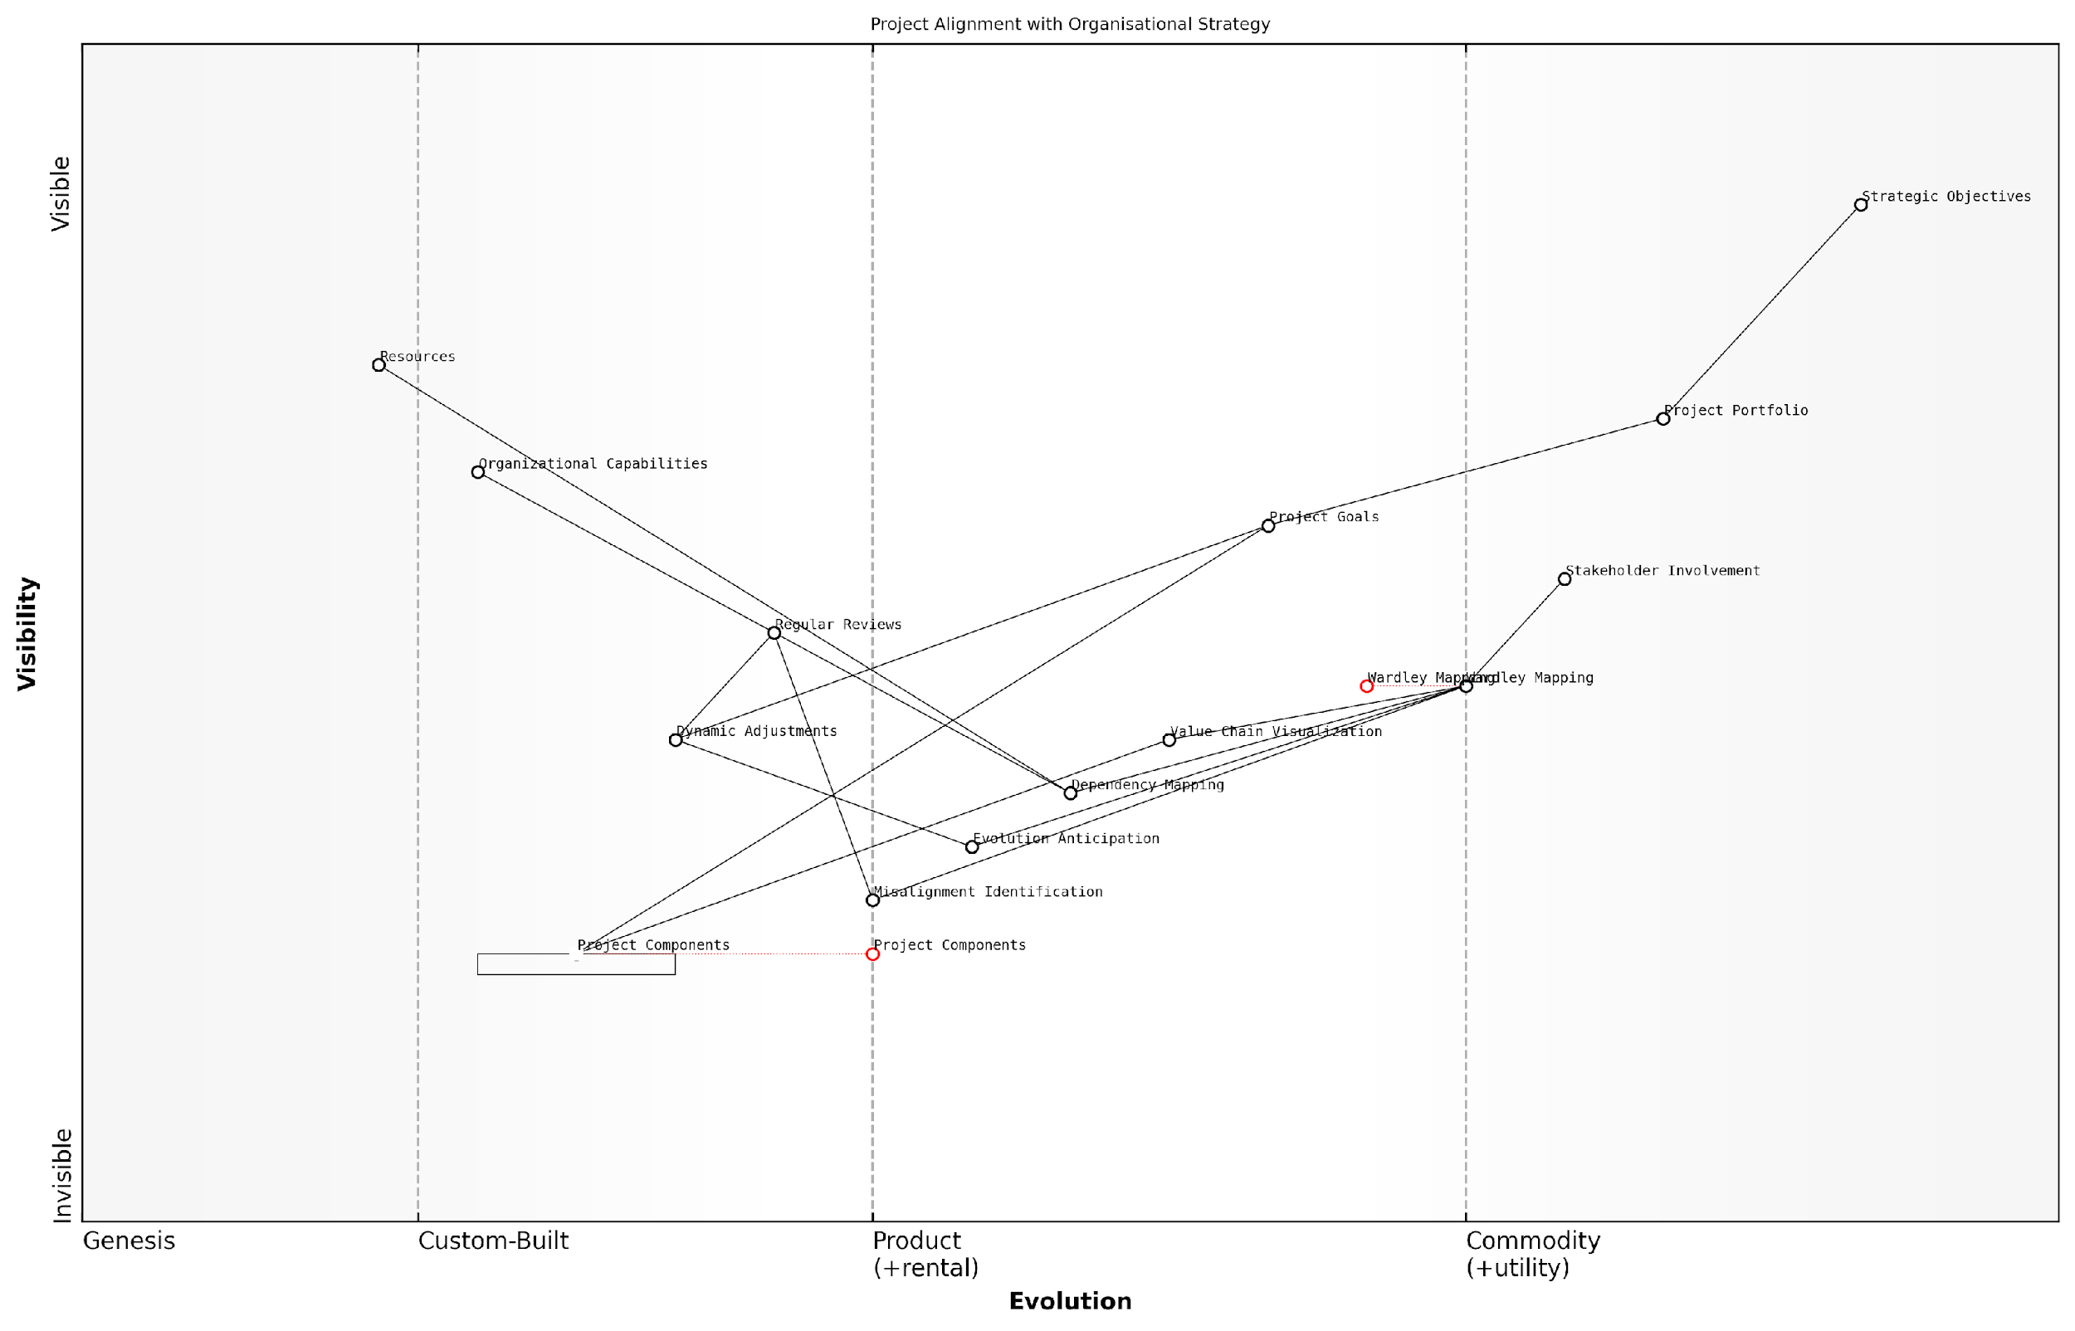

*Draft Wardley Map: [Insert Wardley Map: Using maps to align project goals with organisational strategy]*

[Edit this draft Wardley Map](https://create.wardleymaps.ai/#clone:736fabf37582c4309b)

Wardley Map Assessment

This Wardley Map represents a sophisticated approach to aligning project goals with organisational strategy, leveraging Wardley Mapping as a central tool. The organisation shows maturity in strategic thinking but has opportunities to enhance its capabilities in dynamic adjustment and advanced analysis. By focusing on stakeholder involvement, regular reviews, and the evolution of key components like Wardley Mapping and Project Components, the organisation can strengthen its strategic alignment processes. Future developments should focus on integrating emerging technologies and creating a more dynamic, real-time approach to strategic project management.

[View full Wardley Map report](http://markdown_wardley_map_reports/wardley_map_report_19_Using_maps_to_align_project_goals_with_organisatio.md)

### Effective communication of project strategy using Wardley Maps

Wardley Maps are powerful tools for communicating project strategy to stakeholders. By visually representing the project’s components, their relationships, and their evolution, project managers can effectively convey complex strategic concepts in a clear and accessible manner.

* Simplify complex concepts: Use Wardley Maps to break down intricate project strategies into visual, easy-to-understand components
* Highlight dependencies: Clearly show how different project elements relate to and depend on each other
* Demonstrate evolution: Illustrate how project components are expected to evolve over time, helping stakeholders anticipate and prepare for change
* Identify strategic opportunities: Use maps to point out areas for innovation or improvement within the project

When presenting Wardley Maps to stakeholders, it’s crucial to tailor the level of detail and focus areas based on the audience. For example, executive stakeholders may be more interested in high-level strategic implications, while technical teams might require more granular component details.

A senior project manager once noted, ‘Wardley Maps have revolutionised how we communicate project strategy. They provide a common language that bridges the gap between technical teams and business stakeholders.’

To maximise the effectiveness of Wardley Maps in communication, consider the following approaches:

* Use interactive presentations: Allow stakeholders to explore the map dynamically, zooming in on areas of interest
* Provide context: Explain the map’s components and their significance to the project’s goals
* Tell a story: Use the map as a narrative tool to walk stakeholders through the project’s strategic journey
* Encourage participation: Invite stakeholders to contribute their insights and perspectives to refine the map

By leveraging Wardley Maps for project strategy communication, project managers can foster better understanding, alignment, and buy-in from diverse stakeholder groups, ultimately contributing to more successful project outcomes.

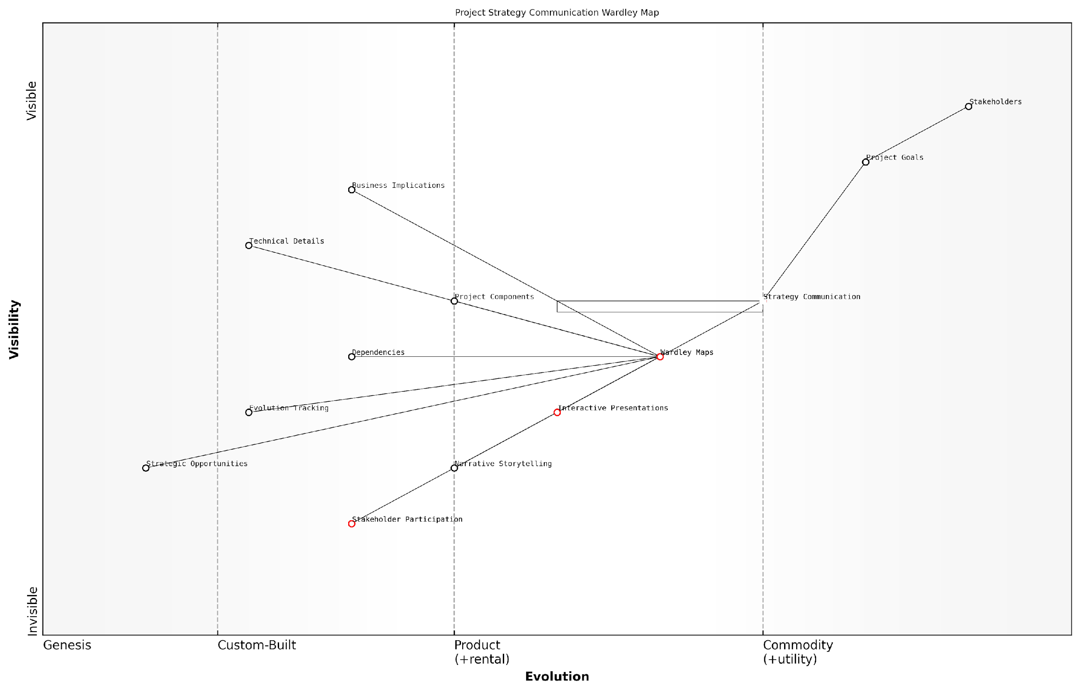

*Draft Wardley Map: [Insert Wardley Map: Effective communication of project strategy using Wardley Maps]*

[Edit this draft Wardley Map](https://create.wardleymaps.ai/#clone:4d4bfe2cd8d411bad3)

Wardley Map Assessment

This Wardley Map reveals a well-structured approach to project strategy communication, with Wardley Maps playing a central role. The key opportunity lies in evolving towards more dynamic, participatory approaches while maintaining the benefits of structured mapping. By focusing on enhancing stakeholder participation and leveraging emerging technologies for strategy visualisation, organisations can significantly improve the effectiveness of their project strategy communication. The challenge will be to balance the need for structure and clarity provided by Wardley Maps with the flexibility and engagement offered by more participatory approaches.

[View full Wardley Map report](http://markdown_wardley_map_reports/wardley_map_report_20_Effective_communication_of_project_strategy_using_.md)

## Building Resilient Project Strategies

### Scenario planning with Wardley Maps

Scenario planning with Wardley Maps is a powerful technique for building resilient project strategies. By combining the visual representation of value chains and evolution with the forward-thinking approach of scenario planning, project managers can create robust strategies that adapt to various potential futures.

To effectively use Wardley Maps for scenario planning, follow these steps:

* Create a baseline Wardley Map of your current project landscape
* Identify key uncertainties and potential disruptors
* Develop multiple future scenarios based on these uncertainties
* Map out each scenario using Wardley Maps
* Analyse the implications of each scenario on your project strategy
* Identify common elements and divergences across scenarios
* Develop flexible strategies that can adapt to multiple scenarios

By visualising different scenarios using Wardley Maps, project managers can gain insights into how various components of their project might evolve under different circumstances. This allows for the identification of potential risks, opportunities, and strategic options that might not be apparent when considering only a single future state.

Scenario planning with Wardley Maps allows us to see not just where we are, but where we might need to go. It’s like having a GPS for the future of our projects.

One key advantage of using Wardley Maps for scenario planning is the ability to identify common patterns or requirements across multiple scenarios. These ‘no-regret’ moves can form the foundation of a resilient strategy, as they are likely to be beneficial regardless of which future unfolds.

By regularly revisiting and updating these scenario-based Wardley Maps throughout the project lifecycle, project managers can maintain a dynamic and adaptive strategy that evolves with changing circumstances. This approach ensures that projects remain aligned with organisational goals and market realities, even in the face of uncertainty and rapid change.

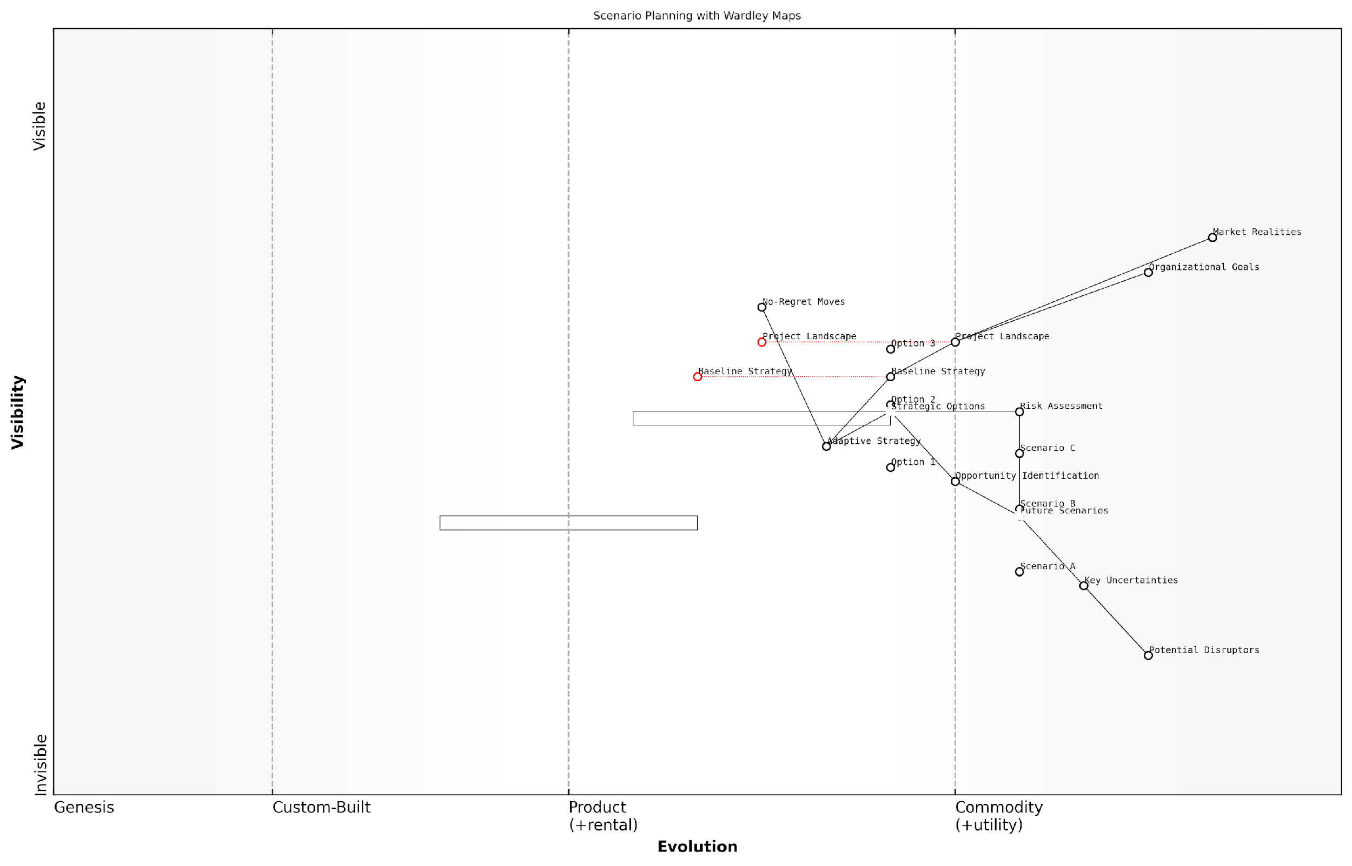

*Draft Wardley Map: [Insert Wardley Map: Scenario planning with Wardley Maps]*

[Edit this draft Wardley Map](https://create.wardleymaps.ai/#clone:3dfc5893b13b83bb1e)

Wardley Map Assessment

This Wardley Map presents a comprehensive framework for scenario planning that enables organisations to develop adaptive strategies in the face of uncertainty. The map effectively links current realities with future possibilities, providing a structured approach to strategy development. Key strengths include the integration of No-Regret Moves and the clear progression from uncertainties to concrete strategies. To maximise the value of this approach, organisations should focus on developing capabilities for rapid strategy adaptation and deepening their understanding of key uncertainties and market realities. The future evolution of this space will likely see increased automation and real-time adaptation, requiring organisations to build agility into their core strategic processes.

[View full Wardley Map report](http://markdown_wardley_map_reports/wardley_map_report_21_Scenario_planning_with_Wardley_Maps.md)

### Adapting to change and uncertainty

In the dynamic world of project management, adapting to change and uncertainty is crucial for building resilient project strategies. Wardley Maps provide a powerful tool for project managers to navigate these challenges effectively.

Wardley Maps help project managers anticipate and respond to change by visualising the evolution of components within a project’s ecosystem. This allows for more informed decision-making and strategic planning in the face of uncertainty.

* Identify potential areas of change: Use Wardley Maps to pinpoint components that are likely to evolve rapidly or face disruption.
* Develop multiple scenarios: Create alternative maps based on different potential futures to prepare for various outcomes.
* Monitor weak signals: Regularly update your maps to reflect emerging trends and early indicators of change.
* Build flexibility into project plans: Design project strategies that can adapt to shifts in the landscape without major disruptions.

By incorporating these practices into your project planning process, you can create more resilient strategies that are better equipped to handle the uncertainties inherent in complex projects.

A seasoned project manager once said, ‘The ability to adapt to change is not just a nice-to-have skill; it’s a survival trait in today’s fast-paced project environments.’

To further enhance your project’s resilience, consider implementing the following approaches:

* Create a culture of continuous learning and adaptation within your project team.
* Establish feedback loops to quickly identify and respond to changes in the project landscape.
* Develop contingency plans for critical components identified in your Wardley Maps.
* Regularly reassess and realign your project strategy with evolving business goals and market conditions.

By leveraging Wardley Maps and embracing a mindset of adaptability, project managers can build truly resilient strategies that not only withstand change and uncertainty but thrive in dynamic environments.

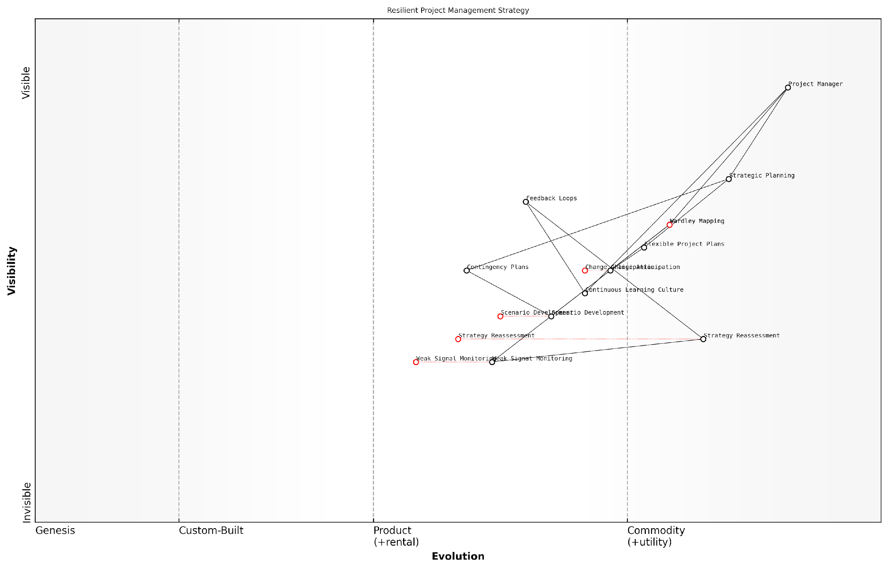

*Draft Wardley Map: [Insert Wardley Map: Adapting to change and uncertainty]*

[Edit this draft Wardley Map](https://create.wardleymaps.ai/#clone:e32da2b2875836e688)

Wardley Map Assessment

This Wardley Map represents a sophisticated approach to resilient project management, balancing strategic foresight with tactical flexibility. The integration of Wardley Mapping as a core component demonstrates a commitment to advanced strategic thinking. Key opportunities lie in evolving early warning systems and enhancing real-time adaptation capabilities. By focusing on these areas and leveraging emerging technologies, this approach has the potential to set new standards for project resilience in uncertain environments.

[View full Wardley Map report](http://markdown_wardley_map_reports/wardley_map_report_22_Adapting_to_change_and_uncertainty.md)

### Creating flexible project roadmaps

In the dynamic world of project management, creating flexible project roadmaps is essential for building resilient project strategies. Wardley Mapping provides a powerful framework for developing adaptable roadmaps that can evolve with changing project conditions and market landscapes.

Flexible project roadmaps built using Wardley Maps allow project managers to:

* Visualise the evolution of project components over time
* Identify potential pivot points and alternative paths
* Anticipate and prepare for future changes in the project landscape
* Align project milestones with the natural evolution of technologies and practices

To create a flexible project roadmap using Wardley Mapping, consider the following steps:

* Map out the current project landscape, including all key components
* Identify the evolutionary stage of each component
* Project the future evolution of components over the project timeline
* Highlight potential areas of change or disruption
* Define multiple scenarios and alternative paths based on potential changes
* Establish checkpoints for reassessing the map and adjusting the roadmap

By incorporating these elements into your project roadmap, you create a living document that can adapt to changing circumstances while maintaining a clear direction towards project goals.

A flexible roadmap is not about predicting the future, but about being prepared for multiple futures.

Remember that flexibility doesn’t mean lack of structure. Your roadmap should still have clear milestones and deliverables, but with built-in mechanisms for adaptation. Regular reviews of your Wardley Map and roadmap will ensure that your project strategy remains resilient in the face of change.

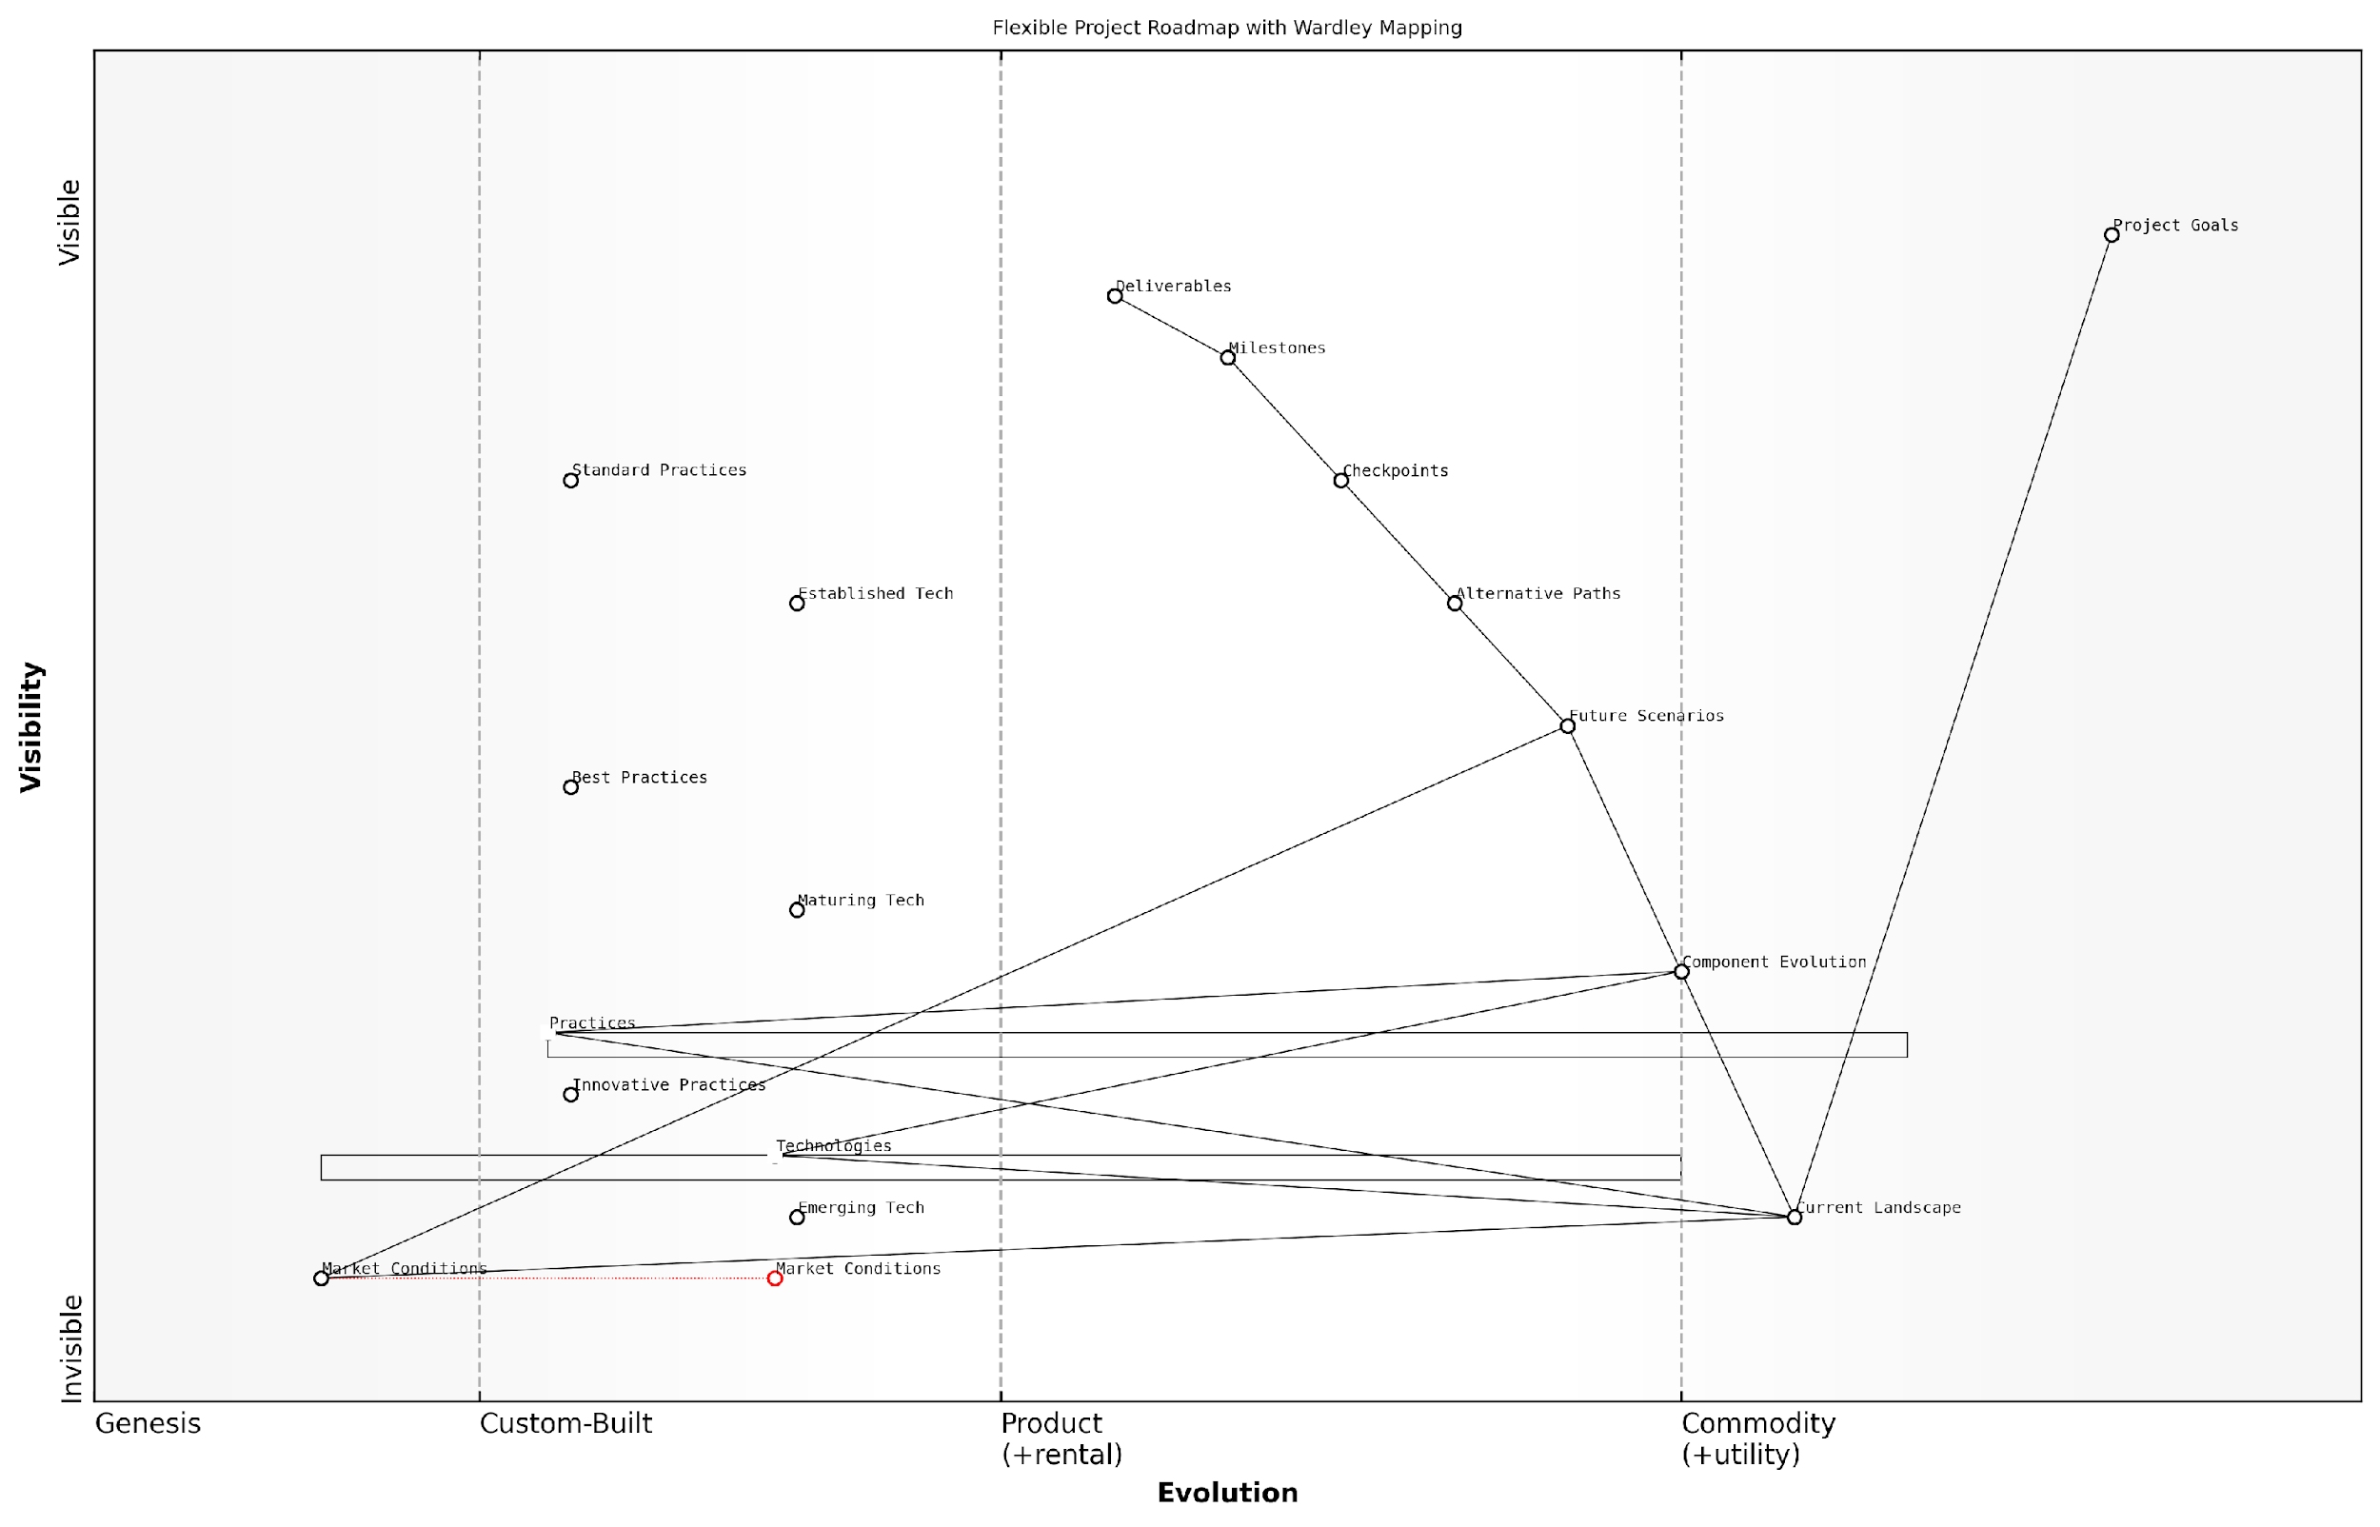

*Draft Wardley Map: [Insert Wardley Map: Creating flexible project roadmaps]*

[Edit this draft Wardley Map](https://create.wardleymaps.ai/#clone:f0977785e13bb5a03d)

Wardley Map Assessment

This Wardley Map presents a sophisticated approach to flexible project roadmapping that balances structure with adaptability. It recognizes the importance of evolving components, alternative scenarios, and emerging technologies in project success. The strategic position is strong, with clear opportunities for innovation in practices and technology integration. Key areas for improvement include enhancing real-time adaptability to market conditions and more seamless integration of emerging technologies into project processes. Overall, this approach positions organisations well to handle complex, dynamic project environments, but requires continuous evolution and capability development to maintain its effectiveness.

[View full Wardley Map report](http://markdown_wardley_map_reports/wardley_map_report_23_Creating_flexible_project_roadmaps.md)

# Chapter 3: Executing Projects with Wardley Mapping

## Tactical Decision-Making During Project Execution

### Using maps for daily and weekly planning

Wardley Maps are not just strategic tools for long-term planning; they can be incredibly valuable for tactical decision-making during project execution. By incorporating Wardley Mapping into daily and weekly planning processes, project managers can make more informed decisions, adapt to changes quickly, and keep their projects aligned with strategic goals.

* Start each day or week by reviewing your project’s Wardley Map
* Identify any changes in component positions or relationships
* Assess the impact of these changes on your immediate tasks and goals
* Prioritise activities based on their position and movement on the map

When using Wardley Maps for daily and weekly planning, focus on the components that are most relevant to your current project phase. Pay special attention to components that are evolving rapidly or approaching transition points between evolutionary stages.

A seasoned project manager once told me, ‘Using Wardley Maps in our daily stand-ups has completely transformed how we prioritise our work. We’re now much more responsive to market changes and better aligned with our strategic goals.’

To effectively use maps for short-term planning, consider the following practices:

* Maintain a digital version of your map that can be easily updated and shared
* Use colour-coding or annotations to highlight areas of immediate focus
* Incorporate map reviews into your daily stand-ups or weekly team meetings
* Encourage team members to contribute their insights to keep the map current
* Use the map to communicate progress and challenges to stakeholders

By integrating Wardley Mapping into your daily and weekly planning routines, you’ll be better equipped to make tactical decisions that align with your project’s strategic direction. This approach helps ensure that short-term actions contribute to long-term success, while also providing the flexibility to adapt to changing circumstances.

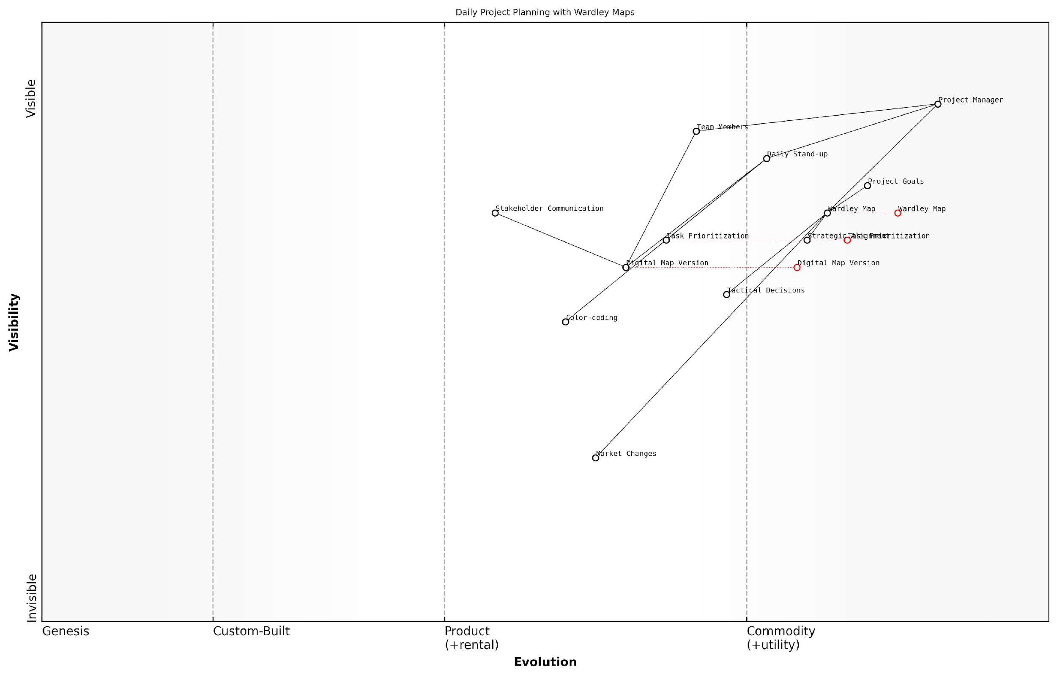

*Draft Wardley Map: [Insert Wardley Map: Using maps for daily and weekly planning]*

[Edit this draft Wardley Map](https://create.wardleymaps.ai/#clone:8ae0cfef2413b9ef85)

Wardley Map Assessment

This Wardley Map represents a sophisticated approach to daily project planning that leverages strategic mapping for tactical decision-making. The system is well-positioned for current needs but shows clear opportunities for evolution, particularly in the areas of digital tool enhancement, AI integration, and ecosystem development. By focusing on these areas, the project management approach can stay ahead of industry trends and maintain a competitive edge in rapidly changing market conditions. The key to success will be balancing the evolution of digital tools with the human elements of project management, ensuring that technological advancements support rather than supplant effective team dynamics and strategic thinking.

[View full Wardley Map report](http://markdown_wardley_map_reports/wardley_map_report_24_Using_maps_for_daily_and_weekly_planning.md)

### Prioritising tasks and activities based on map insights

Wardley Maps provide project managers with a powerful tool for prioritising tasks and activities during project execution. By leveraging the insights gained from these maps, project managers can make more informed decisions about where to focus their team’s efforts and resources.

When prioritising tasks based on Wardley Map insights, consider the following key factors:

* Evolution stage of components
* Dependencies between components
* Strategic importance of components
* Potential for value creation or cost reduction

To effectively prioritise tasks using Wardley Maps, follow these steps:

* Identify critical path components on the map
* Assess the evolution stage of each component
* Evaluate dependencies and potential bottlenecks
* Consider the strategic importance of each component
* Align priorities with overall project and organisational goals

By focusing on components in the ‘custom-built’ or ‘product’ stages that are critical to the project’s success, project managers can often achieve significant gains. These components typically offer the most opportunity for differentiation and value creation.

A seasoned project manager once said, ‘Wardley Maps helped us identify a key component that was ripe for evolution. By prioritising its development, we were able to leapfrog our competition and deliver exceptional value to our customers.’

It’s important to note that priorities may shift as the project progresses and the competitive landscape evolves. Regularly revisiting and updating your Wardley Map will ensure that your prioritisation remains aligned with the current reality of your project and market conditions.

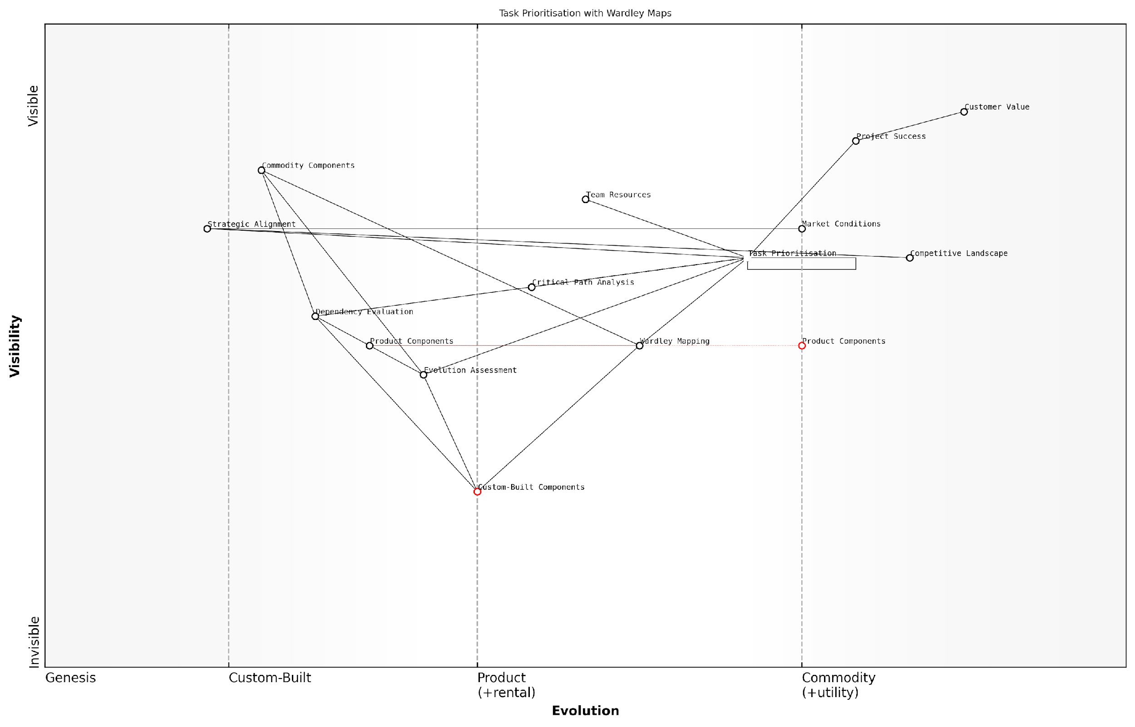

*Draft Wardley Map: [Insert Wardley Map: Prioritising tasks and activities based on map insights]*

[Edit this draft Wardley Map](https://create.wardleymaps.ai/#clone:4adb7d2f64506b24f2)

Wardley Map Assessment

This Wardley Map represents a sophisticated approach to task prioritisation that leverages strategic tools like Wardley Mapping to align project activities with customer value. The organisation shows strength in strategic thinking and custom solutions, but may benefit from increased automation and standardisation. The central position of Task Prioritisation and its dependencies illustrate a clear understanding of its importance in project success. Moving forward, the key challenge will be to balance the use of custom-built strategic tools with the efficiency gains of more evolved, standardised solutions, while maintaining a strong focus on customer value and project success.

[View full Wardley Map report](http://markdown_wardley_map_reports/wardley_map_report_25_Prioritising_tasks_and_activities_based_on_map_ins.md)

### Managing dependencies and constraints

Effective project execution requires a keen understanding of dependencies and constraints. Wardley Mapping provides project managers with a powerful tool to visualise and manage these critical elements throughout the project lifecycle.

By leveraging Wardley Maps during project execution, project managers can identify and manage dependencies more effectively, ensuring smoother project flow and reducing the risk of bottlenecks or delays.

* Identify critical path components on the map
* Visualise dependencies between different project elements
* Highlight potential constraints that may impact project progress

One of the key advantages of using Wardley Maps for managing dependencies is the ability to see how changes in one area of the project can impact others. This allows for more informed decision-making when faced with unexpected challenges or opportunities.

A seasoned project manager once said, ‘Wardley Mapping has revolutionised how we handle dependencies. It’s like having a GPS for our project, showing us all the interconnected routes and potential roadblocks.’

When it comes to managing constraints, Wardley Maps can help project managers identify potential bottlenecks early and develop strategies to mitigate their impact. By mapping out constraints alongside the project components, teams can proactively address issues before they become critical problems.

* Use the map to identify resource constraints
* Visualise time-based constraints and their impact on project flow
* Highlight regulatory or compliance constraints that may affect certain components

By regularly updating the Wardley Map throughout project execution, project managers can maintain a clear view of how dependencies and constraints are evolving. This dynamic approach allows for more agile decision-making and helps keep the project on track even as conditions change.

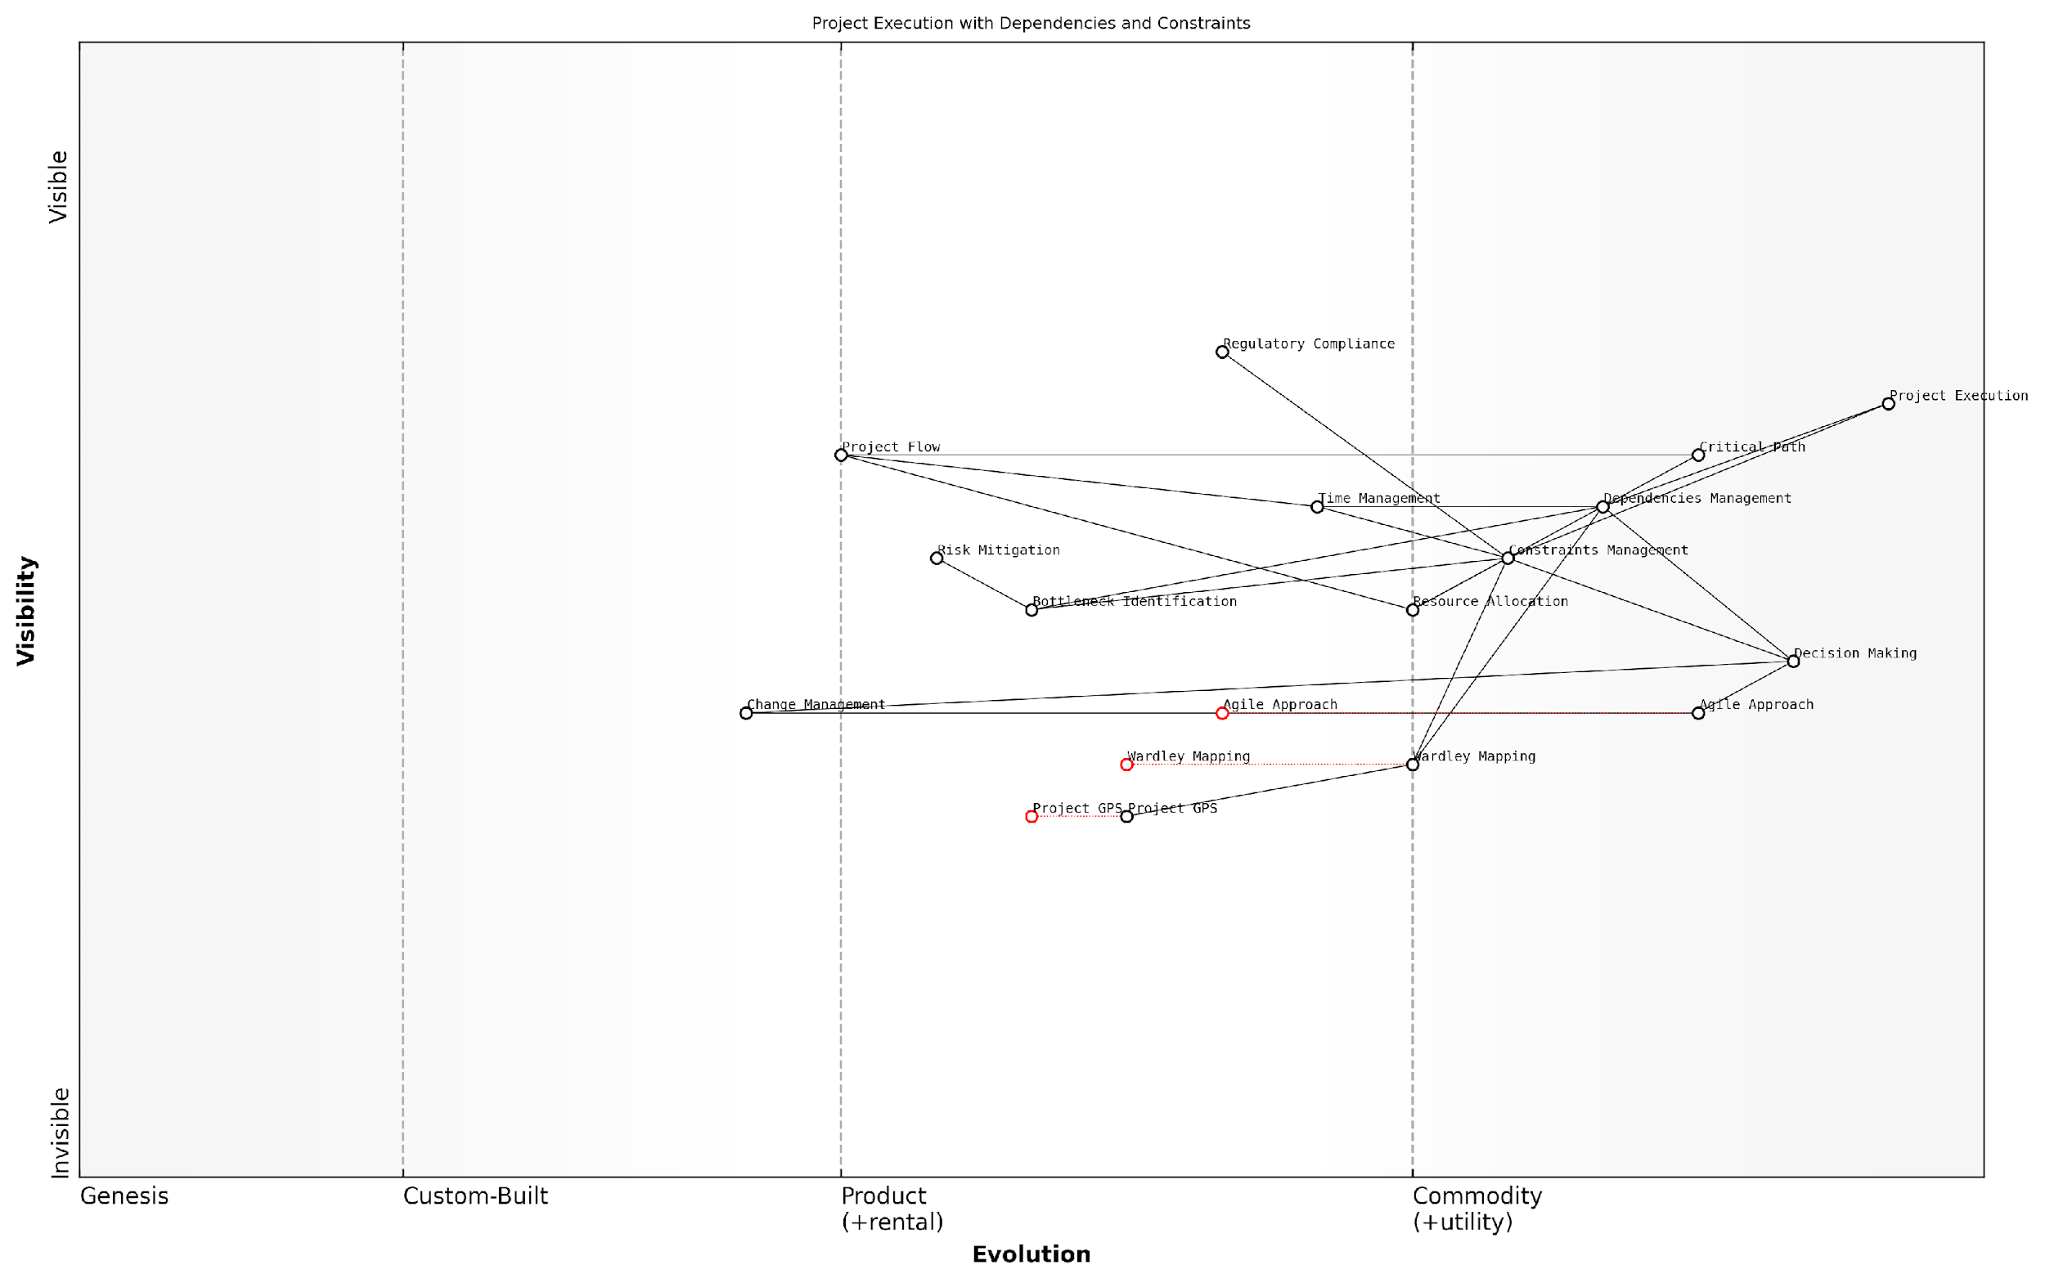

*Draft Wardley Map: [Insert Wardley Map: Managing dependencies and constraints]*

[Edit this draft Wardley Map](https://create.wardleymaps.ai/#clone:e4ed7aef4cd52b5f64)

Wardley Map Assessment

This Wardley Map represents a forward-thinking approach to project management that integrates strategic visualisation tools with established execution methodologies. The key strategic opportunity lies in fully leveraging evolving components like Wardley Mapping and Project GPS to enhance decision-making and adaptability. By focusing on the integration of these tools with AI-driven optimization and predictive capabilities, organisations can create a significant competitive advantage in managing complex projects with multiple dependencies and constraints. The challenge will be in effectively managing the evolution of these components while maintaining operational excellence and regulatory compliance.

[View full Wardley Map report](http://markdown_wardley_map_reports/wardley_map_report_26_Managing_dependencies_and_constraints.md)

## Monitoring and Controlling Projects with Wardley Maps

### Tracking project progress and evolution

Wardley Maps provide project managers with a powerful tool for monitoring and controlling project progress and evolution. By leveraging the visual nature of these maps, project managers can gain real-time insights into the changing landscape of their projects and make informed decisions to keep initiatives on track.

* Regularly update your Wardley Map to reflect current project status
* Track the evolution of components along the value chain
* Monitor the emergence of new components or the obsolescence of others
* Identify shifts in component relationships and dependencies

One of the key benefits of using Wardley Maps for project tracking is the ability to visualise the evolution of project components over time. As the project progresses, certain elements may move along the evolution axis, indicating increased maturity or commoditisation. This movement can signal the need for strategic adjustments in resource allocation or approach.

A seasoned project manager once noted, ‘Wardley Maps act as a living document of our project’s journey. They help us spot trends and potential issues before they become critical problems.’

To effectively track progress using Wardley Maps, project managers should establish a regular cadence for map reviews and updates. This could be aligned with sprint reviews in Agile projects or milestone reviews in traditional waterfall approaches. During these reviews, the team should collaboratively assess the current state of the map and make necessary adjustments.

* Use colour coding to highlight components that have changed since the last review
* Annotate the map with key metrics or KPIs for critical components
* Document decisions and actions taken based on map insights
* Compare current maps with historical versions to visualise project evolution

By consistently tracking project progress and evolution through Wardley Maps, project managers can maintain a strategic view of their initiatives, anticipate challenges, and proactively steer their projects towards success. This approach enables teams to remain agile and responsive to changes in the project landscape, ensuring that efforts remain aligned with organisational goals and market demands.

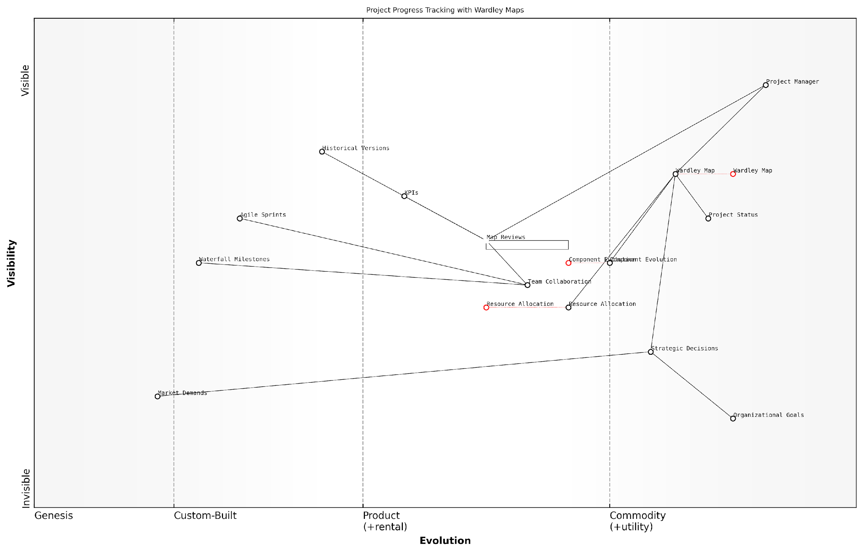

*Draft Wardley Map: [Insert Wardley Map: Tracking project progress and evolution]*

[Edit this draft Wardley Map](https://create.wardleymaps.ai/#clone:79f3e4cdcf21c22e28)

Wardley Map Assessment

This Wardley Map represents a sophisticated approach to project progress tracking that leverages strategic mapping techniques to enhance decision-making and align project execution with organisational goals. The system shows a good balance between custom and commoditized components, with clear opportunities for innovation in automation and AI-driven analysis. By focusing on evolving key components and addressing identified gaps, this approach has the potential to significantly enhance project management effectiveness and strategic alignment.

[View full Wardley Map report](http://markdown_wardley_map_reports/wardley_map_report_27_Tracking_project_progress_and_evolution.md)

### Identifying and addressing bottlenecks

Wardley Maps provide project managers with a powerful tool for identifying and addressing bottlenecks during project execution. By visualising the project’s components and their dependencies, managers can quickly spot areas where progress is being hindered or resources are being strained.

* Identify bottlenecks by looking for components with multiple dependencies
* Analyse the evolution stage of bottleneck components
* Assess the impact of bottlenecks on downstream components
* Prioritise bottlenecks based on their impact on user needs

Once bottlenecks are identified, project managers can use Wardley Maps to develop strategies for addressing them. This may involve reallocating resources, changing project priorities, or exploring alternative approaches to meet user needs.

A seasoned project manager once said, ‘Wardley Maps helped us spot a critical bottleneck in our supply chain that we hadn’t noticed with traditional project management tools. By visualising the entire value chain, we could see how this one component was holding up multiple downstream processes.’

To address bottlenecks effectively, project managers should consider the following strategies:

* Evolve bottleneck components to more mature stages
* Explore outsourcing or utility options for bottleneck components
* Redesign processes to reduce dependencies on bottleneck components
* Invest in capability building for critical bottleneck areas

By regularly updating and reviewing Wardley Maps throughout the project lifecycle, managers can stay ahead of potential bottlenecks and ensure smooth project execution. This proactive approach allows for timely interventions and helps maintain project momentum.

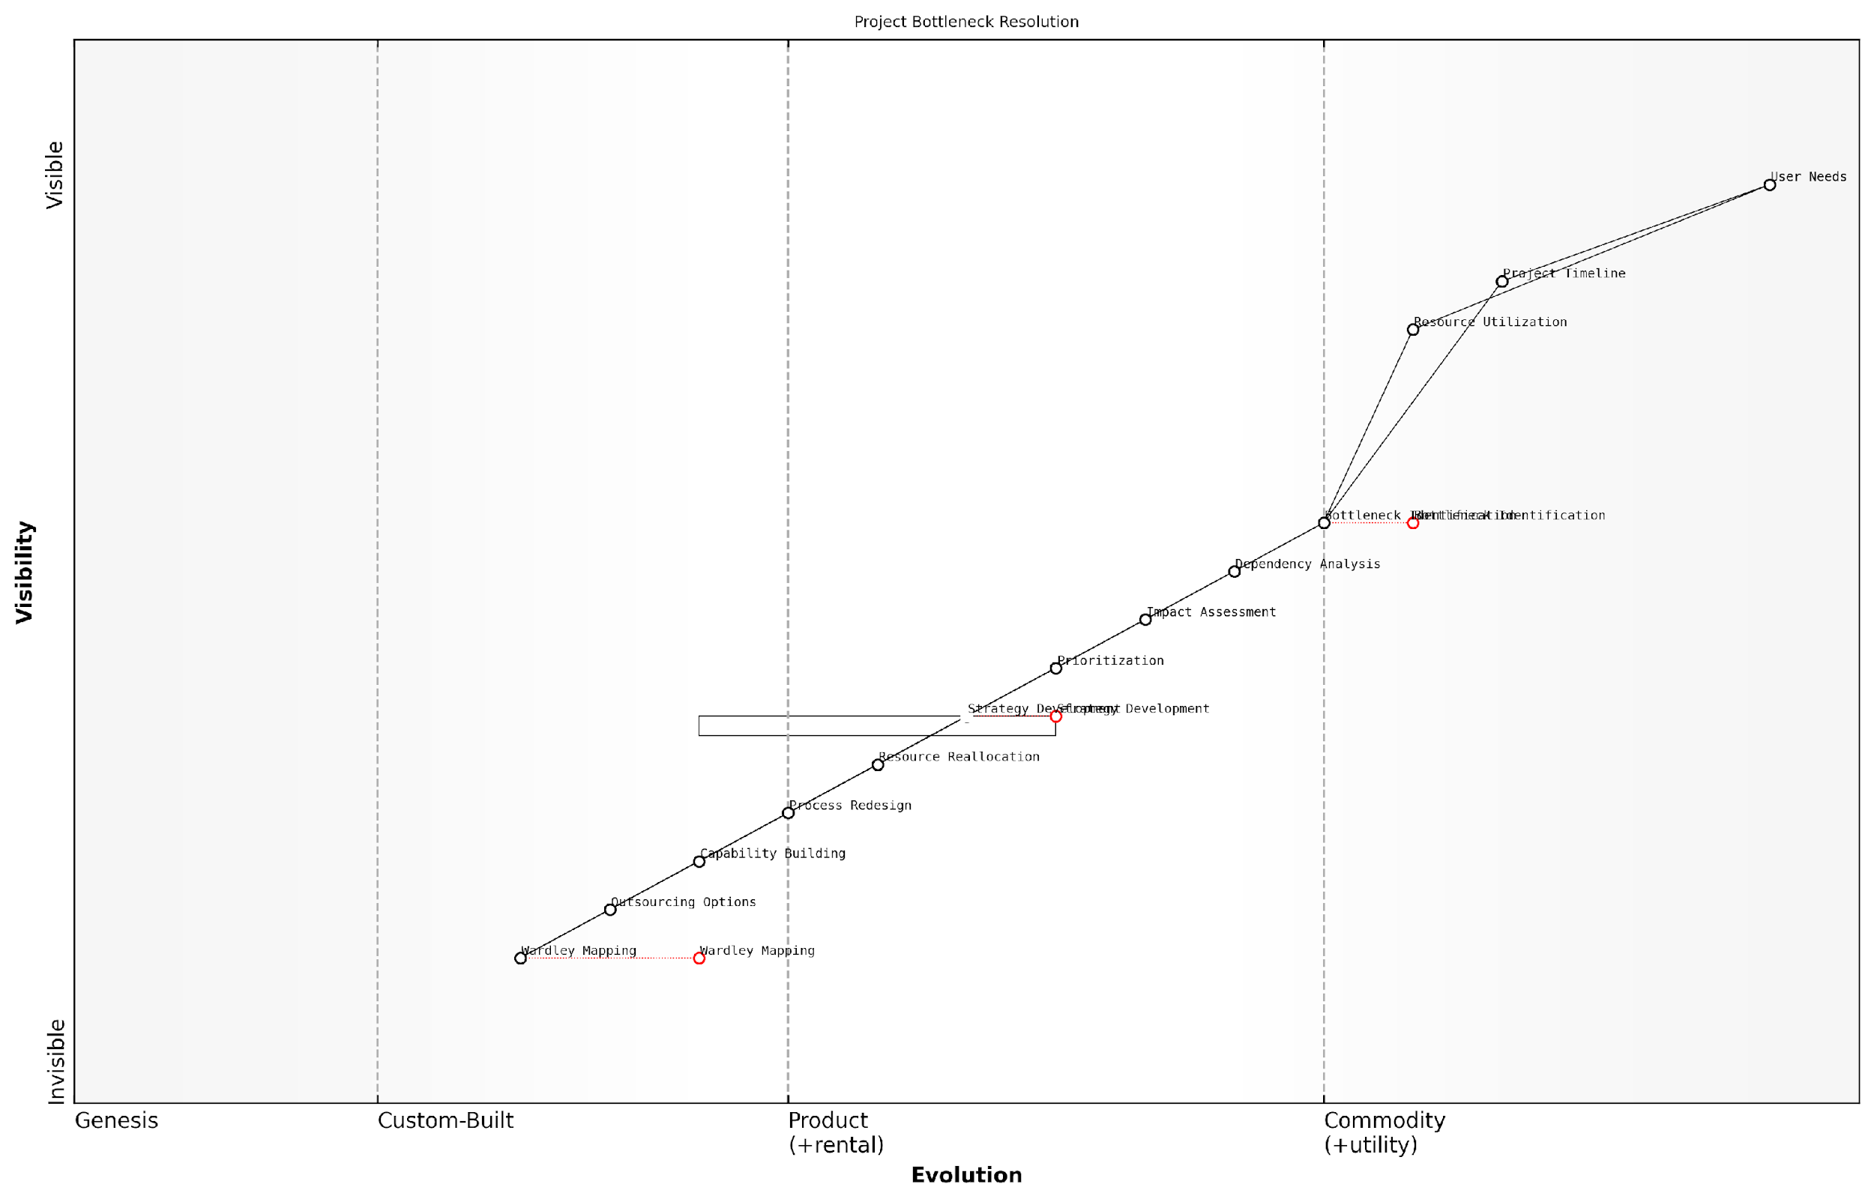

*Draft Wardley Map: [Insert Wardley Map: Identifying and addressing bottlenecks]*

[Edit this draft Wardley Map](https://create.wardleymaps.ai/#clone:b4a7d751cfd08e9d5e)

Wardley Map Assessment

This Wardley Map presents a comprehensive and strategically sound approach to project bottleneck resolution. It effectively integrates strategic analysis tools, particularly Wardley Mapping, with practical project management concerns. The map indicates a mature understanding of the bottleneck resolution process, with opportunities for further evolution in predictive capabilities and real-time adaptability. Key strengths lie in the integrated approach to analysis and strategy development, while potential areas for improvement include tighter coupling between strategy and execution components. Overall, this map provides a solid foundation for effective project management and continuous improvement in bottleneck resolution practices.

[View full Wardley Map report](http://markdown_wardley_map_reports/wardley_map_report_28_Identifying_and_addressing_bottlenecks.md)

### Adapting to unexpected changes and challenges

In the dynamic world of project management, unexpected changes and challenges are inevitable. Wardley Maps provide project managers with a powerful tool to navigate these uncertainties and adapt their strategies accordingly.

When faced with unexpected changes, project managers can use their Wardley Maps to quickly assess the impact on their project’s value chain and evolution. This allows for rapid decision-making and course correction.

* Identify affected components: Pinpoint which components of your project are directly impacted by the change or challenge.
* Assess ripple effects: Trace the connections in your map to understand how the change might affect other components.
* Evaluate evolution stages: Determine if the change accelerates or delays the evolution of certain components.
* Reassess dependencies: Review the dependencies between components to identify any new risks or opportunities.

Once the impact is understood, project managers can use their maps to develop adaptive strategies. This might involve reprioritising tasks, reallocating resources, or even pivoting the project direction.

A seasoned project manager once said, ‘Wardley Maps are like a GPS for your project. When you hit an unexpected roadblock, they help you find the best alternative route.’

It’s crucial to remember that adapting to changes often requires updating the Wardley Map itself. This iterative process ensures that the map remains an accurate representation of the project landscape, even as it evolves in response to challenges.

By leveraging Wardley Maps in this way, project managers can turn unexpected challenges into opportunities for innovation and improvement, ensuring their projects remain resilient and adaptable in the face of change.

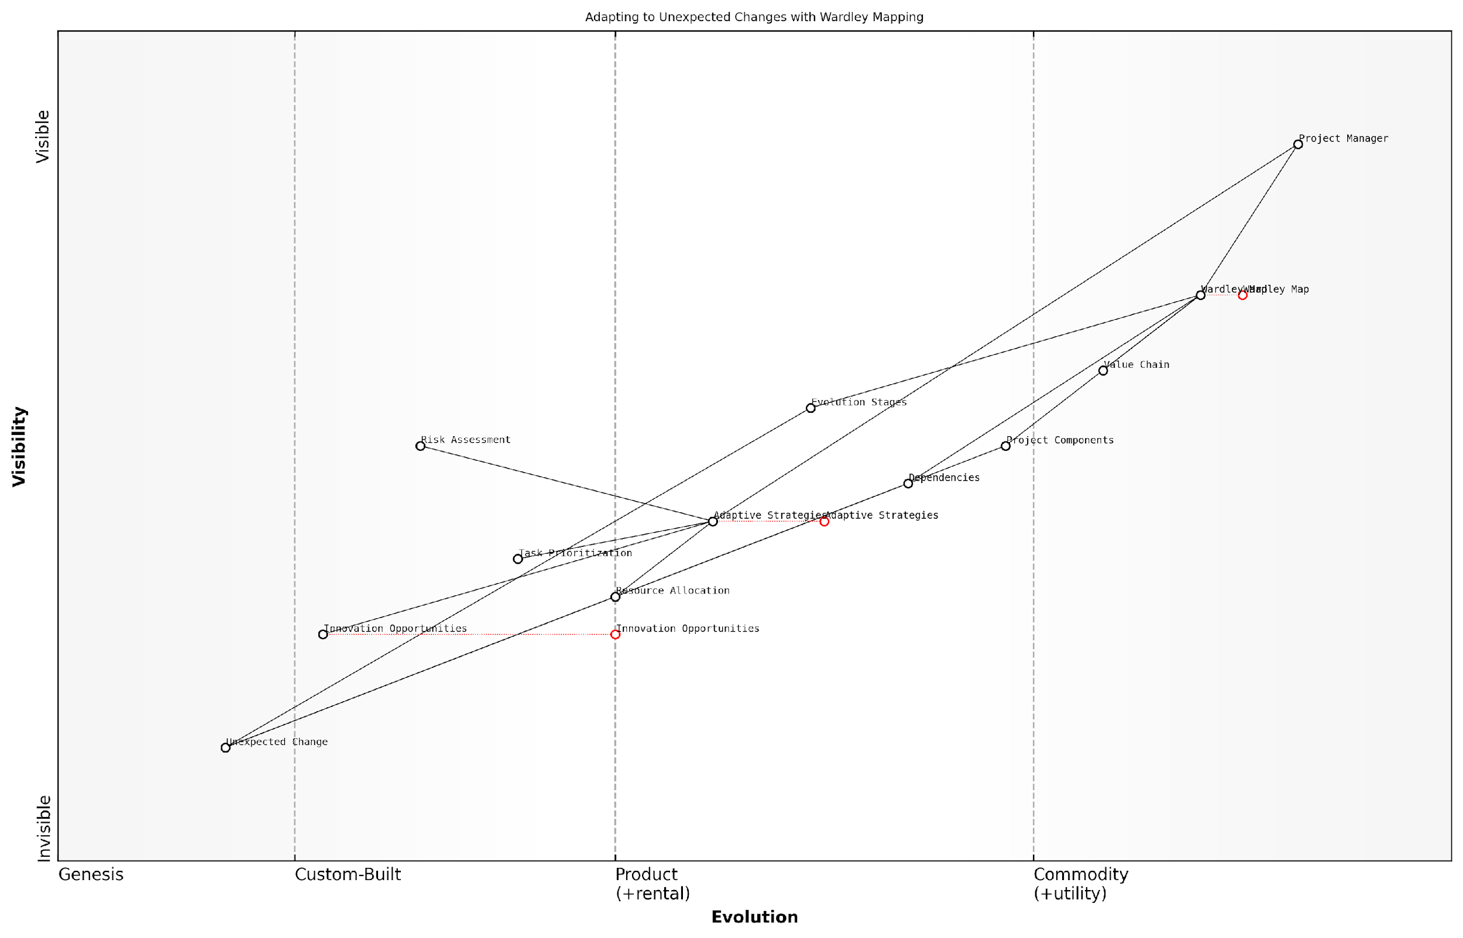

*Draft Wardley Map: [Insert Wardley Map: Adapting to unexpected changes and challenges]*

[Edit this draft Wardley Map](https://create.wardleymaps.ai/#clone:aea0de86a84127c430)

Wardley Map Assessment

This Wardley Map represents a forward-thinking approach to project management that emphasises adaptability and strategic visualisation. The integration of Wardley Mapping with adaptive strategies positions the system well for handling unexpected changes. However, there are opportunities to enhance predictive capabilities, innovation management, and real-time adaptability. By focusing on these areas and evolving key components like Adaptive Strategies and Innovation Opportunities, the system can significantly improve its ability to navigate complex, changing project environments. The emphasis on Wardley Mapping as a central tool provides a unique advantage, but care should be taken to avoid over-reliance on a single methodology. Overall, this approach shows promise for leading the next evolution in adaptive project management practices.

[View full Wardley Map report](http://markdown_wardley_map_reports/wardley_map_report_29_Adapting_to_unexpected_changes_and_challenges.md)

## Continuous Improvement and Learning

### Using maps for post-project reviews

Wardley Maps provide a powerful tool for conducting comprehensive post-project reviews, enabling project managers to gain valuable insights and drive continuous improvement. By revisiting and analysing the project’s Wardley Map at the conclusion of the project, teams can identify areas of success, challenges, and opportunities for future enhancements.

* Compare initial map to final project state
* Analyse component evolution and its impact
* Identify unexpected shifts in the landscape
* Evaluate the effectiveness of strategic decisions

One of the key benefits of using Wardley Maps in post-project reviews is the ability to visualise the project’s journey. By comparing the initial map created during the planning phase with the final state of the project, teams can easily identify where expectations were met, exceeded, or fell short.

Using Wardley Maps for our post-project review completely transformed our understanding of what went right and wrong. It was like seeing our project’s entire journey laid out before us, with all its twists and turns.

Additionally, Wardley Maps can help teams identify patterns and trends across multiple projects. By analysing maps from various projects, organisations can develop a more nuanced understanding of their strengths, weaknesses, and areas for improvement in project execution.

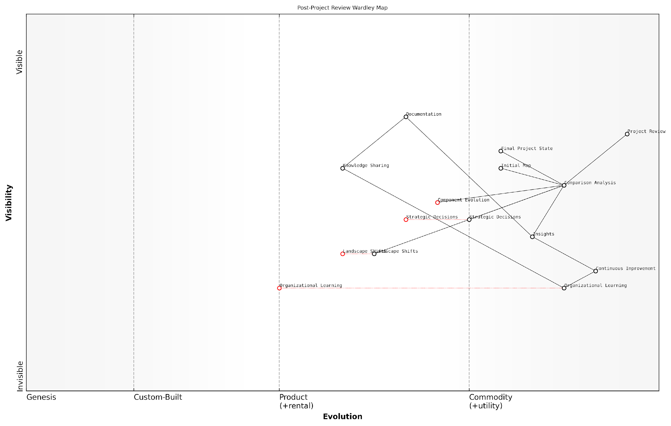

*Draft Wardley Map: [Insert Wardley Map: Using maps for post-project reviews]*

[Edit this draft Wardley Map](https://create.wardleymaps.ai/#clone:a4eca02a37d44bb4c1)

Wardley Map Assessment

This Wardley Map reveals a thoughtful approach to post-project reviews that goes beyond simple retrospectives to drive organisational learning and continuous improvement. The inclusion of Wardley Mapping elements like Component Evolution and Landscape Shifts suggests a sophisticated understanding of project dynamics. However, the map also highlights potential gaps, particularly in the transition from project-specific insights to broader organisational learning. By focusing on automating analytical processes, enhancing knowledge sharing, and developing robust organisational learning capabilities, the organisation can significantly improve its ability to learn from projects and adapt to changing landscapes. The emphasis on continuous improvement positions the organisation well for future challenges, but realising this potential will require concerted effort in developing currently underdeveloped components.

[View full Wardley Map report](http://markdown_wardley_map_reports/wardley_map_report_30_Using_maps_for_post-project_reviews.md)

To maximise the benefits of using Wardley Maps in post-project reviews, project managers should establish a structured process for map analysis and ensure that insights gained are effectively documented and shared across the organisation. This approach will foster a culture of continuous learning and improvement, ultimately leading to more successful project outcomes in the future.

### Building organisational knowledge through mapping

Wardley Mapping is not just a tool for individual project managers; it’s a powerful method for building and sharing organisational knowledge. By consistently using Wardley Maps across projects, teams can create a repository of strategic insights that benefit the entire organisation.

* Create a central repository for project maps
* Encourage cross-team map sharing and discussion
* Use maps to identify patterns and trends across projects
* Develop a common language for strategic discussions

One of the key benefits of building organisational knowledge through mapping is the ability to learn from past projects and apply those lessons to future initiatives. By comparing maps from successful and unsuccessful projects, teams can identify common patterns, potential pitfalls, and best practices.

By mapping our projects consistently over the past year, we’ve been able to identify recurring bottlenecks in our value chain and address them proactively. This has led to a 30% reduction in project delays across the organisation.

To maximise the benefits of organisational learning through Wardley Mapping, consider implementing the following strategies:

* Regular map review sessions with cross-functional teams
* Integration of Wardley Mapping insights into project post-mortems
* Creation of a ‘map of maps’ to visualise relationships between different projects and initiatives
* Development of training programmes to ensure consistent mapping practices across the organisation

By fostering a culture of continuous learning and improvement through Wardley Mapping, organisations can enhance their strategic decision-making capabilities, improve project outcomes, and build a sustainable competitive advantage.

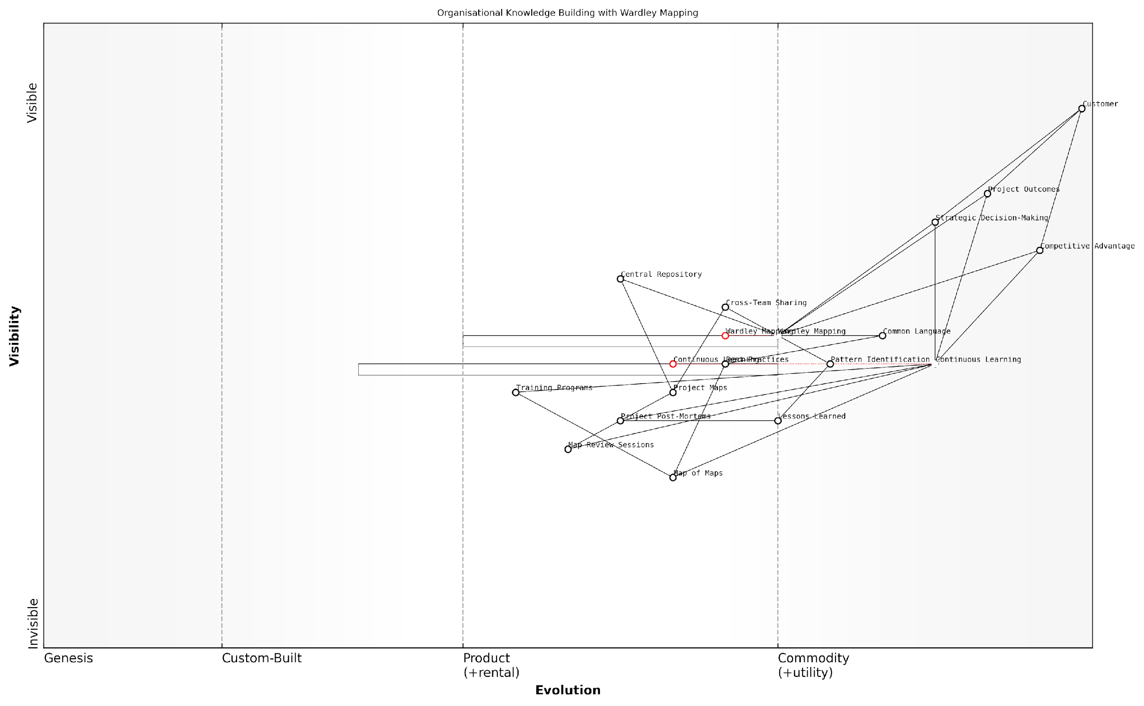

*Draft Wardley Map: [Insert Wardley Map: Building organisational knowledge through mapping]*

[Edit this draft Wardley Map](https://create.wardleymaps.ai/#clone:16686a04563d1e25ba)

Wardley Map Assessment

The organisation demonstrates a strong commitment to building knowledge through Wardley Mapping, positioning itself well for strategic advantage. Key opportunities lie in automating and enhancing the mapping process, strengthening cross-team collaboration, and leveraging emerging technologies for deeper insights. The focus on continuous learning provides a solid foundation for adapting to future changes and maintaining competitive edge. To maximise the value of this approach, the organisation should prioritise the evolution of its mapping practices, invest in supporting technologies, and foster a broader ecosystem for knowledge sharing and collaboration.

[View full Wardley Map report](http://markdown_wardley_map_reports/wardley_map_report_31_Building_organisational_knowledge_through_mapping.md)

### Evolving project management practices based on map insights

Wardley Mapping provides project managers with a powerful tool for continuous improvement and learning. By regularly updating and analysing maps throughout the project lifecycle, teams can gain valuable insights that drive the evolution of project management practices.

* Identify recurring patterns and challenges across projects
* Adapt methodologies based on the evolving landscape
* Refine estimation and planning techniques
* Improve risk management strategies
* Enhance resource allocation and team structure

One of the key benefits of using Wardley Maps for continuous improvement is the ability to visualise the evolution of project components over time. This allows project managers to anticipate changes and proactively adjust their practices to meet emerging needs.

By mapping our projects consistently, we’ve been able to identify bottlenecks and inefficiencies that weren’t apparent through traditional project management tools. This has led to significant improvements in our delivery process.

To effectively evolve project management practices based on map insights, organisations should establish a feedback loop that includes:

* Regular map reviews and updates
* Cross-project analysis to identify trends
* Collaborative workshops to discuss insights and propose improvements
* Pilot testing of new practices based on map findings
* Documentation and sharing of lessons learned

By integrating Wardley Mapping into the continuous improvement process, project managers can create a dynamic and responsive approach to project management that adapts to the changing needs of their organisation and industry.

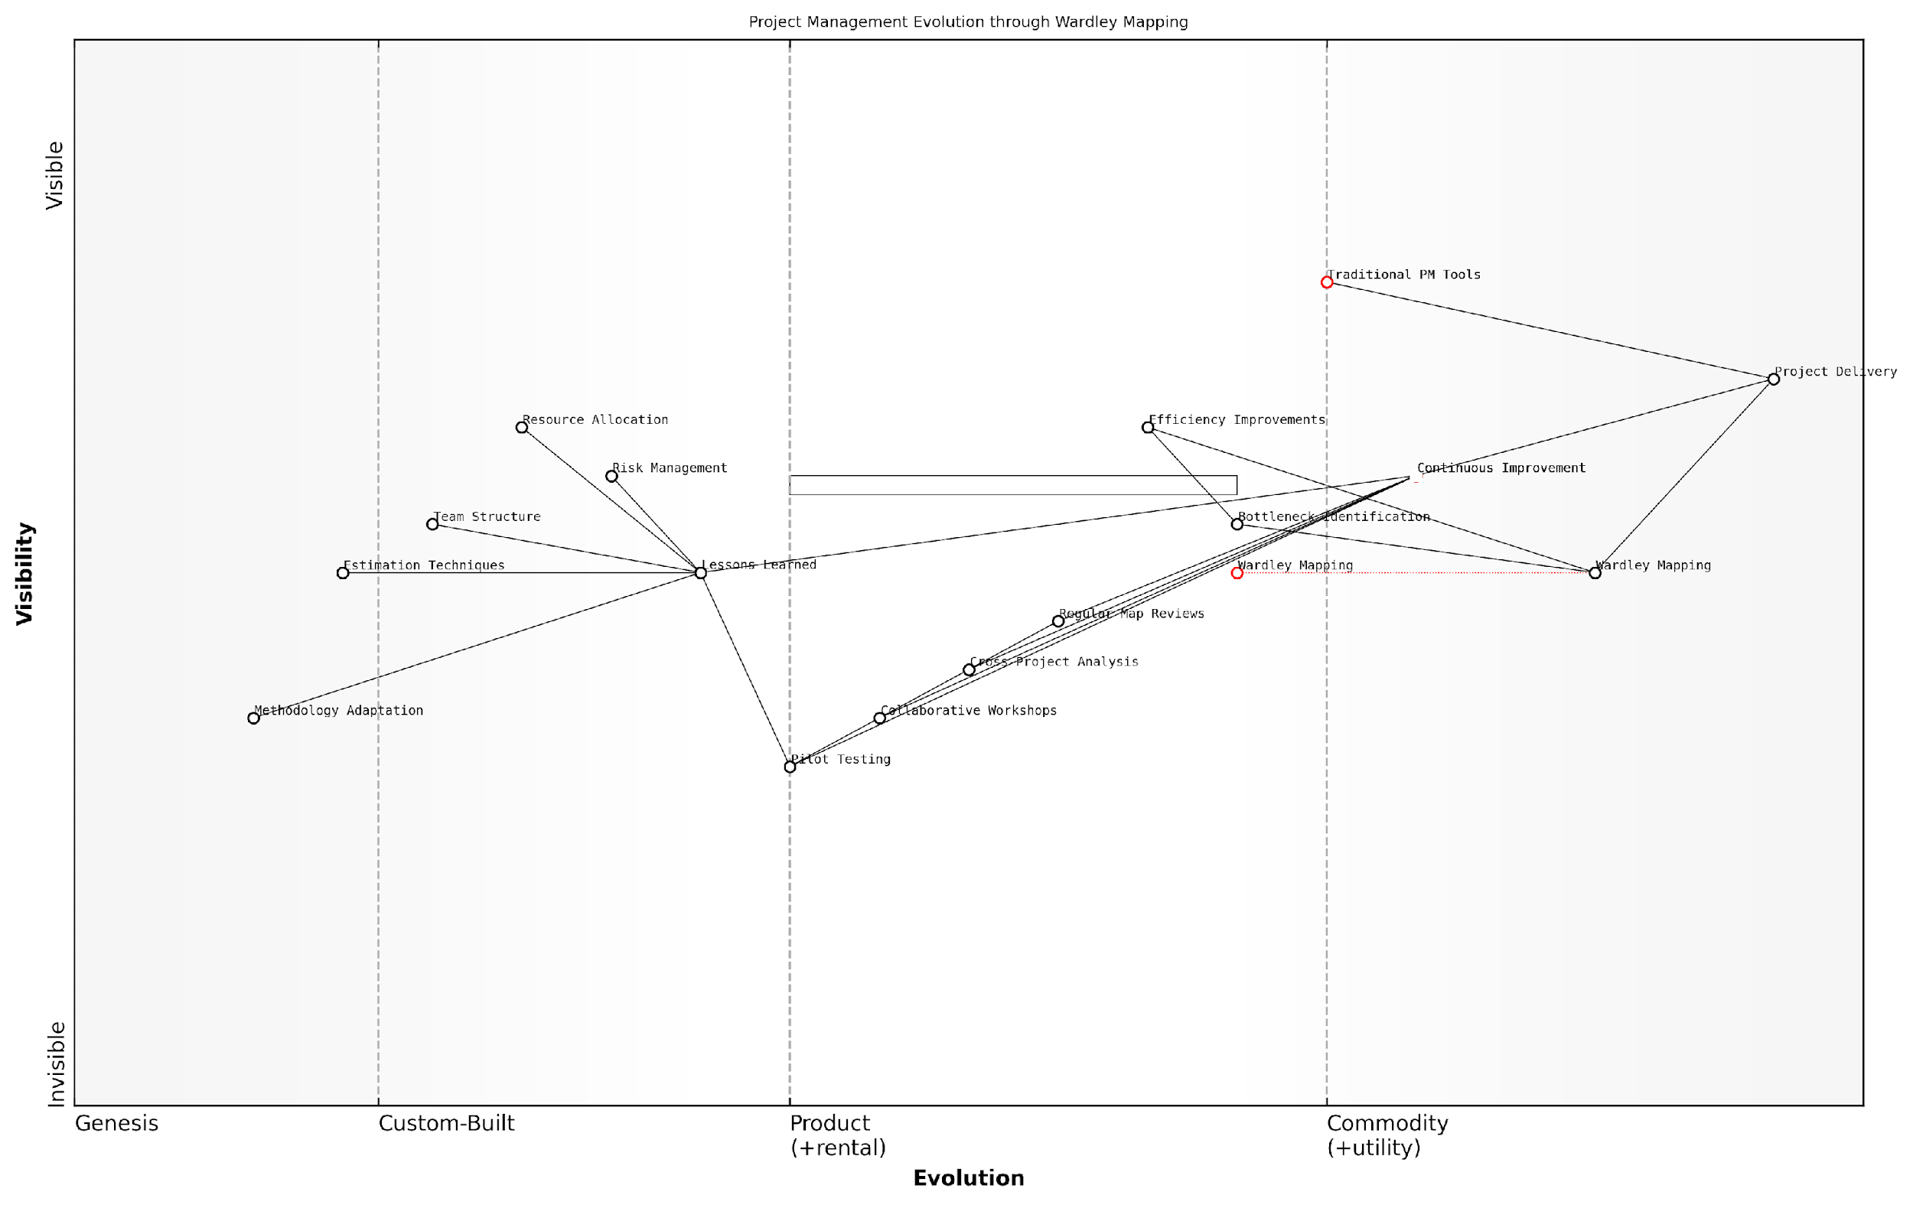

*Draft Wardley Map: [Insert Wardley Map: Evolving project management practices based on map insights]*

[Edit this draft Wardley Map](https://create.wardleymaps.ai/#clone:34d185a09751127975)

Wardley Map Assessment

This map represents a progressive approach to project management that leverages Wardley Mapping for strategic insights and continuous improvement. The organisation is well-positioned to evolve its project management practices but must focus on developing capabilities in adaptive methodologies and cross-project learning to fully realise the benefits of this approach. The integration of Wardley Mapping with traditional project management offers a unique competitive advantage if executed effectively.

[View full Wardley Map report](http://markdown_wardley_map_reports/wardley_map_report_32_Evolving_project_management_practices_based_on_map.md)

# Chapter 4: Advanced Wardley Mapping Techniques for Project Managers

## Multi-Project and Programme Management

### Creating and managing portfolio maps

Portfolio maps are an advanced application of Wardley Mapping that allow project managers to visualise and manage multiple projects or programmes simultaneously. These maps provide a holistic view of an organisation’s project landscape, enabling better strategic decision-making and resource allocation.

To create a portfolio map, project managers need to follow these key steps:

* Identify all relevant projects and programmes within the portfolio
* Map each project individually, focusing on key components and their evolutionary stages
* Combine individual project maps into a single, comprehensive portfolio map
* Identify common components, dependencies, and potential synergies across projects
* Highlight areas of overlap or conflict in resource allocation

Managing portfolio maps requires ongoing attention and regular updates. Project managers should:

* Regularly review and update the portfolio map as projects progress and evolve
* Use the map to facilitate discussions on resource allocation and prioritisation
* Identify opportunities for consolidation or standardisation across projects
* Monitor the overall strategic alignment of the portfolio with organisational goals
* Use the map to communicate portfolio status and strategy to stakeholders

A seasoned project management consultant once remarked, ‘Portfolio maps are like a strategic radar for organisations. They help you see the big picture and navigate through the complexity of multiple projects with clarity and purpose.’

By effectively creating and managing portfolio maps, project managers can gain a competitive advantage in multi-project environments. These maps enable better decision-making, improved resource utilisation, and a more strategic approach to project and programme management.

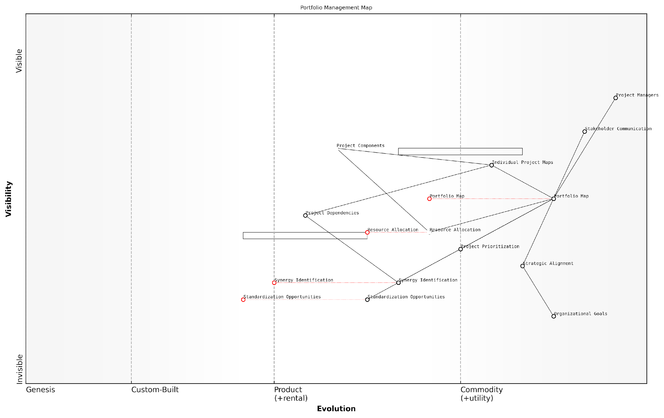

*Draft Wardley Map: [Insert Wardley Map: Creating and managing portfolio maps]*

[Edit this draft Wardley Map](https://create.wardleymaps.ai/#clone:9ae741c2bfe168f1b1)

Wardley Map Assessment

This Wardley Map reveals a portfolio management system that is evolving from custom-built solutions towards more productized offerings. The central role of the Portfolio Map provides a strong foundation, but there are significant opportunities for innovation in resource allocation, synergy identification, and standardisation. By focusing on these areas and leveraging emerging technologies, organisations can create a more efficient, value-driven approach to multi-project and programme management. The key to success will be balancing customization with standardisation, and integrating advanced analytics to drive decision-making and optimization across the portfolio.

[View full Wardley Map report](http://markdown_wardley_map_reports/wardley_map_report_33_Creating_and_managing_portfolio_maps.md)

### Balancing resources across multiple projects

Wardley Mapping provides project managers with a powerful tool for balancing resources across multiple projects within a programme or portfolio. By visualising the value chains and evolution of components across different projects, managers can identify synergies, overlaps, and potential resource conflicts.

* Identify common components across projects
* Assess the evolutionary stage of shared resources
* Prioritise resource allocation based on strategic importance
* Optimise resource utilisation through cross-project coordination

One of the key benefits of using Wardley Maps for resource balancing is the ability to identify shared components across multiple projects. By mapping out the value chains of different projects side by side, project managers can quickly spot where resources are being duplicated or where there’s potential for sharing.

A seasoned project portfolio manager once remarked, ‘Wardley Mapping revealed resource overlaps we hadn’t noticed before, allowing us to consolidate efforts and significantly improve our overall efficiency.’

Another crucial aspect of resource balancing is understanding the evolutionary stage of shared components. This insight allows project managers to make informed decisions about where to invest resources for maximum impact. For instance, components in the genesis or custom-built stages may require more resources and attention than those in the product or commodity stages.

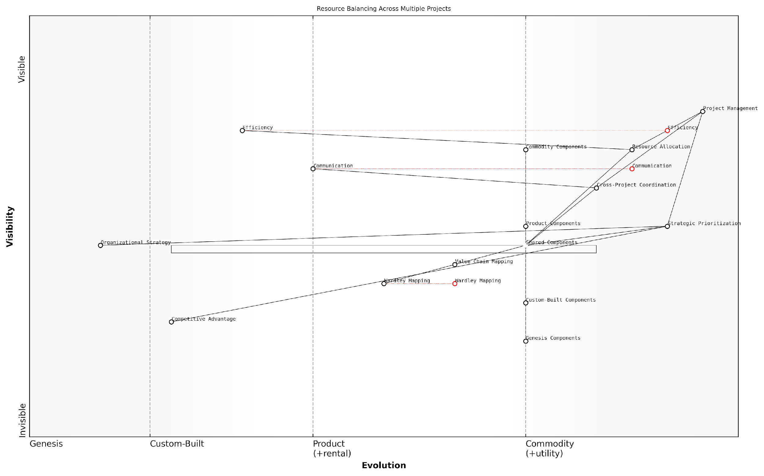

*Draft Wardley Map: [Insert Wardley Map: Balancing resources across multiple projects]*

[Edit this draft Wardley Map](https://create.wardleymaps.ai/#clone:768485608b53aaa53a)

Wardley Map Assessment

This Wardley Map reveals an organisation with strong foundational project management capabilities, actively working to balance resources across multiple projects. The inclusion of strategic components like Wardley Mapping indicates a forward-thinking approach. However, there are opportunities to enhance efficiency through greater standardisation and evolution of custom components. The organisation is well-positioned to leverage emerging technologies and methodologies to gain a competitive advantage in multi-project management, provided it addresses the identified capability gaps and focuses on the recommended strategic initiatives.

[View full Wardley Map report](http://markdown_wardley_map_reports/wardley_map_report_34_Balancing_resources_across_multiple_projects.md)

By leveraging Wardley Maps, project managers can also prioritise resource allocation based on strategic importance. Components that are higher up the value chain or those that are evolving rapidly may require more resources to maintain a competitive advantage. This strategic view enables managers to make tough decisions about resource allocation when conflicts arise between projects.

* Use maps to identify strategic components across projects
* Allocate more resources to high-value, rapidly evolving components
* De-prioritise or outsource commodity components to free up resources
* Regularly review and adjust resource allocation based on evolving maps

Finally, Wardley Mapping facilitates better cross-project coordination for optimal resource utilisation. By providing a common visual language, maps enable project managers, team leads, and executives to discuss resource allocation more effectively. This improved communication can lead to more efficient use of shared resources, reduced duplication of effort, and better alignment of projects with overall organisational strategy.

### Identifying synergies and conflicts between projects

When managing multiple projects or programmes, Wardley Mapping becomes an invaluable tool for identifying synergies and conflicts between different initiatives. By creating maps for each project and overlaying them, project managers can gain a holistic view of their portfolio and make informed decisions about resource allocation, timing, and strategic alignment.

* Create individual Wardley Maps for each project
* Overlay maps to identify common components and dependencies
* Analyse evolution stages of shared components across projects
* Identify potential resource conflicts and bottlenecks
* Spot opportunities for shared infrastructure or capabilities

When examining overlaid maps, project managers should look for components that appear in multiple projects. These shared components can represent either synergies or conflicts, depending on their nature and the projects’ timelines.

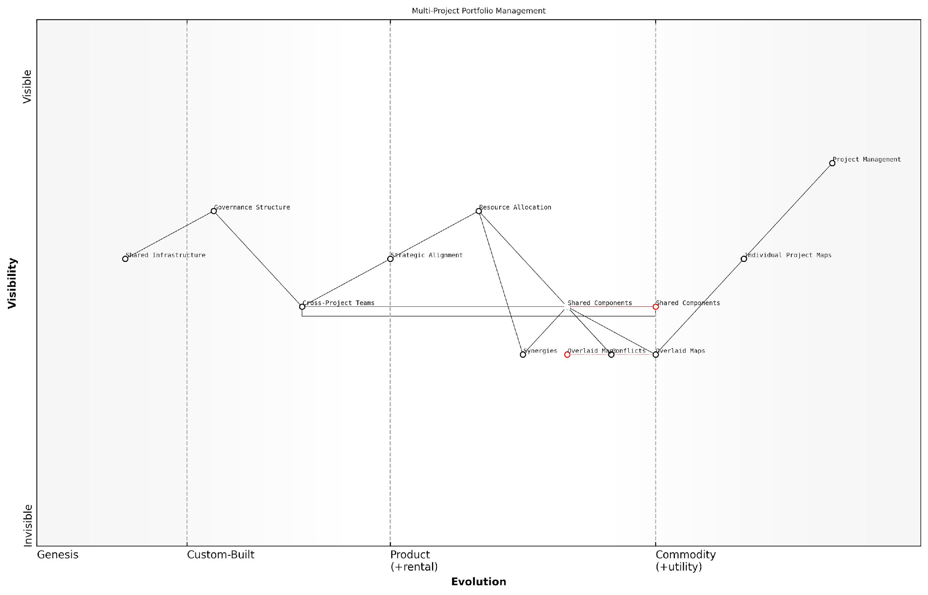

*Draft Wardley Map: [Insert Wardley Map: Identifying synergies and conflicts between projects]*

[Edit this draft Wardley Map](https://create.wardleymaps.ai/#clone:bb2167420f8d4cb01e)

Wardley Map Assessment

This Wardley Map reveals a maturing multi-project portfolio management approach with clear areas for improvement and innovation. The focus on Overlaid Maps and Shared Components presents significant opportunities for enhancing efficiency and strategic alignment. By addressing the identified bottlenecks, leveraging emerging technologies, and fostering a more integrated approach to cross-project collaboration, organisations can significantly improve their multi-project management capabilities. The evolution towards more data-driven, AI-enhanced project management will be crucial for maintaining competitive advantage in complex project environments.

[View full Wardley Map report](http://markdown_wardley_map_reports/wardley_map_report_35_Identifying_synergies_and_conflicts_between_projec.md)

Synergies often emerge when projects share components in similar evolutionary stages. For example, if two projects require the development of a new API, combining these efforts can lead to cost savings and improved standardisation. Conflicts, on the other hand, may arise when multiple projects compete for the same limited resources or when they have conflicting goals for shared components.

By using Wardley Maps to visualise our entire project portfolio, we were able to identify several opportunities for shared services that we hadn’t previously considered. This not only reduced our overall costs but also improved consistency across our systems.

To effectively manage synergies and conflicts, project managers should consider the following strategies:

* Prioritise projects based on strategic importance and component evolution
* Create cross-project teams to manage shared components
* Develop a roadmap for evolving shared components to benefit multiple projects
* Implement a governance structure to manage conflicts and allocate resources
* Regularly review and update project maps to reflect changing landscapes

By leveraging Wardley Mapping in multi-project and programme management, organisations can optimise their project portfolios, reduce redundancies, and maximise the value delivered across all initiatives.

## Integrating Wardley Mapping with Other Strategic Tools

### Combining Wardley Maps with SWOT analysis

Content for Combining Wardley Maps with SWOT analysis not found.

### Using Wardley Maps alongside Balanced Scorecards

Content for Using Wardley Maps alongside Balanced Scorecards not found.

### Enhancing Risk Management with Wardley Mapping

Content for Enhancing Risk Management with Wardley Mapping not found.

## Wardley Mapping for Specific Project Types

### IT and software development projects

Content for IT and software development projects not found.

### Product development and innovation projects

Content for Product development and innovation projects not found.

### Organisational change and transformation projects

Content for Organisational change and transformation projects not found.

# Conclusion: Becoming a Wardley Mapping Master

## Developing Your Wardley Mapping Skills

### Continuous learning and practice

Content for Continuous learning and practice not found.

### Building a community of practice within your organisation

Content for Building a community of practice within your organisation not found.

### Resources for further study and improvement

Content for Resources for further study and improvement not found.

## The Future of Project Management with Wardley Mapping

### Emerging trends and developments

Content for Emerging trends and developments not found.

### Potential impacts on the project management profession

Content for Potential impacts on the project management profession not found.

### Preparing for the evolving landscape of strategic project management

Content for Preparing for the evolving landscape of strategic project management not found.

# Appendix - Book Generation Details

* Initial Topic: Understanding Wardley Mapping for Project Managers
* Refined Topic: Understanding Wardley Mapping for Project Managers
* Total Output Tokens: 104,179
* Total LLM Cost: $1.56

# Appendix: Further Reading on Wardley Mapping

The following books, primarily authored by Mark Craddock, offer comprehensive insights into various aspects of Wardley Mapping:

## Core Wardley Mapping Series

1. **Wardley Mapping, The Knowledge: Part One, Topographical Intelligence in Business**
   * Author: Simon Wardley
   * Editor: Mark Craddock
   * Part of the Wardley Mapping series (5 books)
   * Available in Kindle Edition
   * [Amazon Link](https://www.amazon.com/dp/B0BVSXB5W5)

* This foundational text introduces readers to the Wardley Mapping approach:
  + Covers key principles, core concepts, and techniques for creating situational maps
  + Teaches how to anchor mapping in user needs and trace value chains
  + Explores anticipating disruptions and determining strategic gameplay
  + Introduces the foundational doctrine of strategic thinking
  + Provides a framework for assessing strategic plays
  + Includes concrete examples and scenarios for practical application
* The book aims to equip readers with:
  + A strategic compass for navigating rapidly shifting competitive landscapes
  + Tools for systematic situational awareness
  + Confidence in creating strategic plays and products
  + An entrepreneurial mindset for continual learning and improvement

1. **Wardley Mapping Doctrine: Universal Principles and Best Practices that Guide Strategic Decision-Making**
   * Author: Mark Craddock
   * Part of the Wardley Mapping series (5 books)
   * Available in Kindle Edition
   * [Amazon Link](https://www.amazon.com/dp/B0C2SFTR7Z)

* This book explores how doctrine supports organisational learning and adaptation:
  + Standardisation: Enhances efficiency through consistent application of best practices
  + Shared Understanding: Fosters better communication and alignment within teams
  + Guidance for Decision-Making: Offers clear guidelines for navigating complexity
  + Adaptability: Encourages continuous evaluation and refinement of practices
* Key features:
  + In-depth analysis of doctrine’s role in strategic thinking
  + Case studies demonstrating successful application of doctrine
  + Practical frameworks for implementing doctrine in various organisational contexts
  + Exploration of the balance between stability and flexibility in strategic planning
* Ideal for:
  + Business leaders and executives
  + Strategic planners and consultants
  + Organisational development professionals
  + Anyone interested in enhancing their strategic decision-making capabilities

1. **Wardley Mapping Gameplays: Transforming Insights into Strategic Actions**
   * Author: Mark Craddock
   * Part of the Wardley Mapping series (5 books)
   * Available in Kindle Edition
   * [Amazon Link](https://www.amazon.com/dp/B0C7CR9R9Q)

* This book delves into gameplays, a crucial component of Wardley Mapping:
  + Gameplays are context-specific patterns of strategic action derived from Wardley Maps
  + Types of gameplays include:
    - User Perception plays (e.g., education, bundling)
    - Accelerator plays (e.g., open approaches, exploiting network effects)
    - De-accelerator plays (e.g., creating constraints, exploiting IPR)
    - Market plays (e.g., differentiation, pricing policy)
    - Defensive plays (e.g., raising barriers to entry, managing inertia)
    - Attacking plays (e.g., directed investment, undermining barriers to entry)
    - Ecosystem plays (e.g., alliances, sensing engines)
* Gameplays enhance strategic decision-making by:
  1. Providing contextual actions tailored to specific situations
  2. Enabling anticipation of competitors’ moves
  3. Inspiring innovative approaches to challenges and opportunities
  4. Assisting in risk management
  5. Optimising resource allocation based on strategic positioning
* The book includes:
  + Detailed explanations of each gameplay type
  + Real-world examples of successful gameplay implementation
  + Frameworks for selecting and combining gameplays
  + Strategies for adapting gameplays to different industries and contexts

1. **Navigating Inertia: Understanding Resistance to Change in Organisations**
   * Author: Mark Craddock
   * Part of the Wardley Mapping series (5 books)
   * Available in Kindle Edition
   * [Amazon Link](https://www.amazon.com/dp/B0C34FX8XC)

* This comprehensive guide explores organisational inertia and strategies to overcome it:
* Key Features:
  + In-depth exploration of inertia in organisational contexts
  + Historical perspective on inertia’s role in business evolution
  + Practical strategies for overcoming resistance to change
  + Integration of Wardley Mapping as a diagnostic tool
* The book is structured into six parts:
  1. Understanding Inertia: Foundational concepts and historical context
  2. Causes and Effects of Inertia: Internal and external factors contributing to inertia
  3. Diagnosing Inertia: Tools and techniques, including Wardley Mapping
  4. Strategies to Overcome Inertia: Interventions for cultural, behavioural, structural, and process improvements
  5. Case Studies and Practical Applications: Real-world examples and implementation frameworks
  6. The Future of Inertia Management: Emerging trends and building adaptive capabilities
* This book is invaluable for:
  + Organisational leaders and managers
  + Change management professionals
  + Business strategists and consultants
  + Researchers in organisational behaviour and management

1. **Wardley Mapping Climate: Decoding Business Evolution**
   * Author: Mark Craddock
   * Part of the Wardley Mapping series (5 books)
   * Available in Kindle Edition
   * [Amazon Link](https://www.amazon.com/dp/B0BVHF2MBH)

* This comprehensive guide explores climatic patterns in business landscapes:
* Key Features:
  + In-depth exploration of 31 climatic patterns across six domains: Components, Financial, Speed, Inertia, Competitors, and Prediction
  + Real-world examples from industry leaders and disruptions
  + Practical exercises and worksheets for applying concepts
  + Strategies for navigating uncertainty and driving innovation
  + Comprehensive glossary and additional resources
* The book enables readers to:
  + Anticipate market changes with greater accuracy
  + Develop more resilient and adaptive strategies
  + Identify emerging opportunities before competitors
  + Navigate complexities of evolving business ecosystems
* It covers topics from basic Wardley Mapping to advanced concepts like the Red Queen Effect and Jevon’s Paradox, offering a complete toolkit for strategic foresight.
* Perfect for:
  + Business strategists and consultants
  + C-suite executives and business leaders
  + Entrepreneurs and startup founders
  + Product managers and innovation teams
  + Anyone interested in cutting-edge strategic thinking

## Practical Resources

1. **Wardley Mapping Cheat Sheets & Notebook**
   * Author: Mark Craddock
   * 100 pages of Wardley Mapping design templates and cheat sheets
   * Available in paperback format
   * [Amazon Link](https://www.amazon.com/dp/B09TPDM9PP)

* This practical resource includes:
  + Ready-to-use Wardley Mapping templates
  + Quick reference guides for key Wardley Mapping concepts
  + Space for notes and brainstorming
  + Visual aids for understanding mapping principles
* Ideal for:
  + Practitioners looking to quickly apply Wardley Mapping techniques
  + Workshop facilitators and educators
  + Anyone wanting to practise and refine their mapping skills

## Specialized Applications

1. **UN Global Platform Handbook on Information Technology Strategy: Wardley Mapping The Sustainable Development Goals (SDGs)**
   * Author: Mark Craddock
   * Explores the use of Wardley Mapping in the context of sustainable development
   * Available for free with Kindle Unlimited or for purchase
   * [Amazon Link](https://www.amazon.com/dp/B09PNKFHG4)

* This specialised guide:
  + Applies Wardley Mapping to the UN’s Sustainable Development Goals
  + Provides strategies for technology-driven sustainable development
  + Offers case studies of successful SDG implementations
  + Includes practical frameworks for policy makers and development professionals

1. **AIconomics: The Business Value of Artificial Intelligence**
   * Author: Mark Craddock
   * Applies Wardley Mapping concepts to the field of artificial intelligence in business
   * [Amazon Link](https://www.amazon.com/dp/B0C6V9VZ9B)

* This book explores:
  + The impact of AI on business landscapes
  + Strategies for integrating AI into business models
  + Wardley Mapping techniques for AI implementation
  + Future trends in AI and their potential business implications
* Suitable for:
  + Business leaders considering AI adoption
  + AI strategists and consultants
  + Technology managers and CIOs
  + Researchers in AI and business strategy

These resources offer a range of perspectives and applications of Wardley Mapping, from foundational principles to specific use cases. Readers are encouraged to explore these works to enhance their understanding and application of Wardley Mapping techniques.

Note: Amazon links are subject to change. If a link doesn’t work, try searching for the book title on Amazon directly.